



Test Cases /home/

ReadySetResource.com

Contents

30.1 - Prepopulated Data 3

30.2 - Layout of Test Cases 3

30.3 - Test Log 3

30.4 - Test Cases Work Log 76

# 30.1 - Prepopulated Data

In order to make reliable testing, the system will be populated with data for up to 3 months previous for members of staff. To see a full list of all the prepopulated data, see ‘Company Data.pdf’ in the Testing directory.

# 30.2 - Layout of Test Cases

Each Test Case will have its own page which will include the following:

* The Test Case ID which links to the description of the case in the Test Procedure
* The attempt number (if the result fails, the test case will be reiterated after fixing)
* The action that will be taken to test the case
* If the test contains normal/extreme/exceptional testing
* The data used for testing (if any)
* The output that is expected of the case
* The actual output that the test provides
* The result of the test (Pass or Fail)
* If the result failed there will be:
  + A description of the reason for the failed error
  + The type of error (Syntax/Logic/Execution/Unknown)
  + Any action taken to remediate the error
* A screenshot of before the test
* A screenshot of after the test
* An additional screenshot may be provided for proof of pass/fail
* Any additional notes

# 30.3 - Test Log

To see the test log for the /home/ section of the website, continue to next page.

Test Case ID: AR1 Attempt Number: 1

Action: User signs up

Comprehensive Test Type: Not Applicable

Test Data: Not Applicable

Expected Output: The ‘administrator’ of a company to make basic administrative tasks

Actual Output: As expected

Result: Pass

Reason for fail (if applicable):

Error Type (if applicable):

Remediation (if applicable):

Screenshot Before:

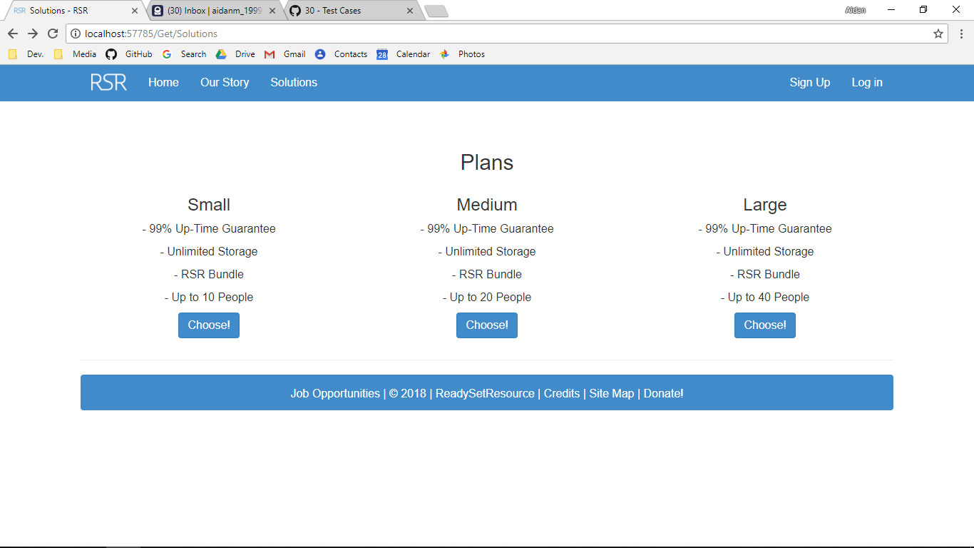

Screenshot After:

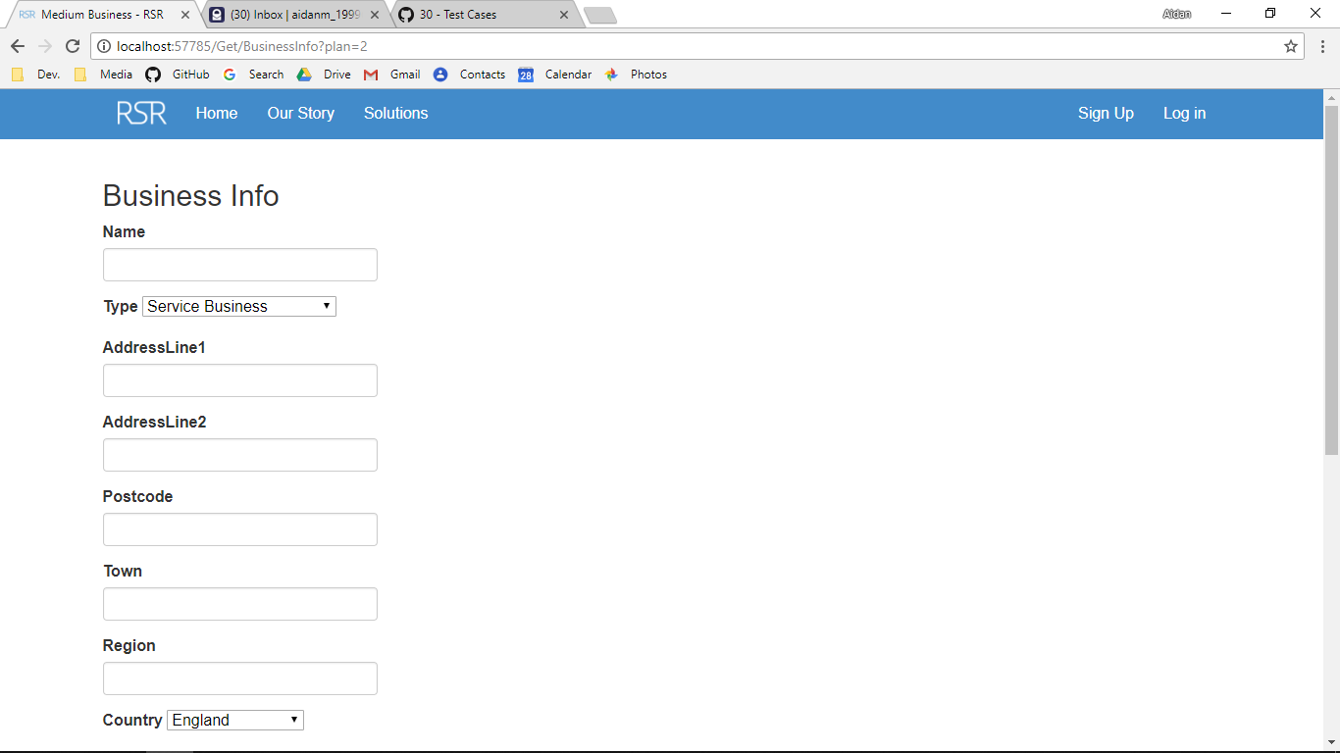

Additional Screenshot (if applicable):

Additional Notes (if applicable):

Test Case ID: AR2 Attempt Number: 1

Action: The user clicks add employee and goes through the necessary steps to add and edit the user

Comprehensive Test Type: Not Applicable

Test Data: Not Applicable

Expected Output: A user is added and emailed

Actual Output: As expected

Result: Pass

Reason for fail (if applicable):

Error Type (if applicable):

Remediation (if applicable):

Screenshot Before:

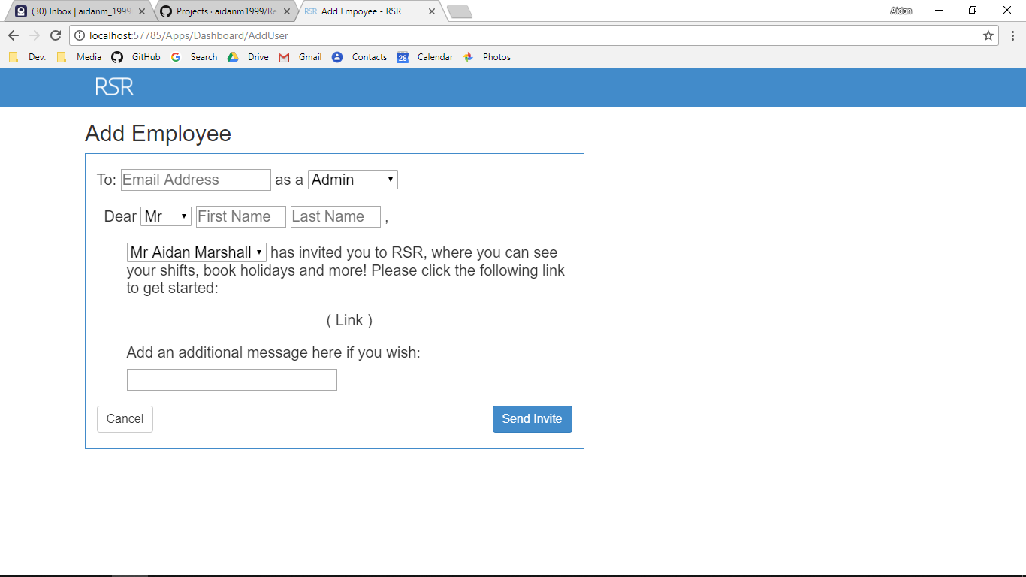

Screenshot After:

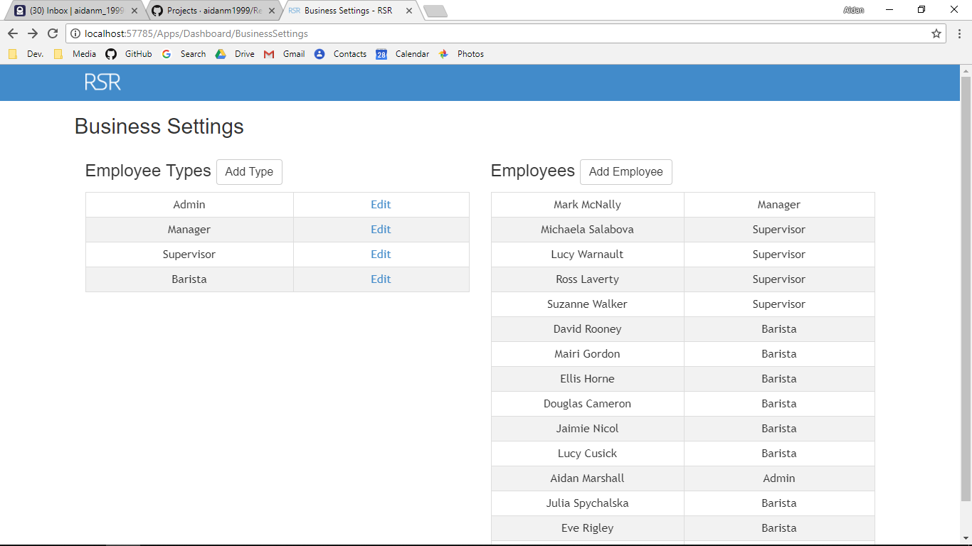

Additional Screenshot (if applicable):

Additional Notes (if applicable):

Test Case ID: AR3 Attempt Number: 1

Action: The administrator clicks on the holidays app icon

Comprehensive Test Type: Not Applicable

Test Data: Not Applicable

Expected Output: The ‘administrator’ can see any holidays that have been requested that week

Actual Output: As expected

Result: Pass

Reason for fail (if applicable):

Error Type (if applicable):

Remediation (if applicable):

Screenshot Before:

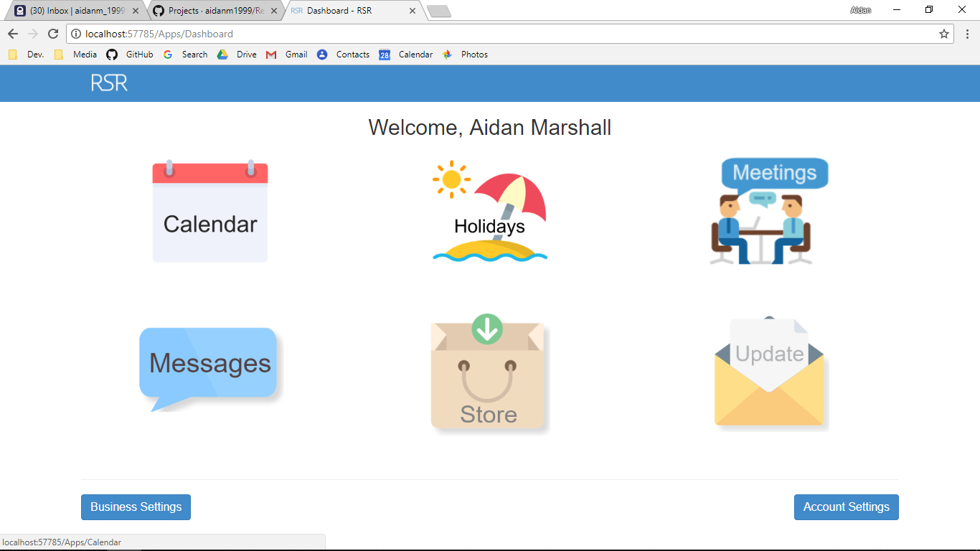

Screenshot After:

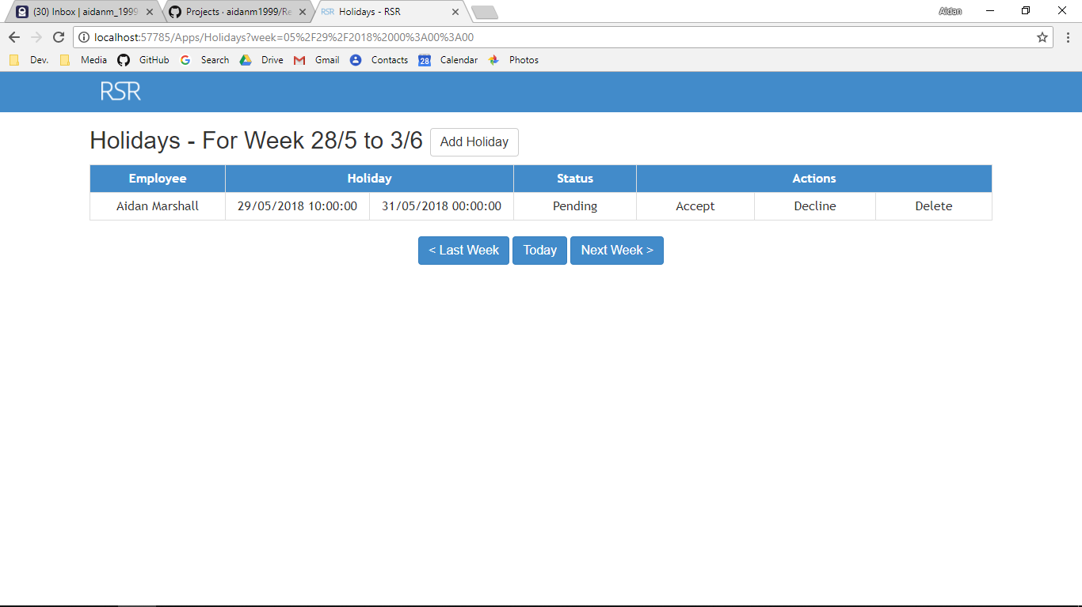

Additional Screenshot (if applicable):

Additional Notes (if applicable):

Test Case ID: AR4 Attempt Number: 1

Action: The administrator books a holiday

Comprehensive Test Type: Not Applicable

Test Data: Not Applicable

Expected Output: A holiday is added to the list of holidays

Actual Output: As expected

Result: Pass

Reason for fail (if applicable):

Error Type (if applicable):

Remediation (if applicable):

Screenshot Before:

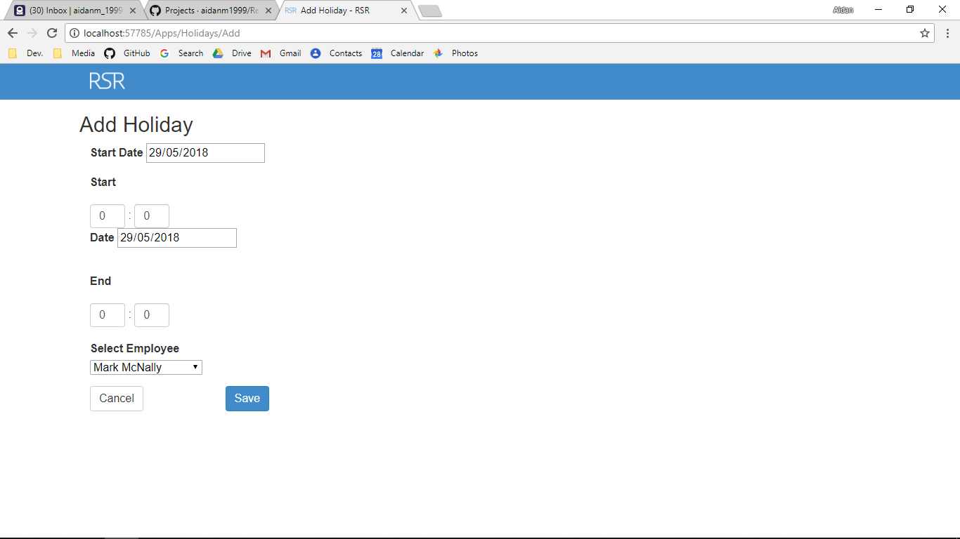

Screenshot After:

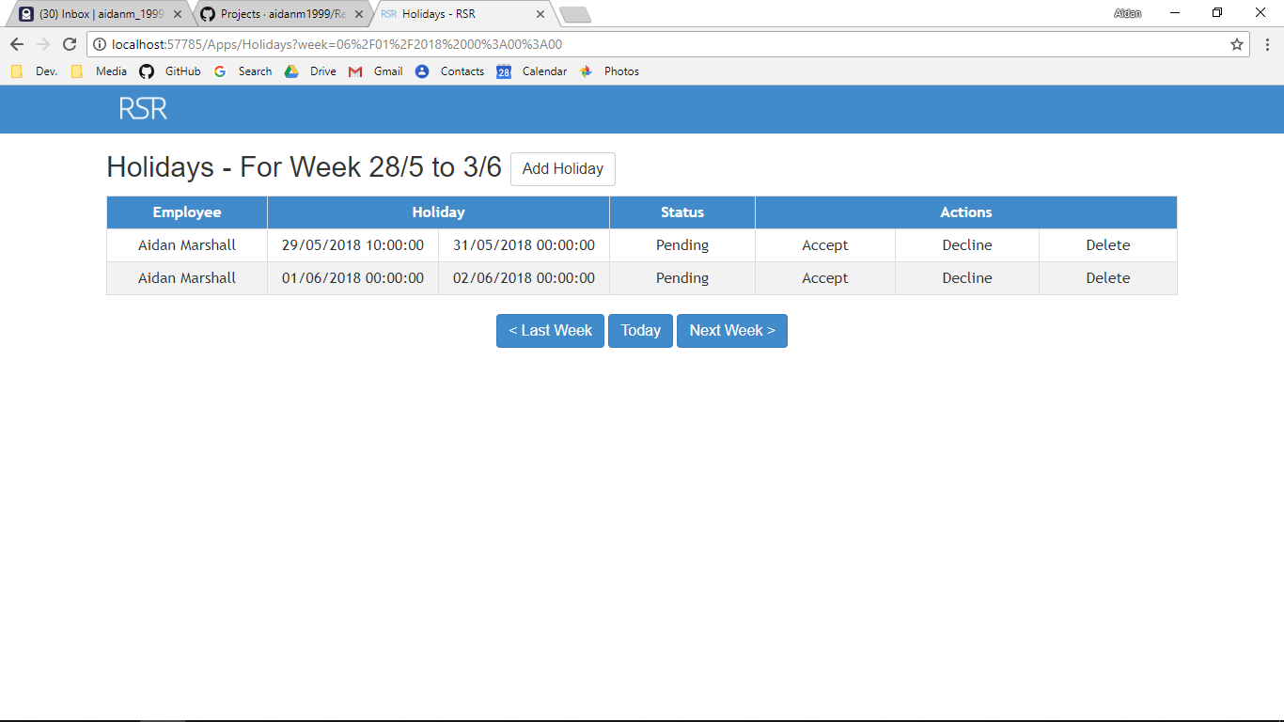

Additional Screenshot (if applicable):

Additional Notes (if applicable):

Test Case ID: AR5 Attempt Number: 1

Action: The user clicks on an employee’s name

Comprehensive Test Type: Not Applicable

Test Data: Not Applicable

Expected Output: The user can see charts with user’s work hours

Actual Output: As expected

Result: Pass

Reason for fail (if applicable):

Error Type (if applicable):

Remediation (if applicable):

Screenshot Before:

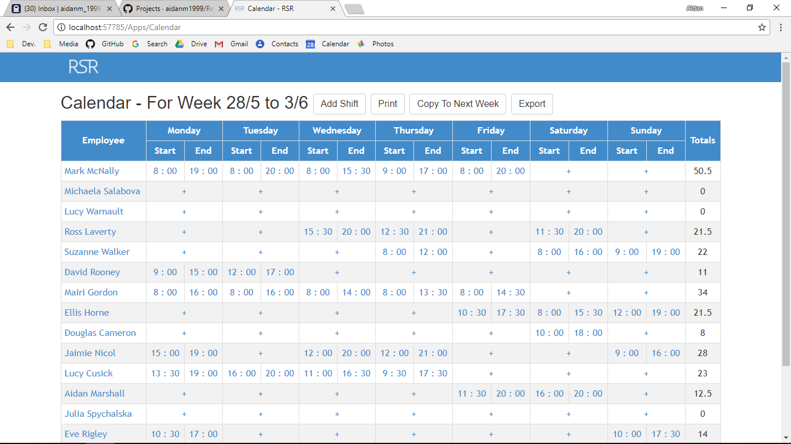

Screenshot After:

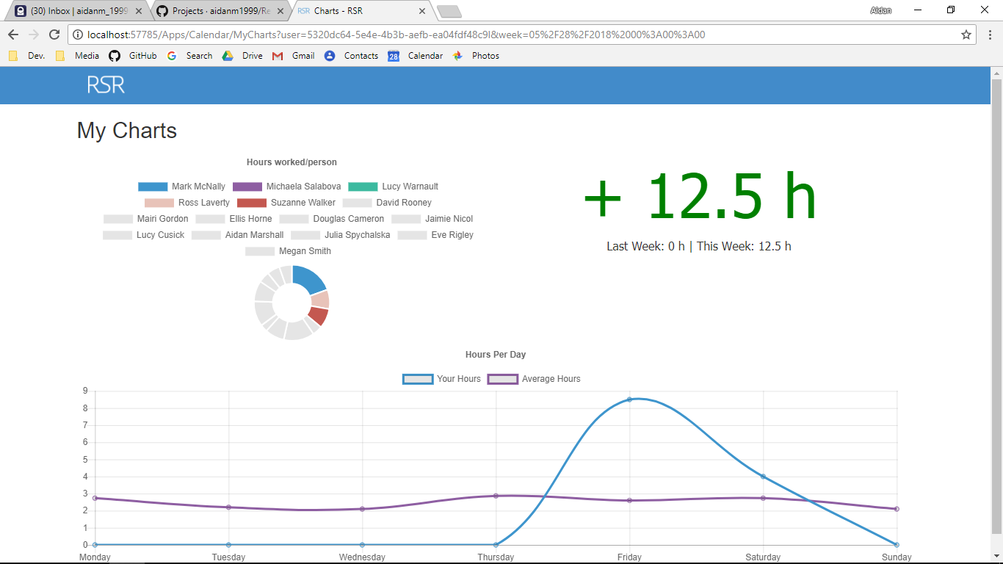

Additional Screenshot (if applicable):

Additional Notes (if applicable):

Test Case ID: AR6 Attempt Number: 1

Action: The manager adds multiple shifts resulting in a rota

Comprehensive Test Type: Not Applicable

Test Data: Not Applicable

Expected Output: The rota is displayed

Actual Output: As expected

Result: Pass

Reason for fail (if applicable):

Error Type (if applicable):

Remediation (if applicable):

Screenshot Before:

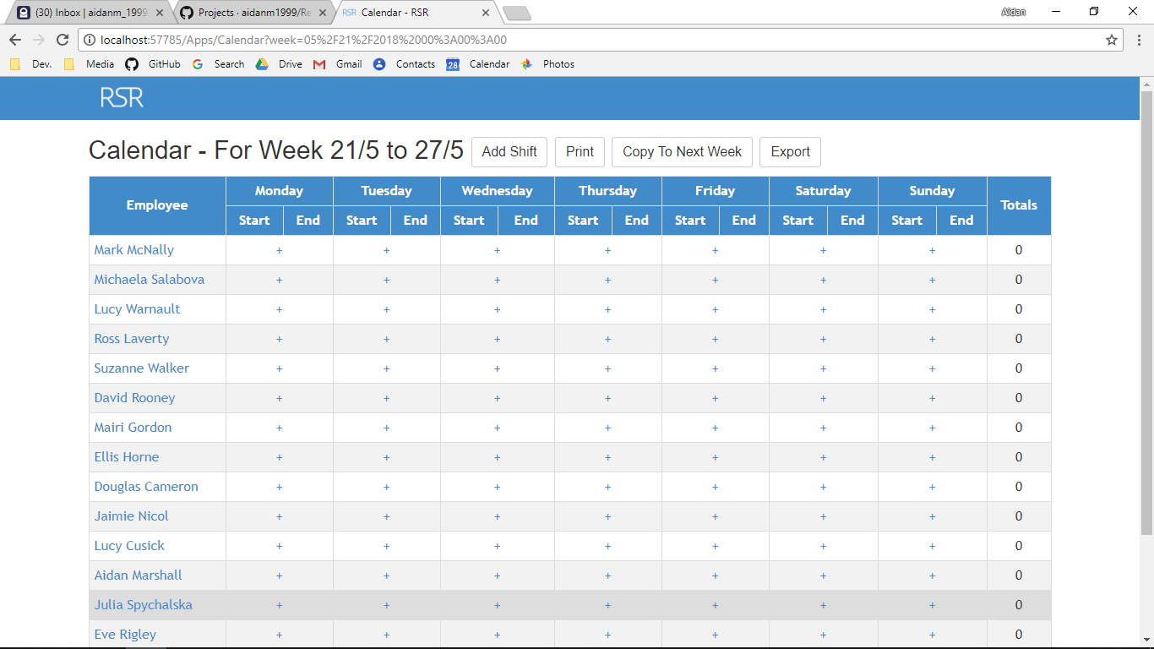

Screenshot After:

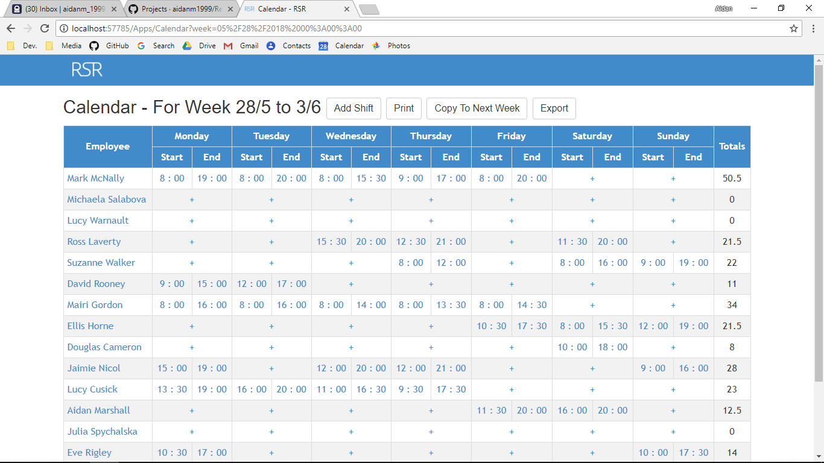

Additional Screenshot (if applicable):

Additional Notes (if applicable):

Test Case ID: AR7 Attempt Number: 1

Action: The user clicks the calendar app icon

Comprehensive Test Type: Not Applicable

Test Data: Not Applicable

Expected Output: The user can see the rota created for that week

Actual Output: As expected

Result: Pass

Reason for fail (if applicable):

Error Type (if applicable):

Remediation (if applicable):

Screenshot Before:

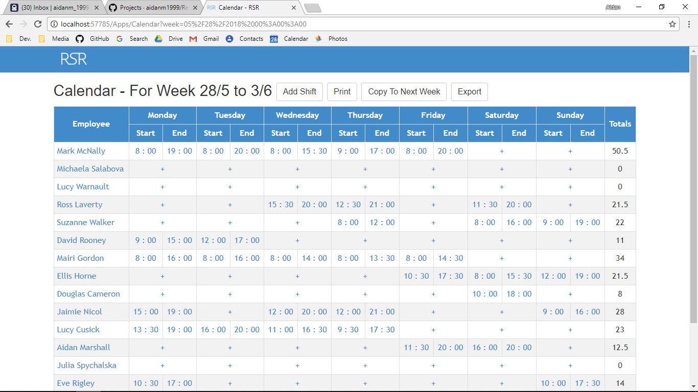

Screenshot After:

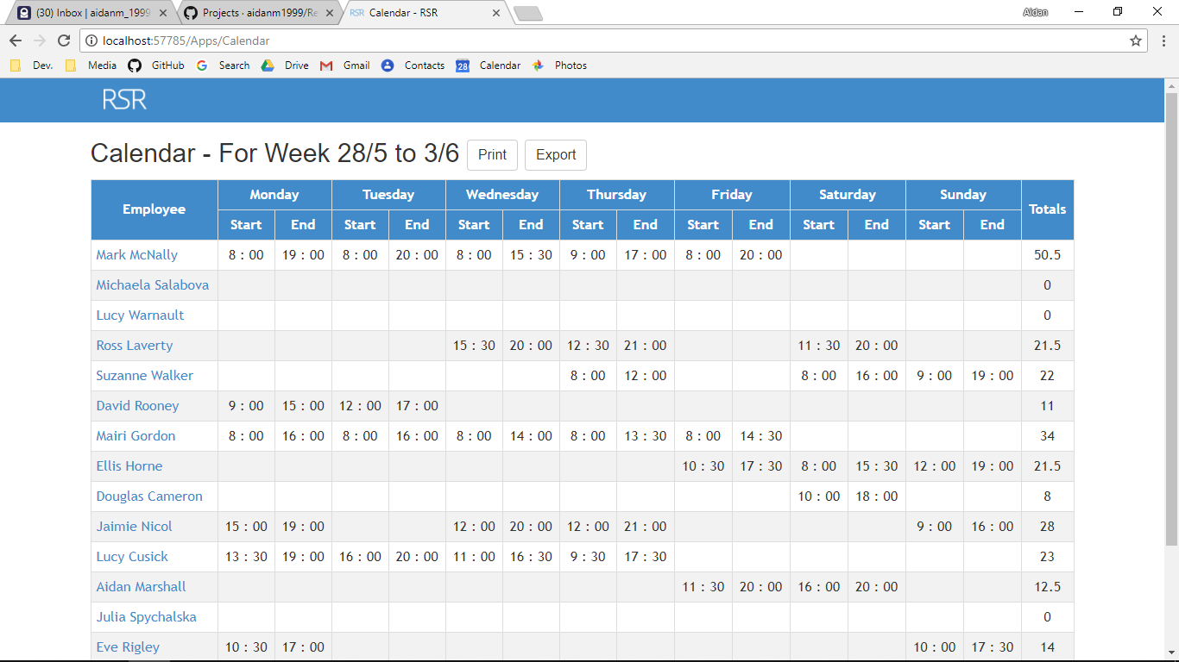

Additional Screenshot (if applicable):

Additional Notes (if applicable):

Test Case ID: AR8 Attempt Number: 1

Action: The user clicks the holidays app icon

Comprehensive Test Type: Not Applicable

Test Data: Not Applicable

Expected Output: The user can log in and see the holidays created for that week

Actual Output: As expected

Result: Pass

Reason for fail (if applicable):

Error Type (if applicable):

Remediation (if applicable):

Screenshot Before:

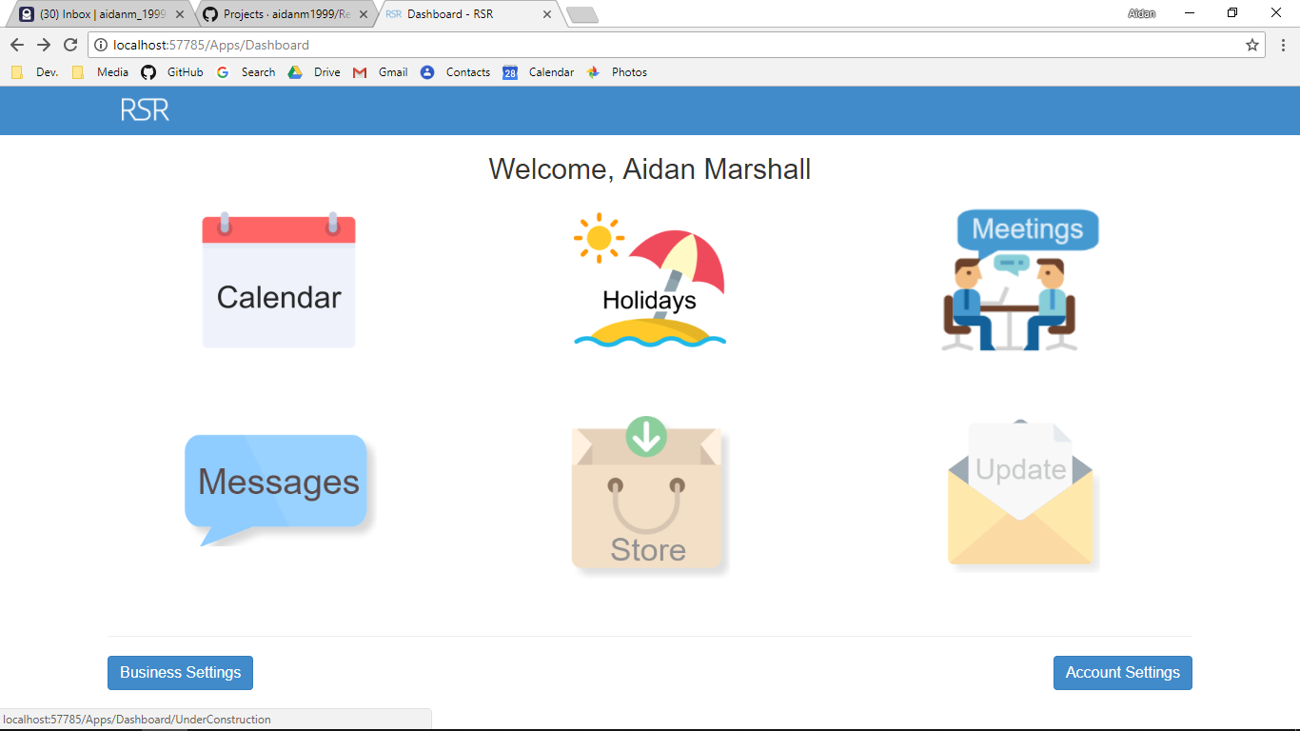

Screenshot After:

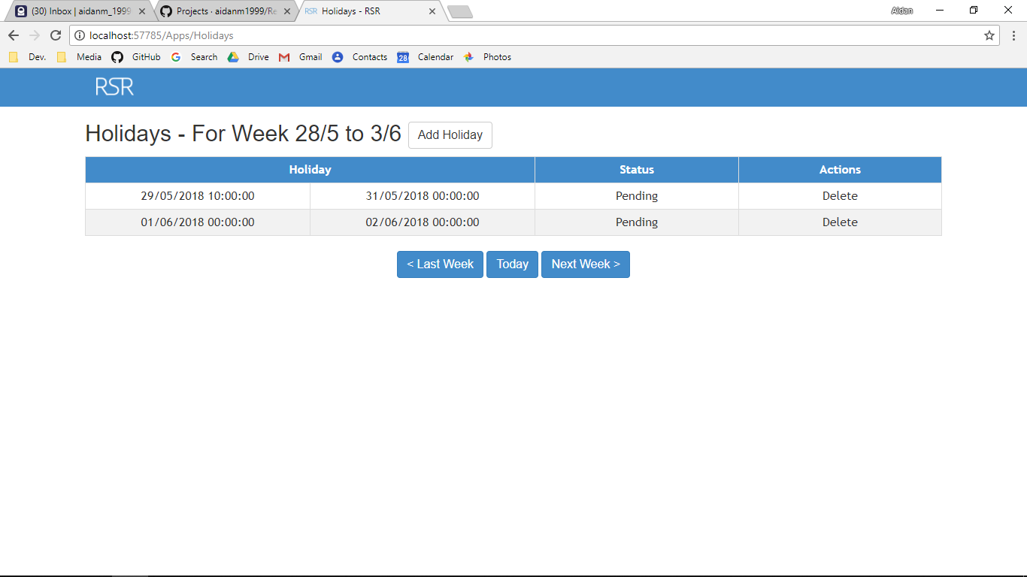

Additional Screenshot (if applicable):

Additional Notes (if applicable):

Test Case ID: AR9 Attempt Number: 1

Action: The employee books a holiday

Comprehensive Test Type: Not Applicable

Test Data: Not Applicable

Expected Output: The holiday is booked with a status of pending

Actual Output: As expected

Result: Pass

Reason for fail (if applicable):

Error Type (if applicable):

Remediation (if applicable):

Screenshot Before:

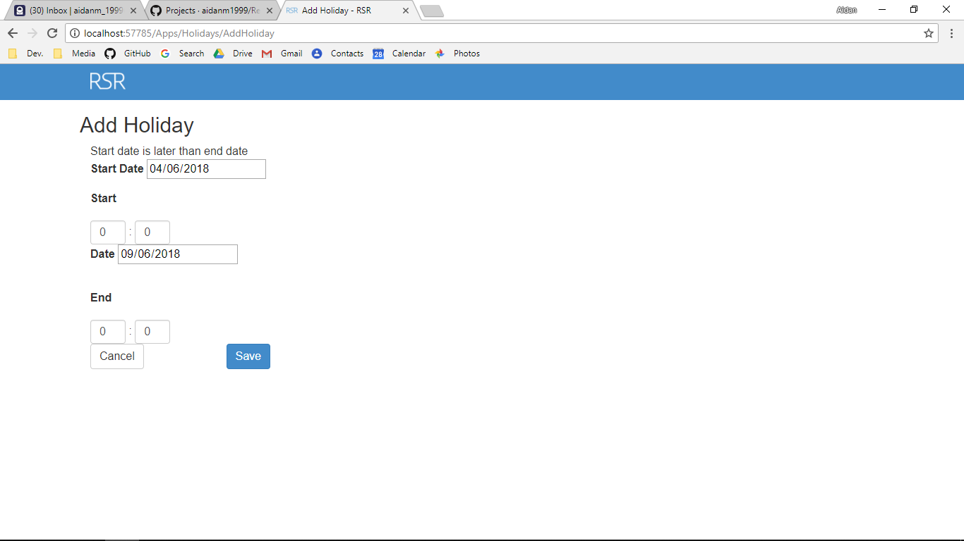

Screenshot After:

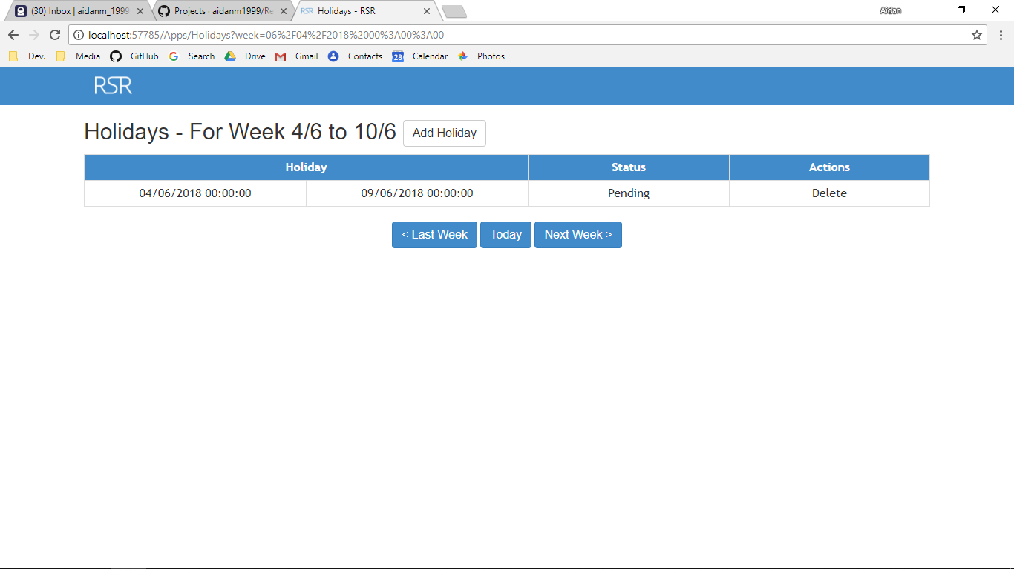

Additional Screenshot (if applicable):

Additional Notes (if applicable):

Test Case ID: AL1 Attempt Number: 1

Action: User clicks on the logo

Comprehensive Test Type: Not Applicable

Test Data: Not Applicable

Expected Output: The user is redirected to index of home controller

Actual Output: As expected

Result: Pass

Reason for fail (if applicable):

Error Type (if applicable):

Remediation (if applicable):

Screenshot Before:

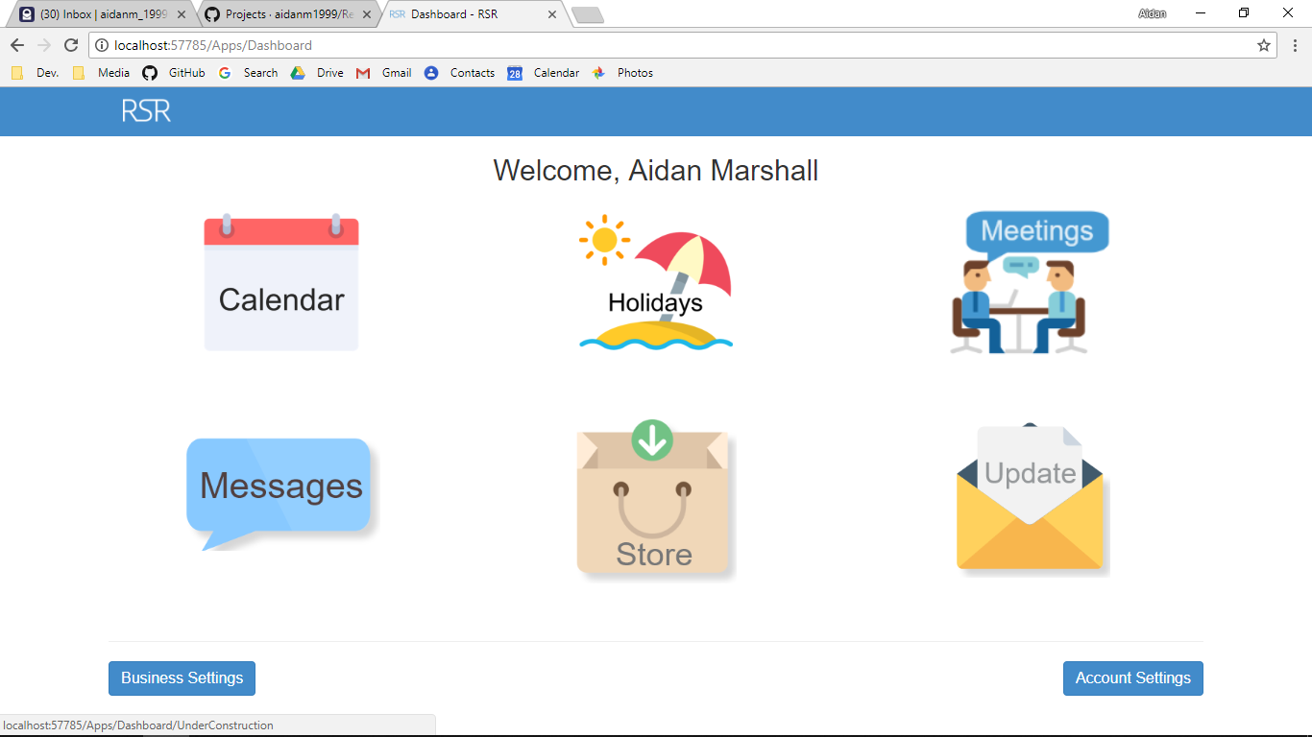

Screenshot After:

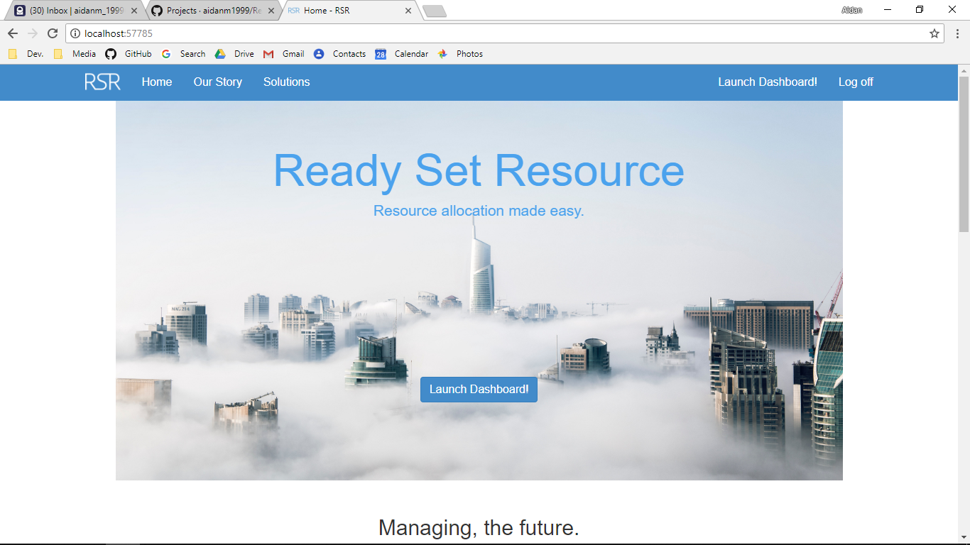

Additional Screenshot (if applicable):

Additional Notes (if applicable):

Test Case ID: AL2 Attempt Number: 1

Action: User clicks on the Calendar icon

Comprehensive Test Type: Not Applicable

Test Data: Not Applicable

Expected Output: The user is redirected to calendar of dashboard controller

Actual Output: As expected

Result: Pass

Reason for fail (if applicable):

Error Type (if applicable):

Remediation (if applicable):

Screenshot Before:



Screenshot After:

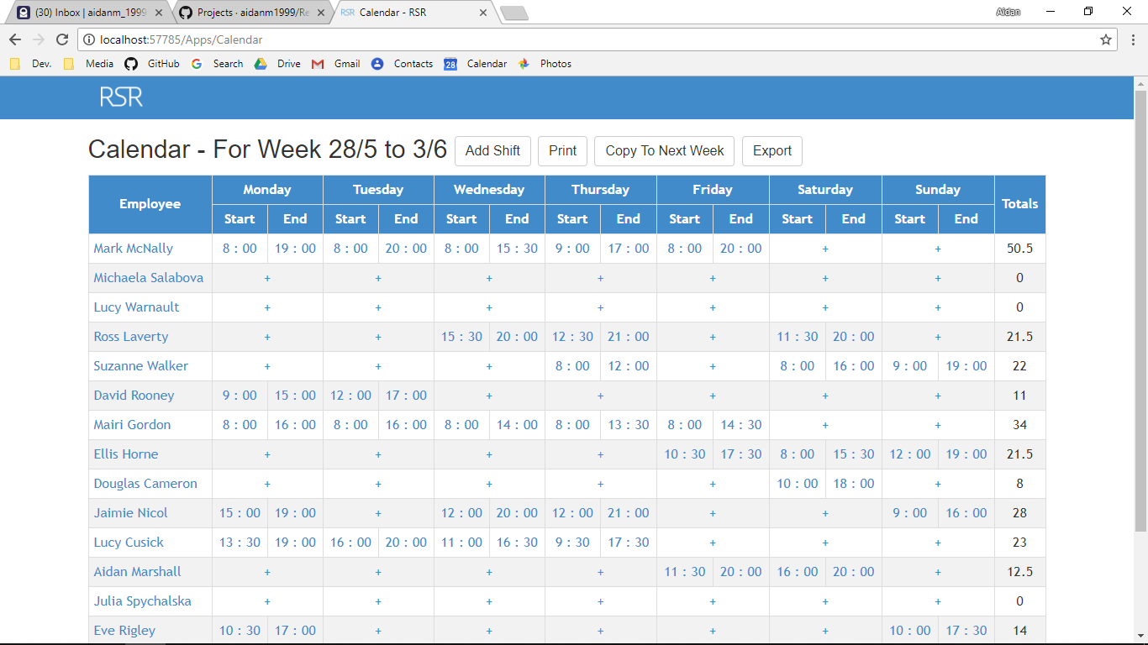

Additional Screenshot (if applicable):

Additional Notes (if applicable):

Test Case ID: AL3 Attempt Number: 1

Action: User clicks on the holidays

Comprehensive Test Type: Not Applicable

Test Data: Not Applicable

Expected Output: The user is redirected to index of holidays controller

Actual Output: As expected

Result: Pass

Reason for fail (if applicable):

Error Type (if applicable):

Remediation (if applicable):

Screenshot Before:



Screenshot After:



Additional Screenshot (if applicable):

Additional Notes (if applicable):

Test Case ID: AL4 Attempt Number: 1

Action: User clicks on the meetings

Comprehensive Test Type: Not Applicable

Test Data: Not Applicable

Expected Output: The user is redirected to under construction page

Actual Output: As expected

Result: Pass

Reason for fail (if applicable):

Error Type (if applicable):

Remediation (if applicable):

Screenshot Before:



Screenshot After:

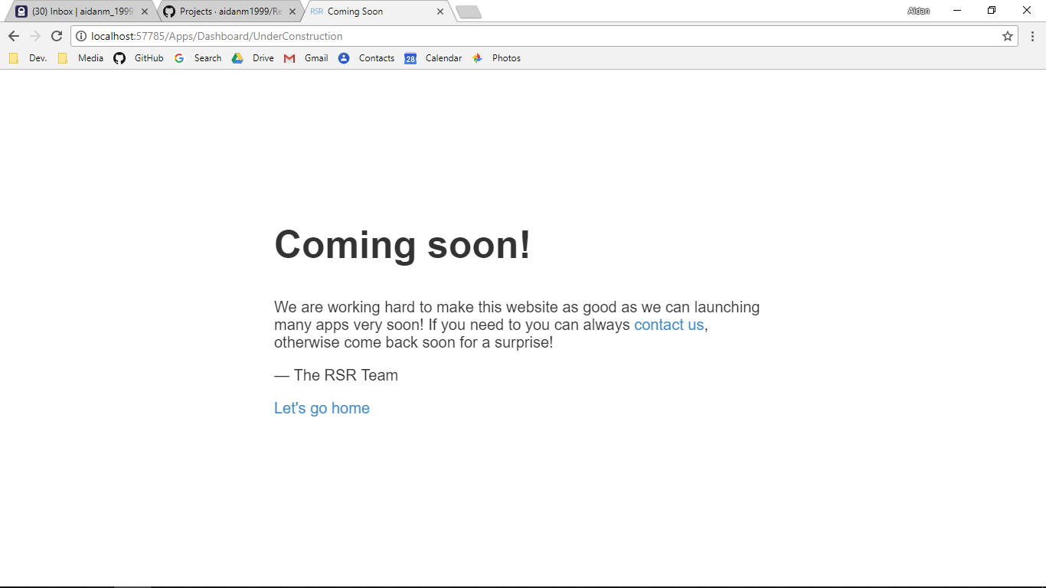

Additional Screenshot (if applicable):

Additional Notes (if applicable):

Test Case ID: AL5 Attempt Number: 1

Action: User clicks on the messages

Comprehensive Test Type: Not Applicable

Test Data: Not Applicable

Expected Output: The user is redirected to under construction

Actual Output: As expected

Result: Pass

Reason for fail (if applicable):

Error Type (if applicable):

Remediation (if applicable):

Screenshot Before:



Screenshot After:



Additional Screenshot (if applicable):

Additional Notes (if applicable):

Test Case ID: AL6 Attempt Number: 1

Action: User clicks on the store

Comprehensive Test Type: Not Applicable

Test Data: Not Applicable

Expected Output: The user is redirected to under construction

Actual Output: As expected

Result: Pass

Reason for fail (if applicable):

Error Type (if applicable):

Remediation (if applicable):

Screenshot Before:



Screenshot After:



Additional Screenshot (if applicable):

Additional Notes (if applicable):

Test Case ID: AL7 Attempt Number: 1

Action: User clicks on the updates icon

Comprehensive Test Type: Not Applicable

Test Data: Not Applicable

Expected Output: The user is redirected to under construction

Actual Output: As expected

Result: Pass

Reason for fail (if applicable):

Error Type (if applicable):

Remediation (if applicable):

Screenshot Before:



Screenshot After:



Additional Screenshot (if applicable):

Additional Notes (if applicable):

Test Case ID: AL8 Attempt Number: 1

Action: User clicks on the business settings button

Comprehensive Test Type: Not Applicable

Test Data: Not Applicable

Expected Output: The user is redirected to business settings page

Actual Output: As expected

Result: Pass

Reason for fail (if applicable):

Error Type (if applicable):

Remediation (if applicable):

Screenshot Before:



Screenshot After:

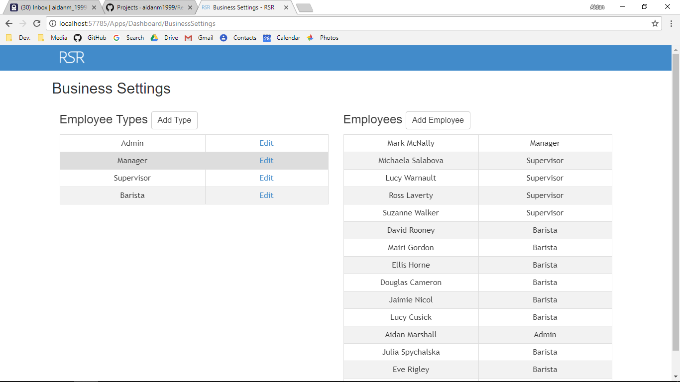

Additional Screenshot (if applicable):

Additional Notes (if applicable):

Test Case ID: AL9 Attempt Number: 1

Action: User clicks on the account settings

Comprehensive Test Type: Not Applicable

Test Data: Not Applicable

Expected Output: The user is redirected to account settings page

Actual Output: As expected

Result: Pass

Reason for fail (if applicable):

Error Type (if applicable):

Remediation (if applicable):

Screenshot Before:



Screenshot After:

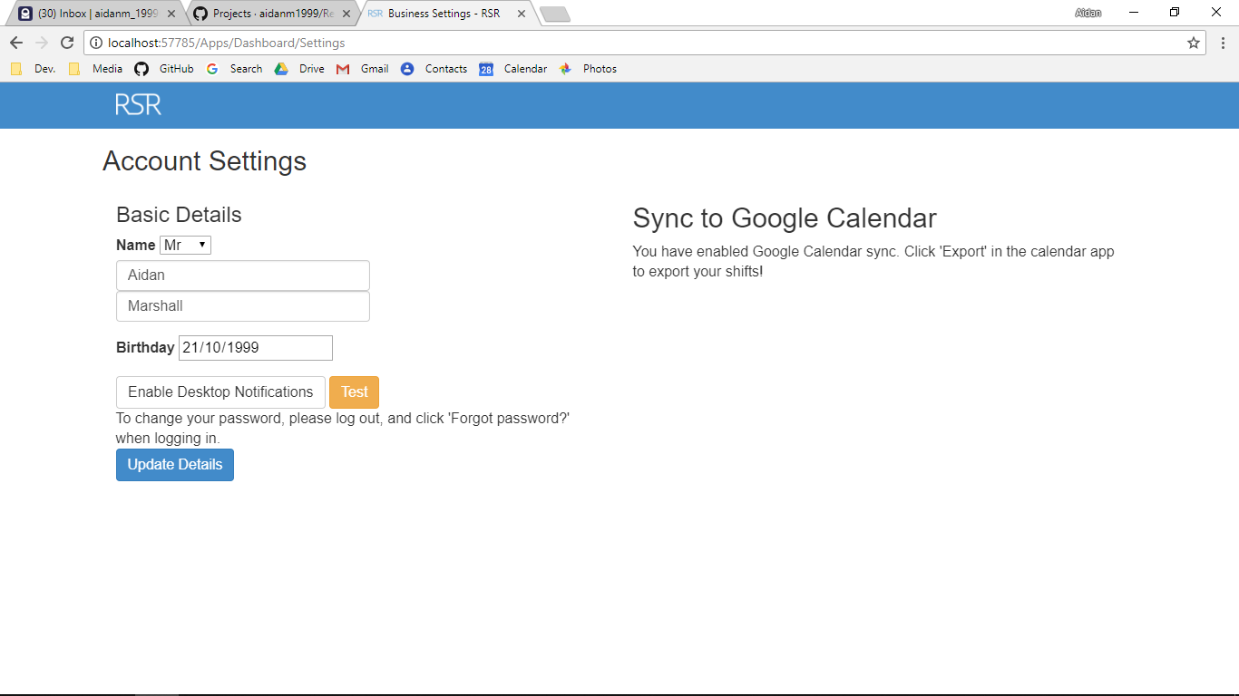

Additional Screenshot (if applicable):

Additional Notes (if applicable):

Test Case ID: AL10 Attempt Number: 1

Action: User clicks on the add type button

Comprehensive Test Type: Not Applicable

Test Data: Not Applicable

Expected Output: The user is redirected to the add type page

Actual Output: As expected

Result: Pass

Reason for fail (if applicable):

Error Type (if applicable):

Remediation (if applicable):

Screenshot Before:

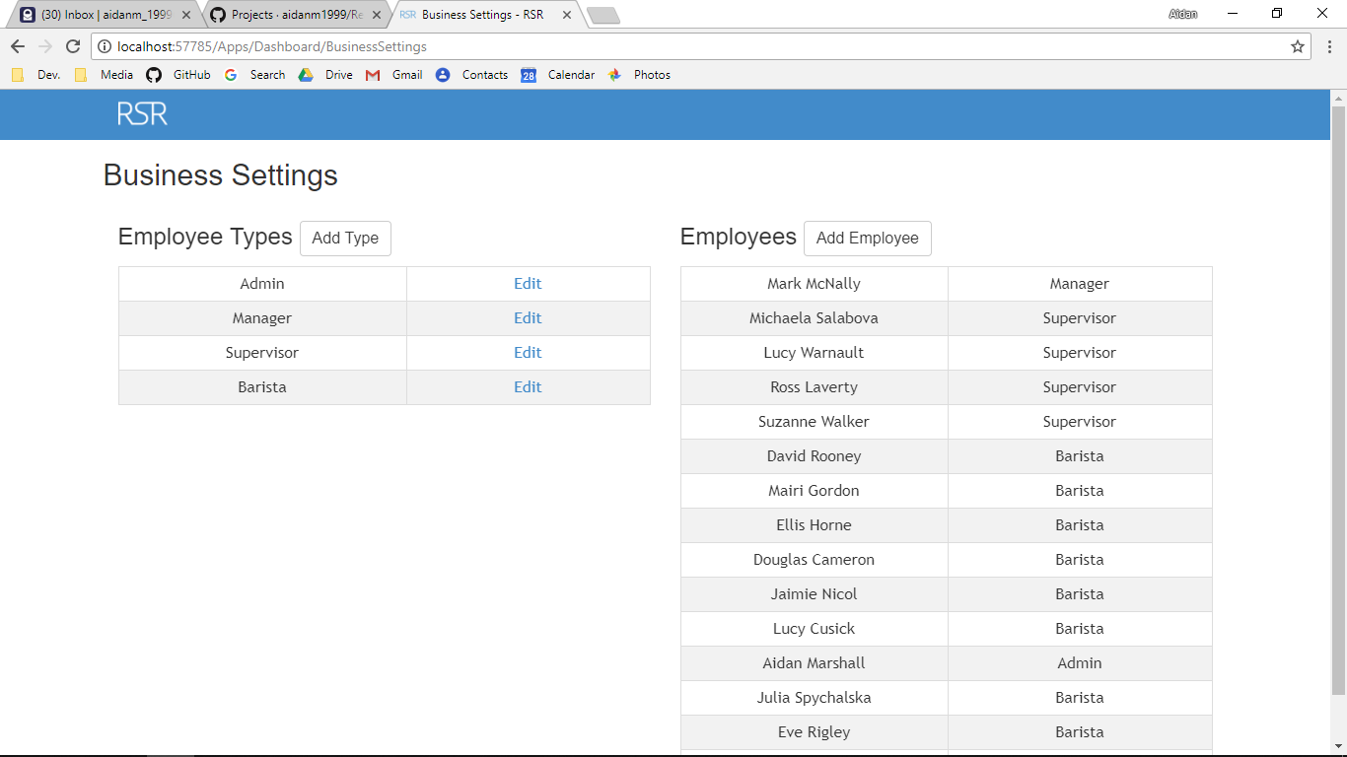

Screenshot After:

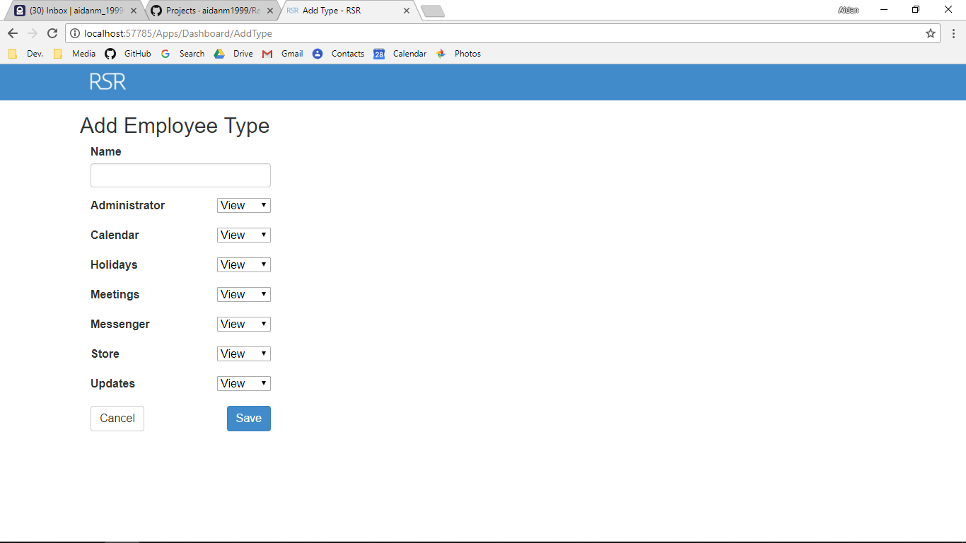

Additional Screenshot (if applicable):

Additional Notes (if applicable):

Test Case ID: AL11 Attempt Number: 1

Action: User clicks on the edit button

Comprehensive Test Type: Not Applicable

Test Data: Not Applicable

Expected Output: The user is redirected to the edit page for the type

Actual Output: As expected

Result: Pass

Reason for fail (if applicable):

Error Type (if applicable):

Remediation (if applicable):

Screenshot Before:



Screenshot After:

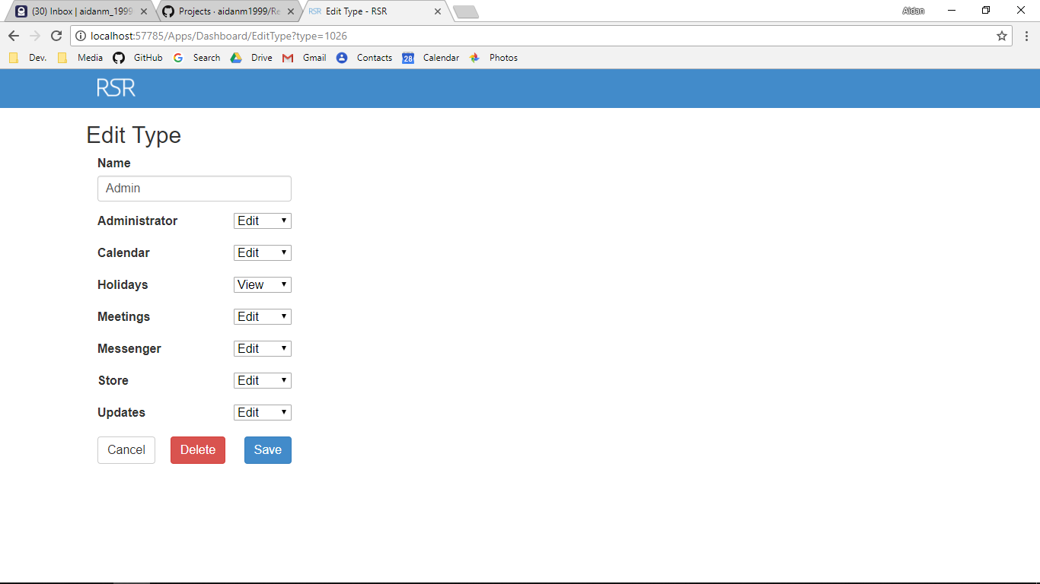

Additional Screenshot (if applicable):

Additional Notes (if applicable):

Test Case ID: AL12 Attempt Number: 1

Action: User clicks on the add employee button

Comprehensive Test Type: Not Applicable

Test Data: Not Applicable

Expected Output: The user is redirected to add employee

Actual Output: As expected

Result: Pass

Reason for fail (if applicable):

Error Type (if applicable):

Remediation (if applicable):

Screenshot Before:



Screenshot After:

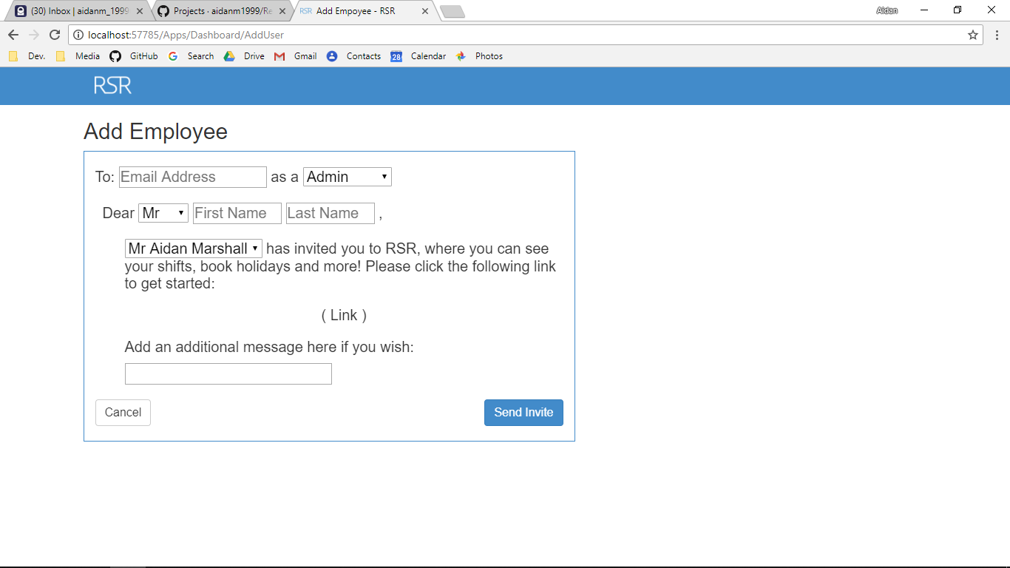

Additional Screenshot (if applicable):

Additional Notes (if applicable):

Test Case ID: AL13 Attempt Number: 1

Action: User clicks on the cancel button

Comprehensive Test Type: Not Applicable

Test Data: Not Applicable

Expected Output: The user is redirected to the index

Actual Output: As expected

Result: Pass

Reason for fail (if applicable):

Error Type (if applicable):

Remediation (if applicable):

Screenshot Before:



Screenshot After:



Additional Screenshot (if applicable):

Additional Notes (if applicable):

Test Case ID: AL14 Attempt Number: 1

Action: User clicks on the cancel button

Comprehensive Test Type: Not Applicable

Test Data: Not Applicable

Expected Output: The user is redirected to index of dashboard controller

Actual Output: As expected

Result: Pass

Reason for fail (if applicable):

Error Type (if applicable):

Remediation (if applicable):

Screenshot Before:

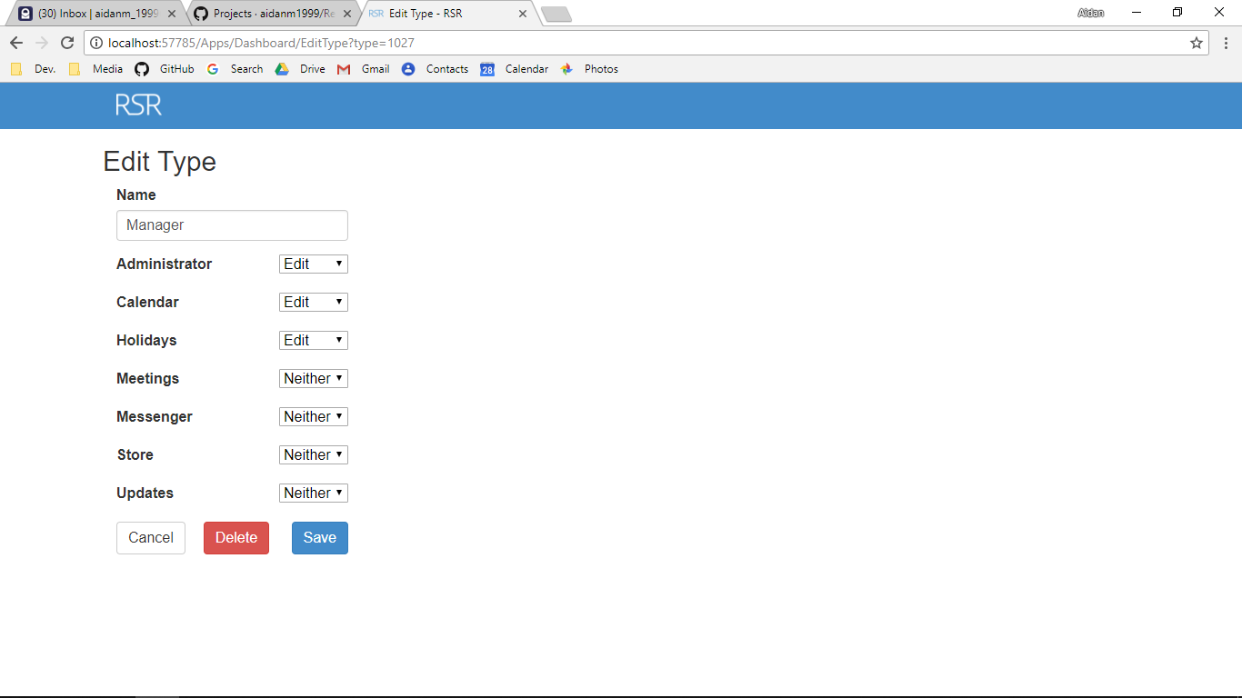

Screenshot After:



Additional Screenshot (if applicable):

Additional Notes (if applicable):

Test Case ID: AL15 Attempt Number: 1

Action: User clicks on the Add shift button

Comprehensive Test Type: Not Applicable

Test Data: Not Applicable

Expected Output: The user is redirected to add shift page

Actual Output: As expected

Result: Pass

Reason for fail (if applicable):

Error Type (if applicable):

Remediation (if applicable):

Screenshot Before:

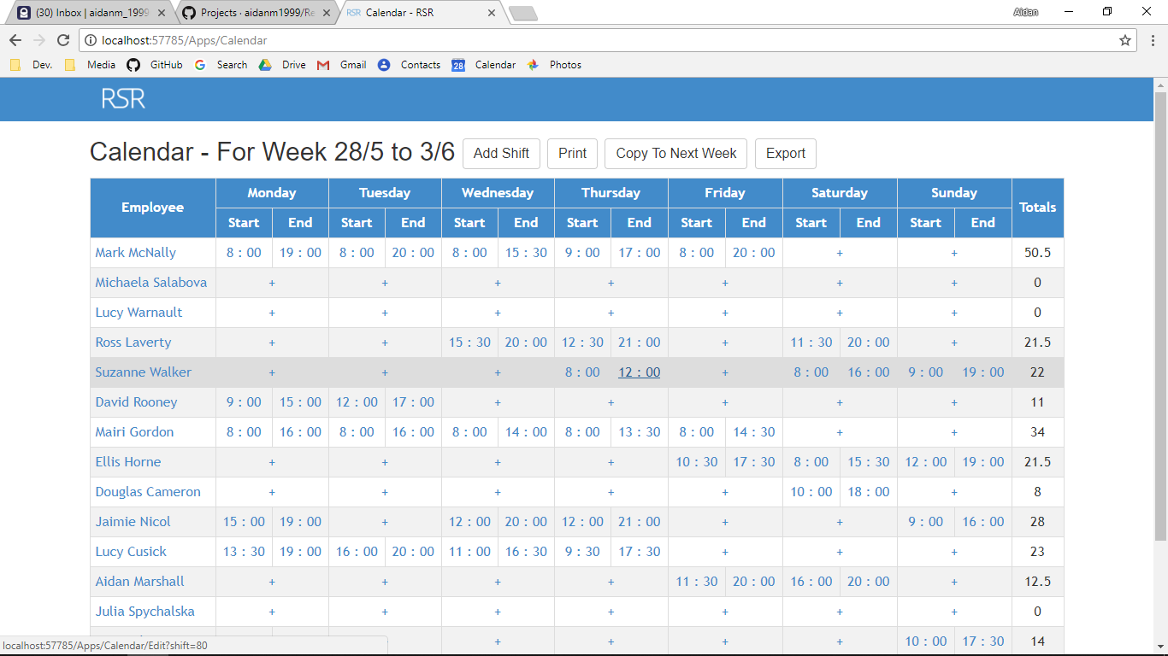

Screenshot After:

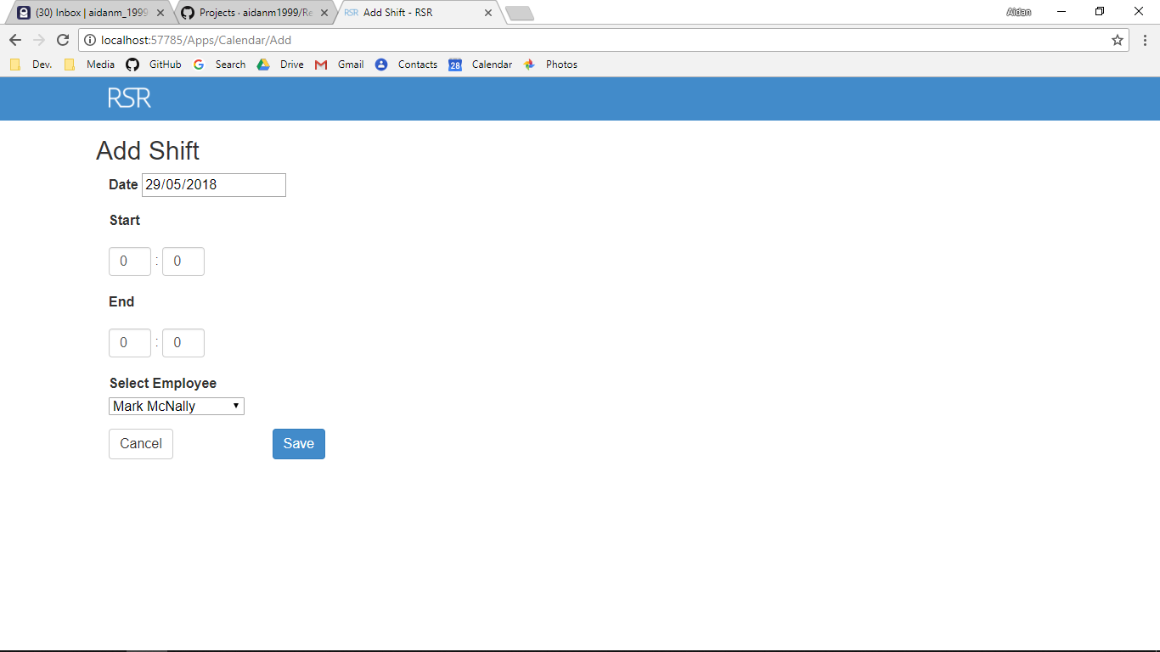

Additional Screenshot (if applicable):

Additional Notes (if applicable):

Test Case ID: AL16 Attempt Number: 1

Action: User clicks on the employee’s name

Comprehensive Test Type: Not Applicable

Test Data: Not Applicable

Expected Output: The user is redirected to MyCharts

Actual Output: As expected

Result: Pass

Reason for fail (if applicable):

Error Type (if applicable):

Remediation (if applicable):

Screenshot Before:



Screenshot After:

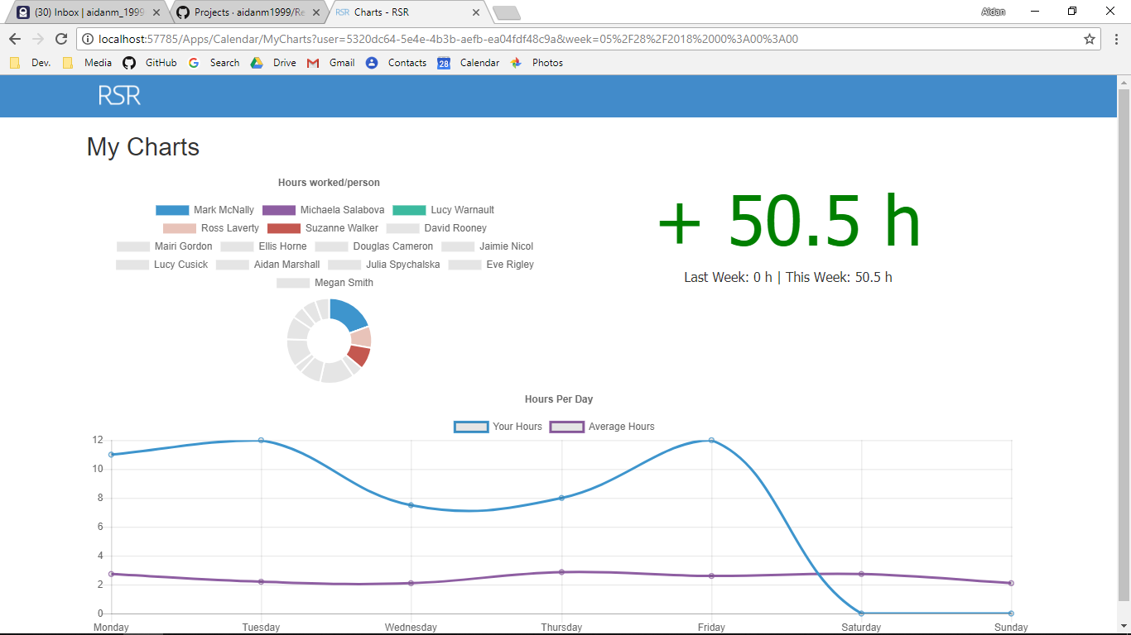

Additional Screenshot (if applicable):

Additional Notes (if applicable):

Test Case ID: AL17 Attempt Number: 1

Action: User clicks on a time in the calendar page

Comprehensive Test Type: Not Applicable

Test Data: Not Applicable

Expected Output: The user is redirected to edit page in the calendar

Actual Output: As expected

Result: Pass

Reason for fail (if applicable):

Error Type (if applicable):

Remediation (if applicable):

Screenshot Before:

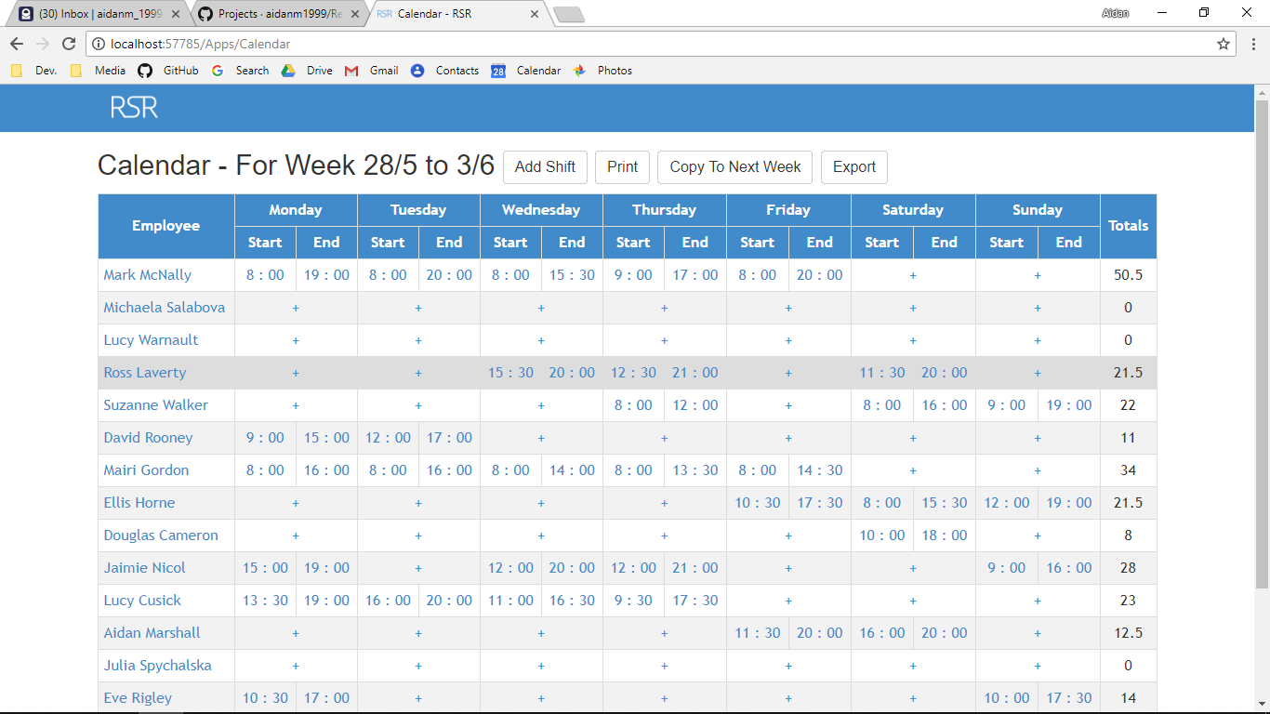

Screenshot After:

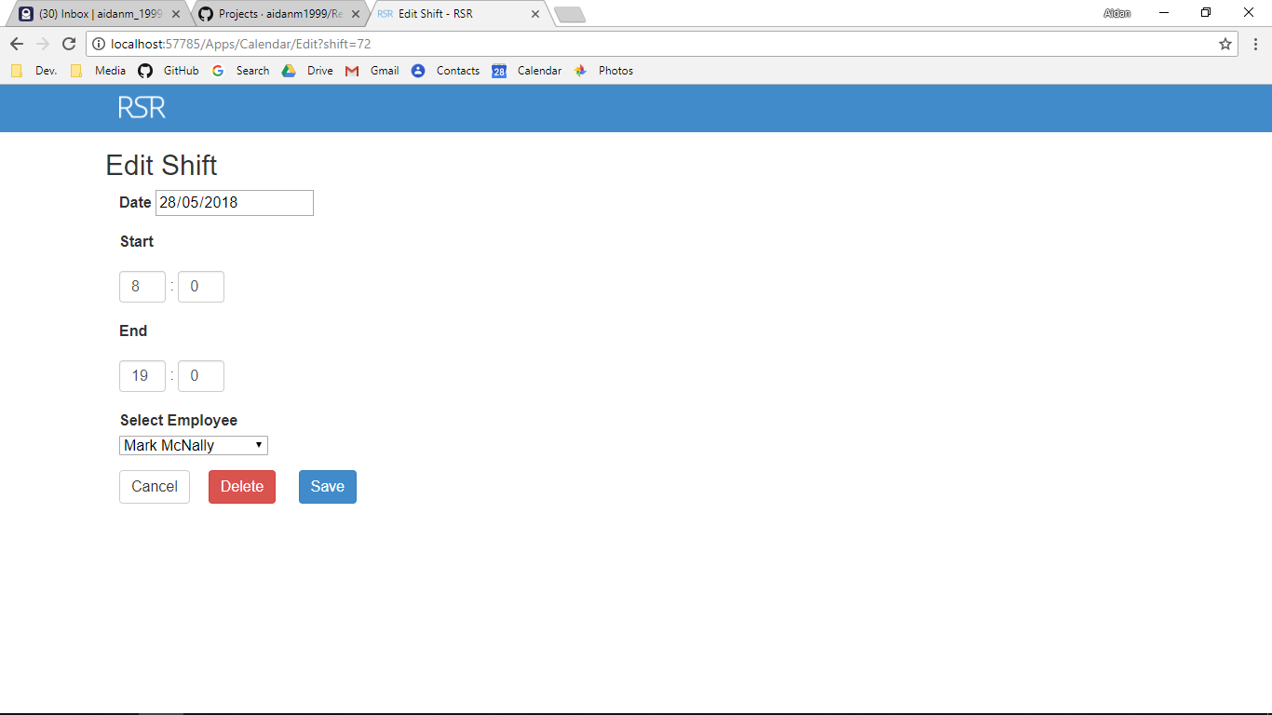

Additional Screenshot (if applicable):

Additional Notes (if applicable):

Test Case ID: AL19 Attempt Number: 1

Action: User clicks on the < Last Week in calendar

Comprehensive Test Type: Not Applicable

Test Data: Not Applicable

Expected Output: The user is redirected to the previous week

Actual Output: As expected

Result: Pass

Reason for fail (if applicable):

Error Type (if applicable):

Remediation (if applicable):

Screenshot Before:

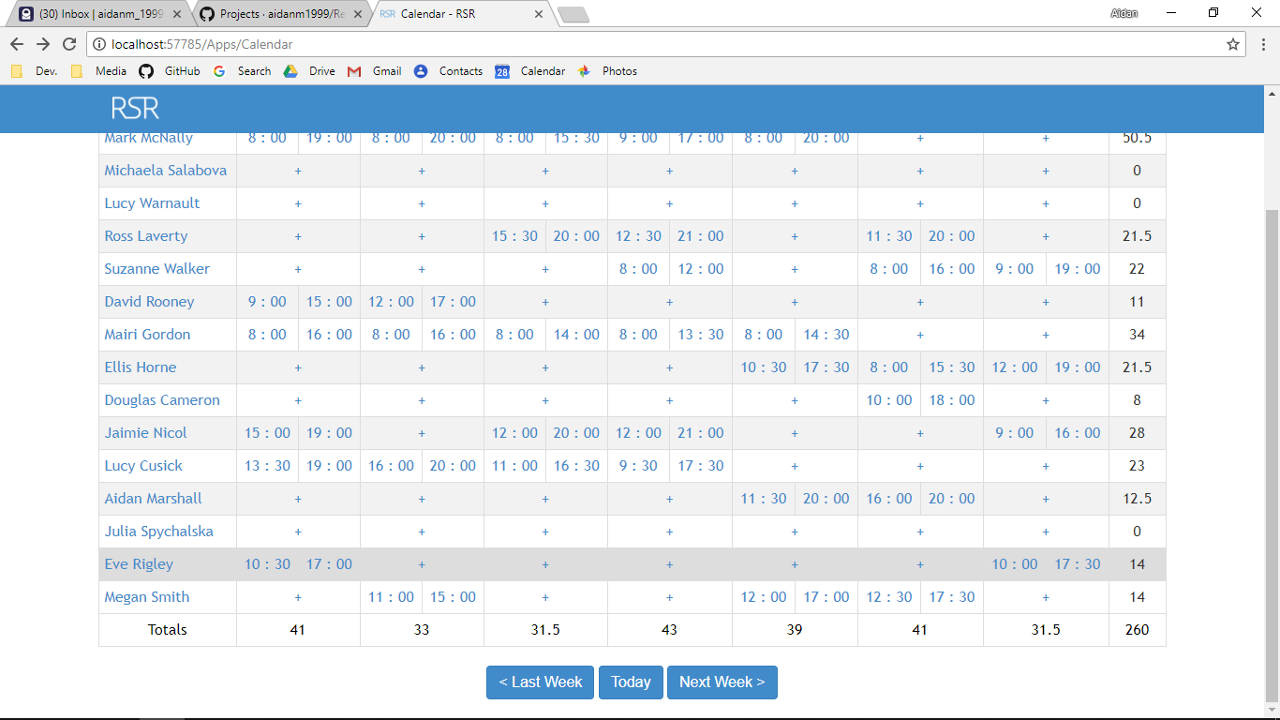

Screenshot After:

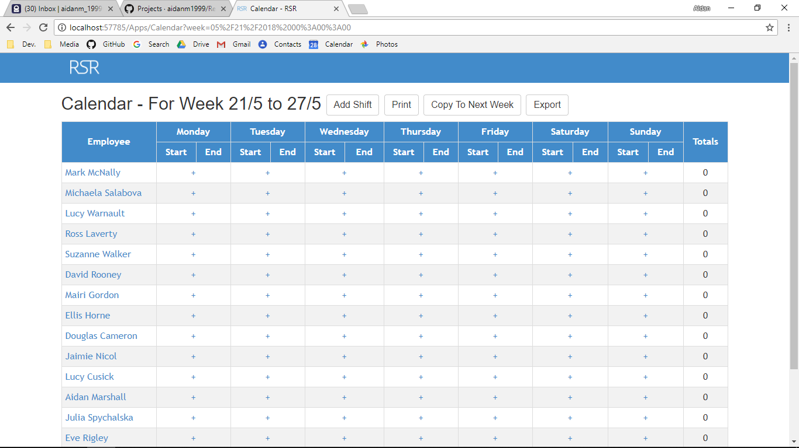

Additional Screenshot (if applicable):

Additional Notes (if applicable):

Test Case ID: AL20 Attempt Number: 1

Action: User clicks on the today button

Comprehensive Test Type: Not Applicable

Test Data: Not Applicable

Expected Output: The user is redirected to index of home controller

Actual Output: As expected

Result: Pass

Reason for fail (if applicable):

Error Type (if applicable):

Remediation (if applicable):

Screenshot Before:

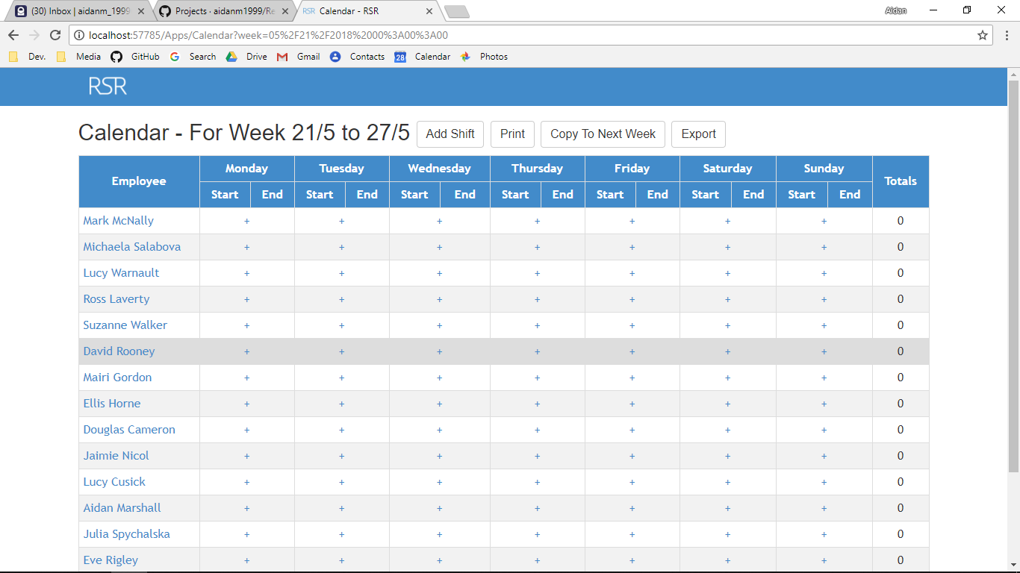

Screenshot After:



Additional Screenshot (if applicable):

Additional Notes (if applicable):

Test Case ID: AL21 Attempt Number: 1

Action: User clicks on the Next Week > button

Comprehensive Test Type: Not Applicable

Test Data: Not Applicable

Expected Output: The user is redirected to the next week of the rota

Actual Output: As expected

Result: Pass

Reason for fail (if applicable):

Error Type (if applicable):

Remediation (if applicable):

Screenshot Before:

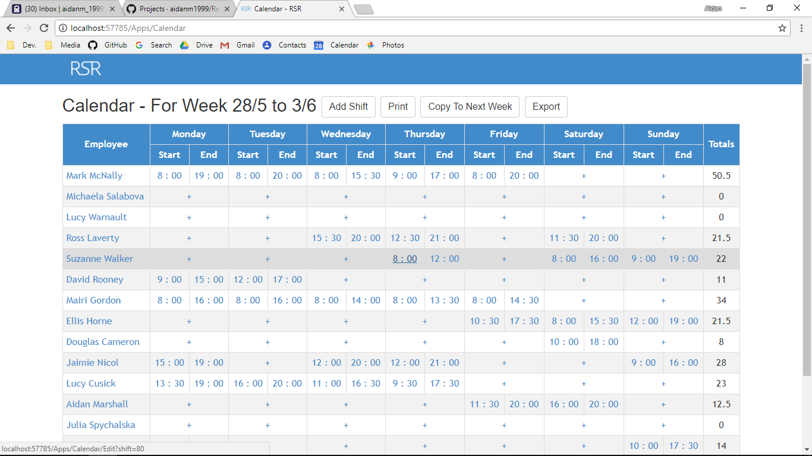

Screenshot After:

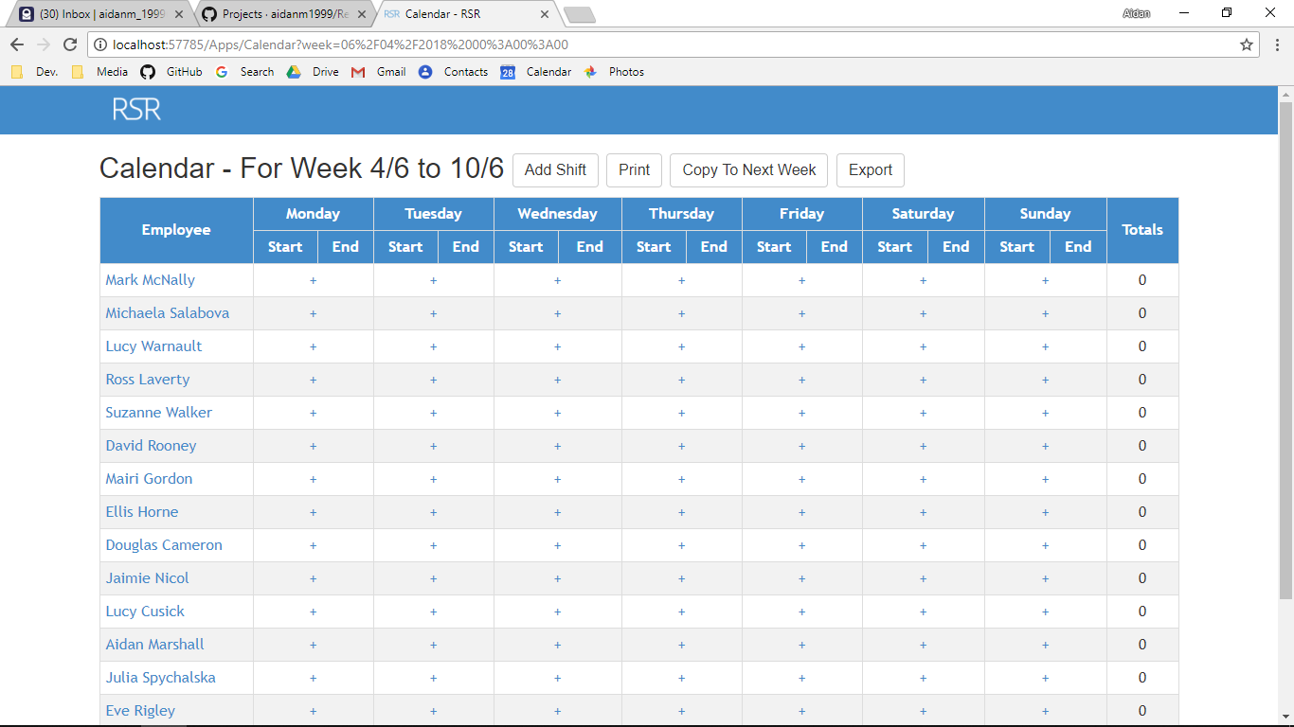

Additional Screenshot (if applicable):

Additional Notes (if applicable):

Test Case ID: AL22 Attempt Number: 1

Action: User clicks on the cancel button

Comprehensive Test Type: Not Applicable

Test Data: Not Applicable

Expected Output: The user is redirected to the index

Actual Output: As expected

Result: Pass

Reason for fail (if applicable):

Error Type (if applicable):

Remediation (if applicable):

Screenshot Before:



Screenshot After:

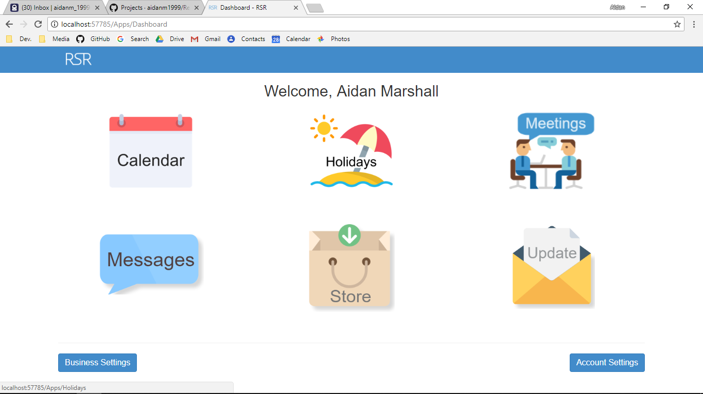

Additional Screenshot (if applicable):

Additional Notes (if applicable):

Test Case ID: AL23 Attempt Number: 1

Action: User clicks on the cancel button

Comprehensive Test Type: Not Applicable

Test Data: Not Applicable

Expected Output: The user is redirected to index

Actual Output: As expected

Result: Pass

Reason for fail (if applicable):

Error Type (if applicable):

Remediation (if applicable):

Screenshot Before:



Screenshot After:



Additional Screenshot (if applicable):

Additional Notes (if applicable):

Test Case ID: AL24 Attempt Number: 1

Action: User clicks on the add holiday

Comprehensive Test Type: Not Applicable

Test Data: Not Applicable

Expected Output: The user is redirected to add holiday page

Actual Output: As expected

Result: Pass

Reason for fail (if applicable):

Error Type (if applicable):

Remediation (if applicable):

Screenshot Before:

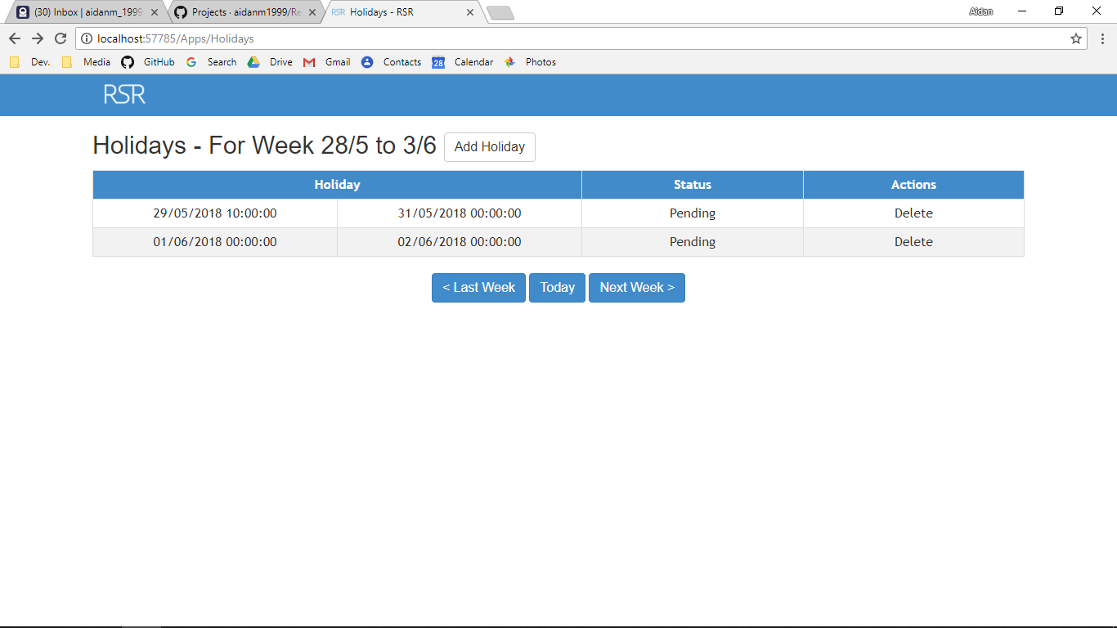

Screenshot After:

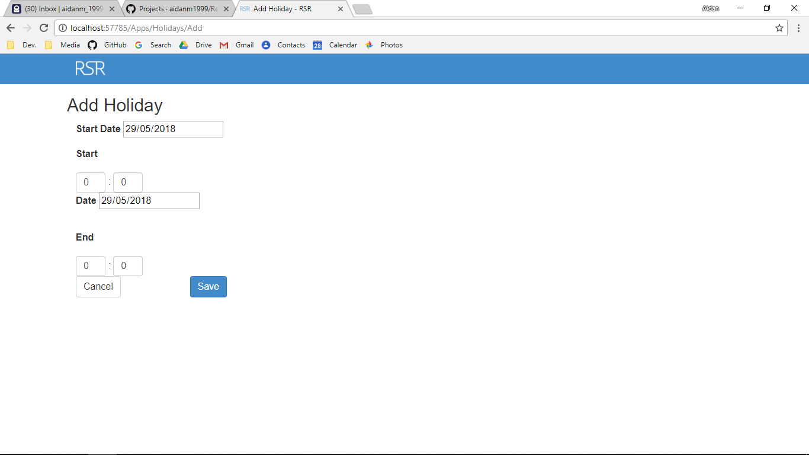

Additional Screenshot (if applicable):

Additional Notes (if applicable):

Test Case ID: AL25 Attempt Number: 1

Action: User clicks on the holiday start time

Comprehensive Test Type: Not Applicable

Test Data: Not Applicable

Expected Output: The user is redirected to holiday edit

Actual Output: As expected

Result: Pass

Reason for fail (if applicable):

Error Type (if applicable):

Remediation (if applicable):

Screenshot Before:



Screenshot After:

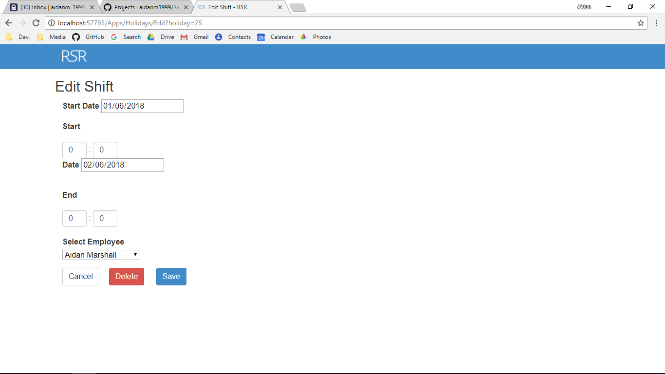

Additional Screenshot (if applicable):

Additional Notes (if applicable):

Test Case ID: AL26 Attempt Number: 1

Action: User clicks on the holiday end time

Comprehensive Test Type: Not Applicable

Test Data: Not Applicable

Expected Output: The user is redirected to holiday edit

Actual Output: As expected

Result: Pass

Reason for fail (if applicable):

Error Type (if applicable):

Remediation (if applicable):

Screenshot Before:



Screenshot After:



Additional Screenshot (if applicable):

Additional Notes (if applicable):

Test Case ID: AL27 Attempt Number: 1

Action: User clicks on the < Last Week in holiday

Comprehensive Test Type: Not Applicable

Test Data: Not Applicable

Expected Output: The user is redirected to the previous week

Actual Output: As expected

Result: Pass

Reason for fail (if applicable):

Error Type (if applicable):

Remediation (if applicable):

Screenshot Before:

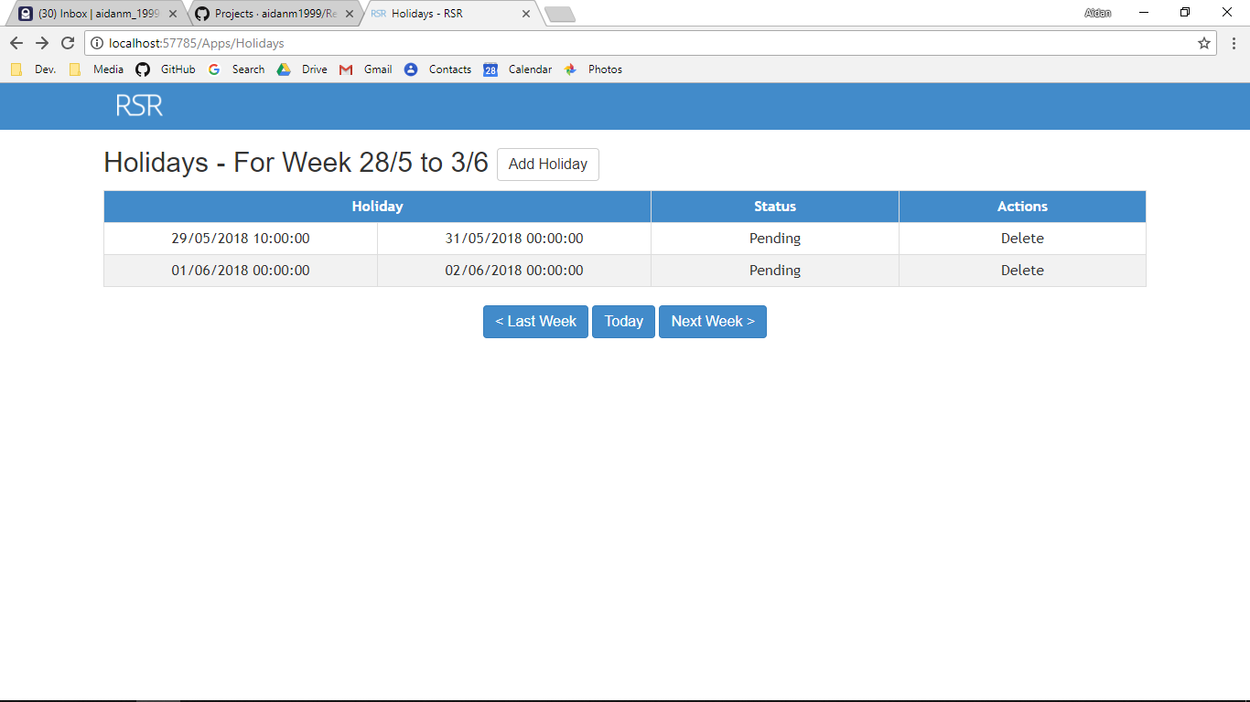

Screenshot After:

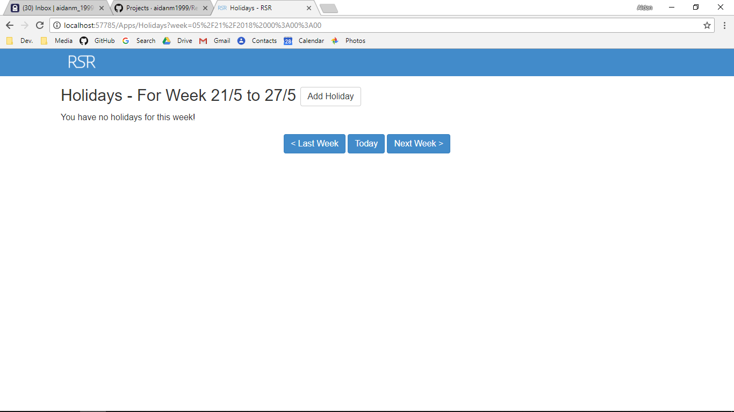

Additional Screenshot (if applicable):

Additional Notes (if applicable):

Test Case ID: AL28 Attempt Number: 1

Action: User clicks on the today button

Comprehensive Test Type: Not Applicable

Test Data: Not Applicable

Expected Output: The user is redirected to index of holiday

Actual Output: As expected

Result: Pass

Reason for fail (if applicable):

Error Type (if applicable):

Remediation (if applicable):

Screenshot Before:



Screenshot After:



Additional Screenshot (if applicable):

Additional Notes (if applicable):

Test Case ID: AL29 Attempt Number: 1

Action: User clicks on the Next Week > button

Comprehensive Test Type: Not Applicable

Test Data: Not Applicable

Expected Output: The user is redirected to the next week of the holidays

Actual Output: As expected

Result: Pass

Reason for fail (if applicable):

Error Type (if applicable):

Remediation (if applicable):

Screenshot Before:



Screenshot After:

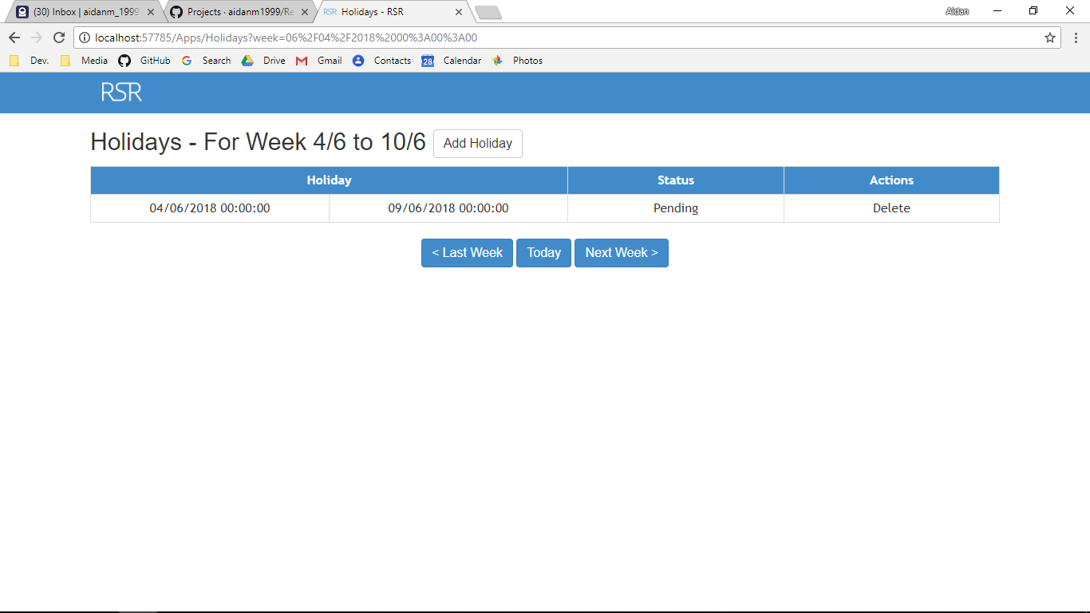

Additional Screenshot (if applicable):

Additional Notes (if applicable):

Test Case ID: AA1 Attempt Number: 1

Action: User clicks on the save button in the add type

Comprehensive Test Type: Not Applicable

Test Data: Not Applicable

Expected Output: The type is written to the database and the user is redirected to the business settings

Actual Output: As expected

Result: Pass

Reason for fail (if applicable):

Error Type (if applicable):

Remediation (if applicable):

Screenshot Before:

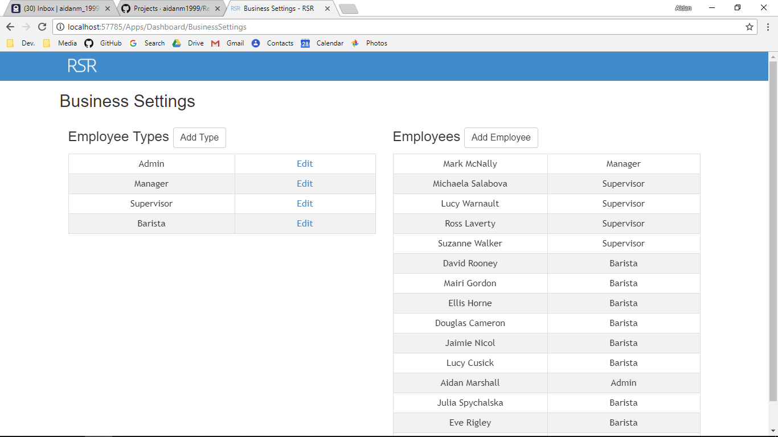

Screenshot After:

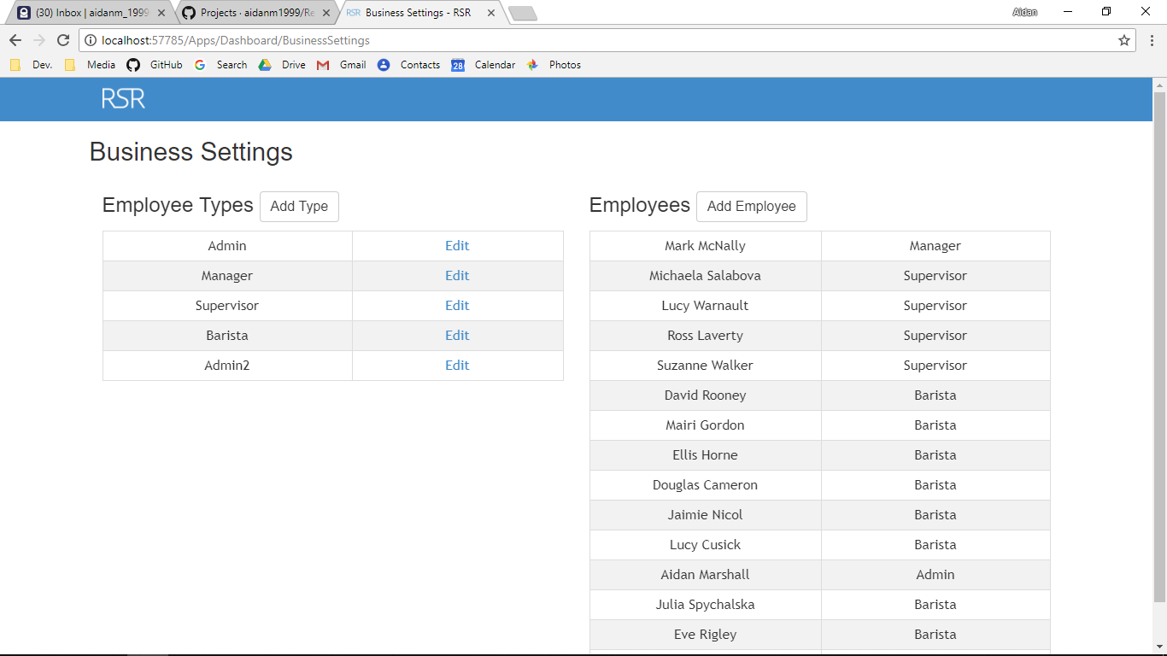

Additional Screenshot (if applicable):

Additional Notes (if applicable):

Test Case ID: AA2 Attempt Number: 1

Action: User deletes the Admin2 type

Comprehensive Test Type: Not Applicable

Test Data: Not Applicable

Expected Output: The type is deleted

Actual Output: As expected

Result: Pass

Reason for fail (if applicable):

Error Type (if applicable):

Remediation (if applicable):

Screenshot Before:

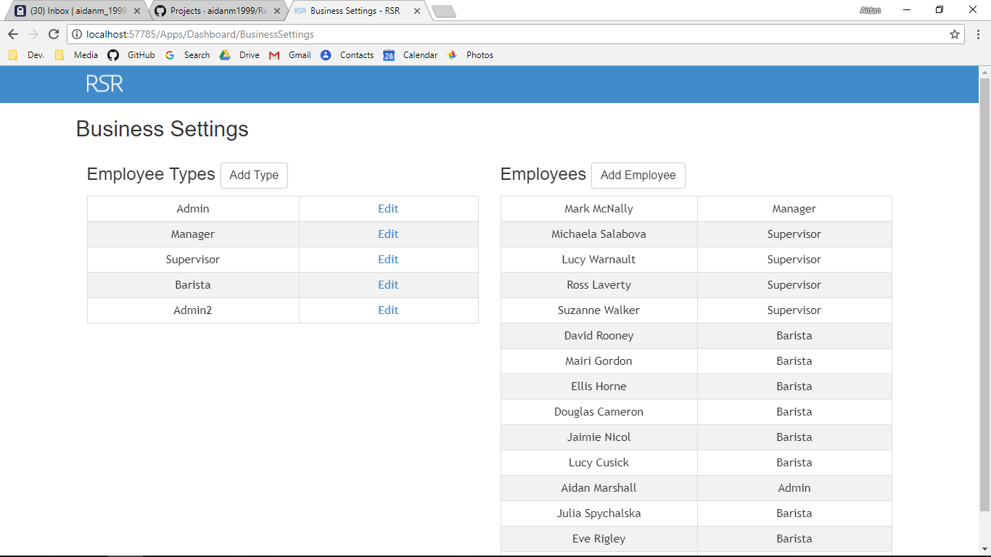

Screenshot After:



Additional Screenshot (if applicable):

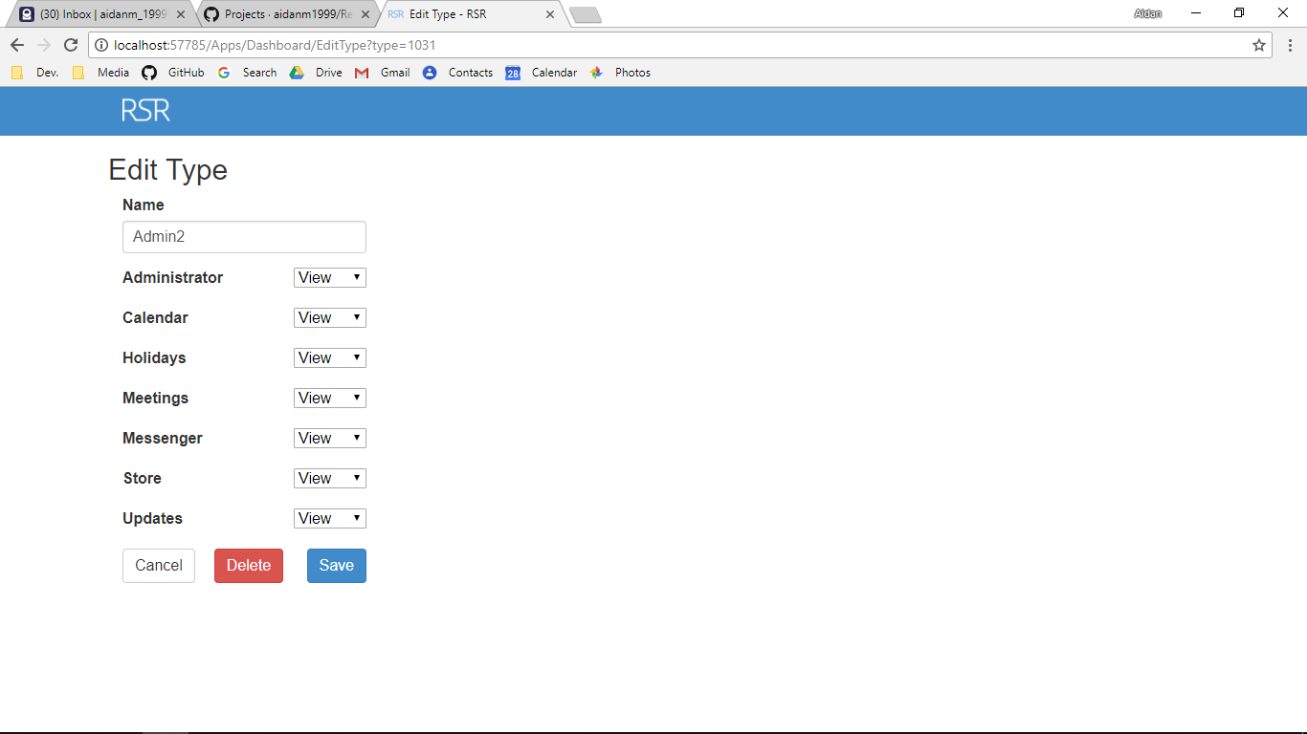

Additional Notes (if applicable):

Test Case ID: AA3 Attempt Number: 1

Action: User changes an attribute in the type and saves

Comprehensive Test Type: Not Applicable

Test Data: Not Applicable

Expected Output: The type is updated to the database and the user is redirected

Actual Output: As expected

Result: Pass

Reason for fail (if applicable):

Error Type (if applicable):

Remediation (if applicable):

Screenshot Before:

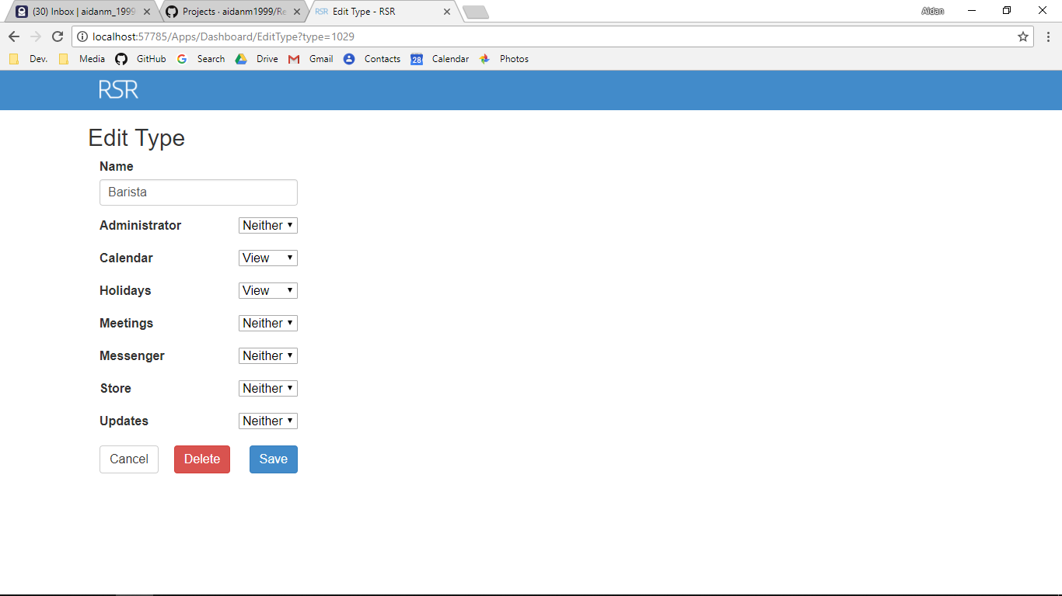

Screenshot After:

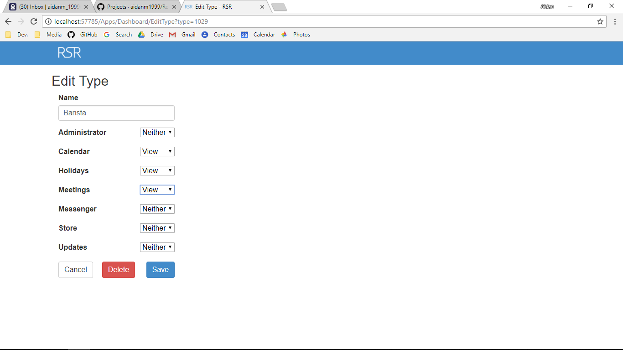

Additional Screenshot (if applicable):

Additional Notes (if applicable):

Test Case ID: AA4 Attempt Number: 1

Action: User clicks on the Update Details button

Comprehensive Test Type: Not Applicable

Test Data: Not Applicable

Expected Output: The user’s details are updated

Actual Output: As expected

Result: Pass

Reason for fail (if applicable):

Error Type (if applicable):

Remediation (if applicable):

Screenshot Before:

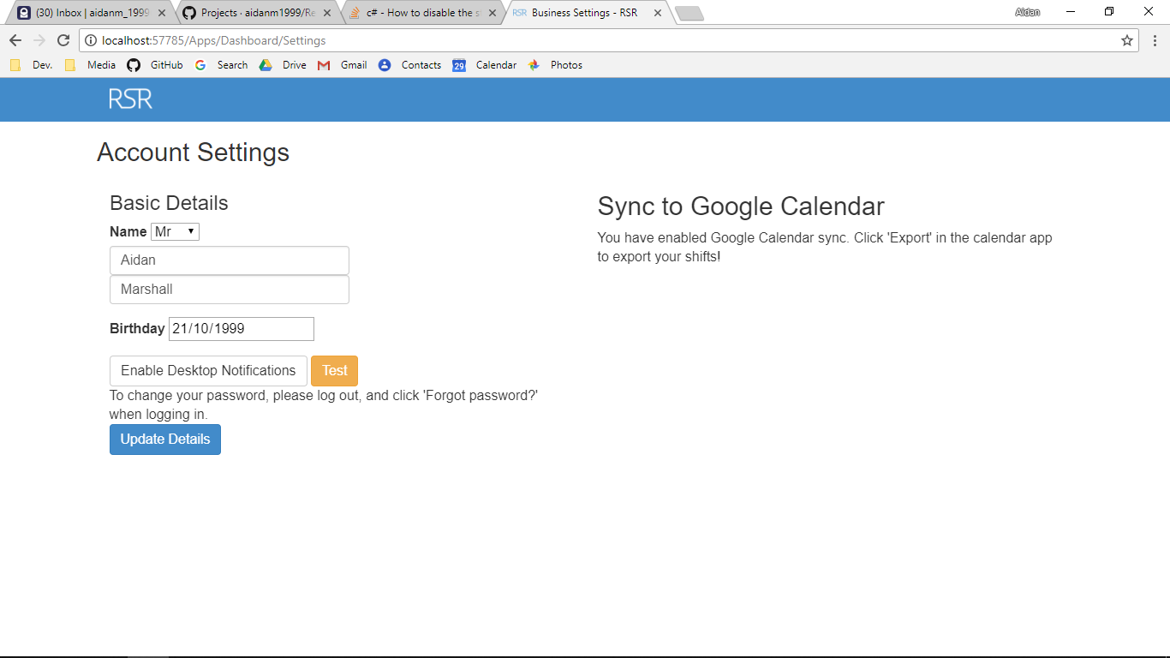

Screenshot After:

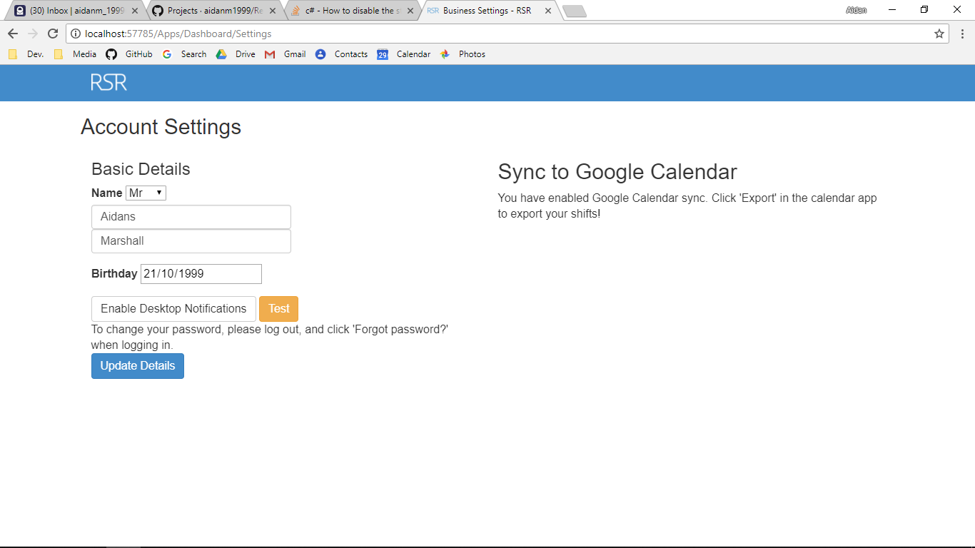

Additional Screenshot (if applicable):

Additional Notes (if applicable):

Test Case ID: AA5 Attempt Number: 1

Action: User clicks on the Enable button

Comprehensive Test Type: Not Applicable

Test Data: Not Applicable

Expected Output: The user is redirected to Google API and then is authorised

Actual Output: As expected

Result: Pass

Reason for fail (if applicable):

Error Type (if applicable):

Remediation (if applicable):

Screenshot Before:



Screenshot After:



Additional Screenshot (if applicable):

Additional Notes (if applicable):

Test Case ID: AA6 Attempt Number: 1

Action: User clicks the print button

Comprehensive Test Type: Not Applicable

Test Data: Not Applicable

Expected Output: That week’s rota is rendered in a PDF

Actual Output: As expected

Result: Pass

Reason for fail (if applicable):

Error Type (if applicable):

Remediation (if applicable):

Screenshot Before:

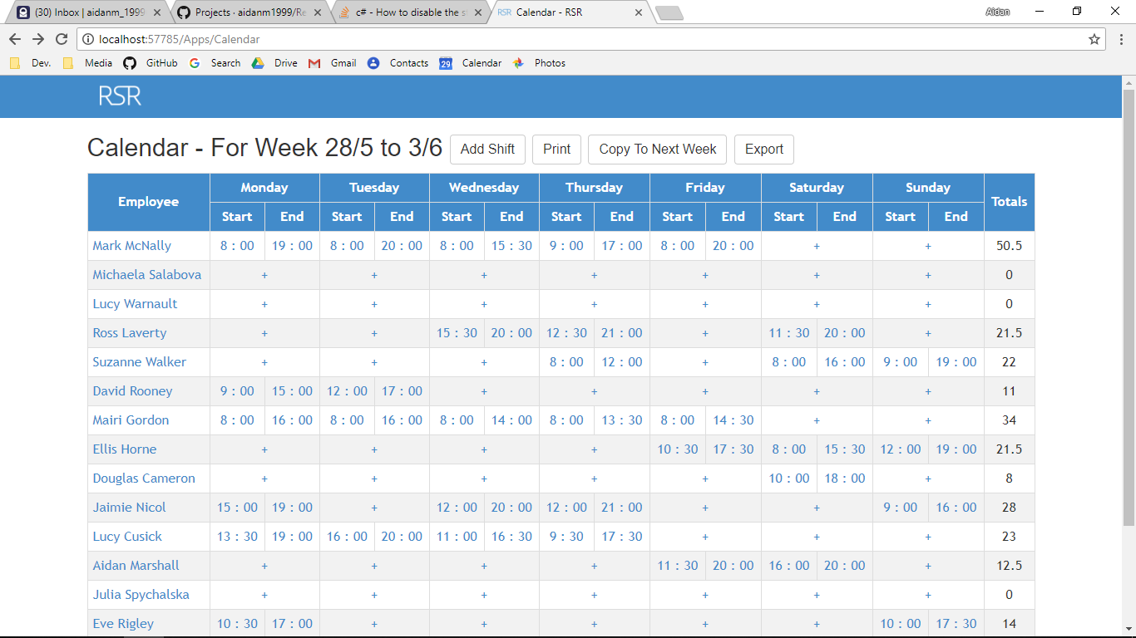

Screenshot After:

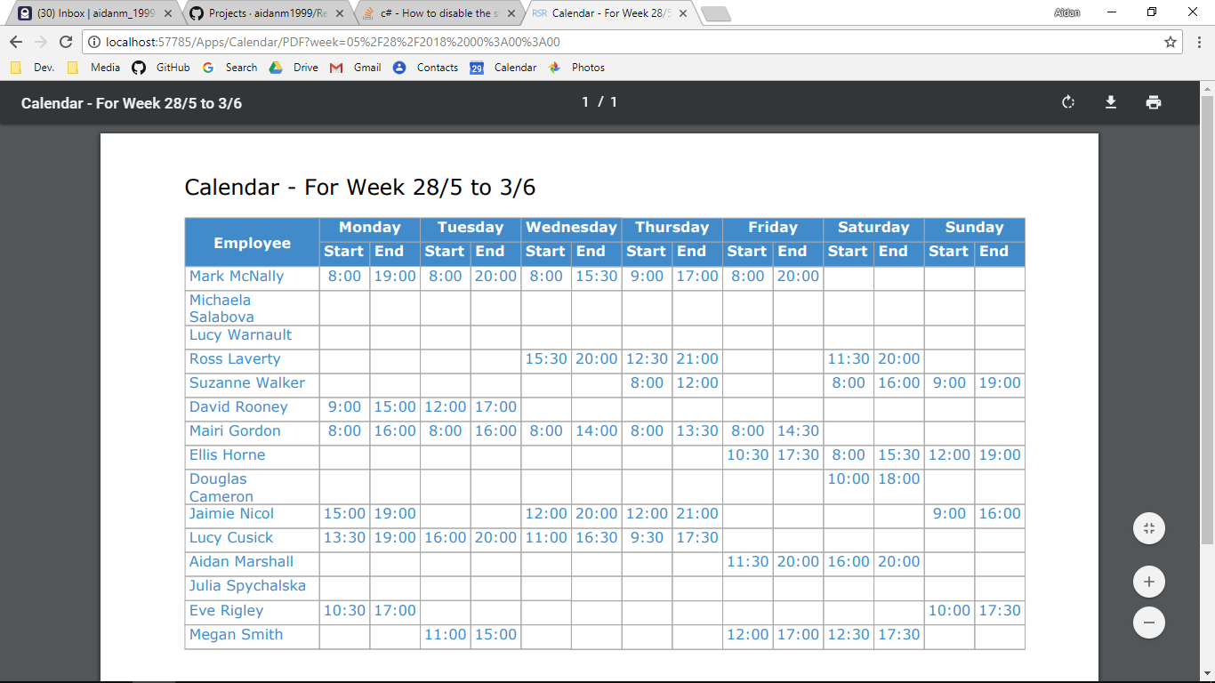

Additional Screenshot (if applicable):

Additional Notes (if applicable):

Test Case ID: AA7 Attempt Number: 1

Action: User clicks on the Copy To Next Week Button

Comprehensive Test Type: Not Applicable

Test Data: Not Applicable

Expected Output: The shifts are copied to the next week and any shifts next week will be deleted.

Actual Output: Nothing

Result: Fail

Reason for fail (if applicable): Not Coded

Error Type (if applicable):

Remediation (if applicable): Nothing

Screenshot Before:

Screenshot After:

Additional Screenshot (if applicable):

Additional Notes (if applicable):

Test Case ID: AA8 Attempt Number: 1

Action: User clicks on the export button

Comprehensive Test Type: Not Applicable

Test Data: Not Applicable

Expected Output: The shifts are exported to google calendar

Actual Output: As expected

Result: Pass

Reason for fail (if applicable):

Error Type (if applicable):

Remediation (if applicable):

Screenshot Before:

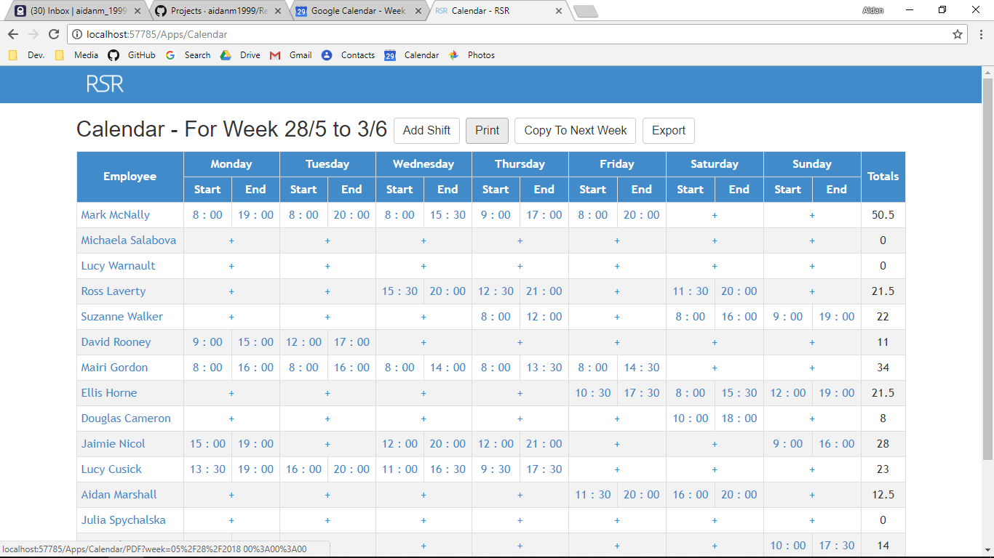

Screenshot After:

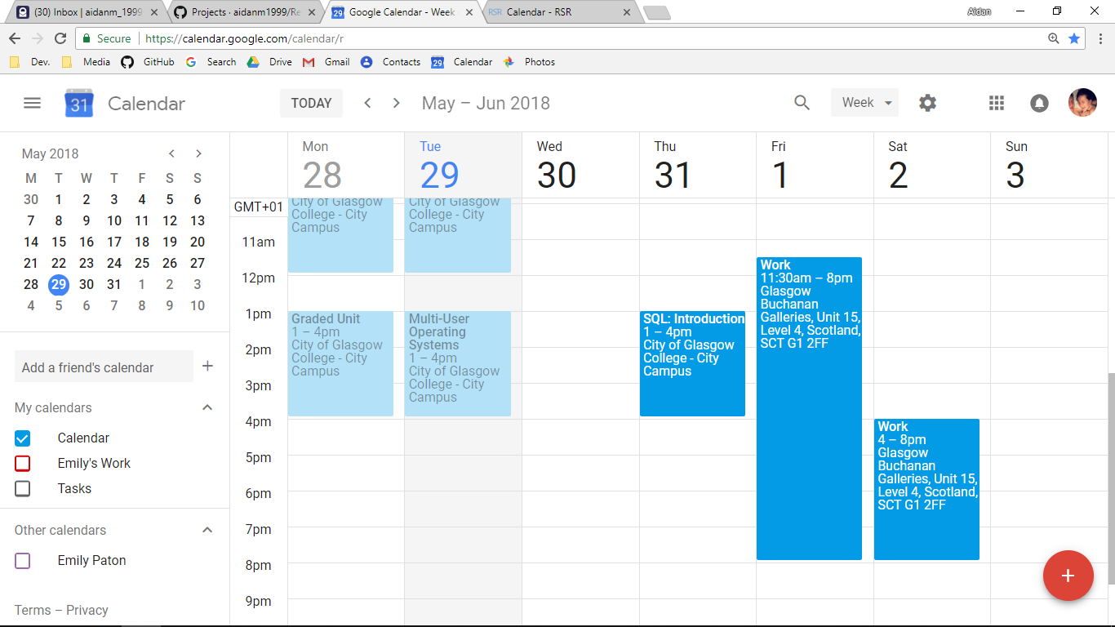

Additional Screenshot (if applicable):

Additional Notes (if applicable):

Test Case ID: AA9 Attempt Number: 1

Action: User clicks on the Calendar icon

Comprehensive Test Type: Not Applicable

Test Data: Not Applicable

Expected Output: The shift totals are calculated and displayed

Actual Output: As expected

Result: Pass

Reason for fail (if applicable):

Error Type (if applicable):

Remediation (if applicable):

Screenshot Before:

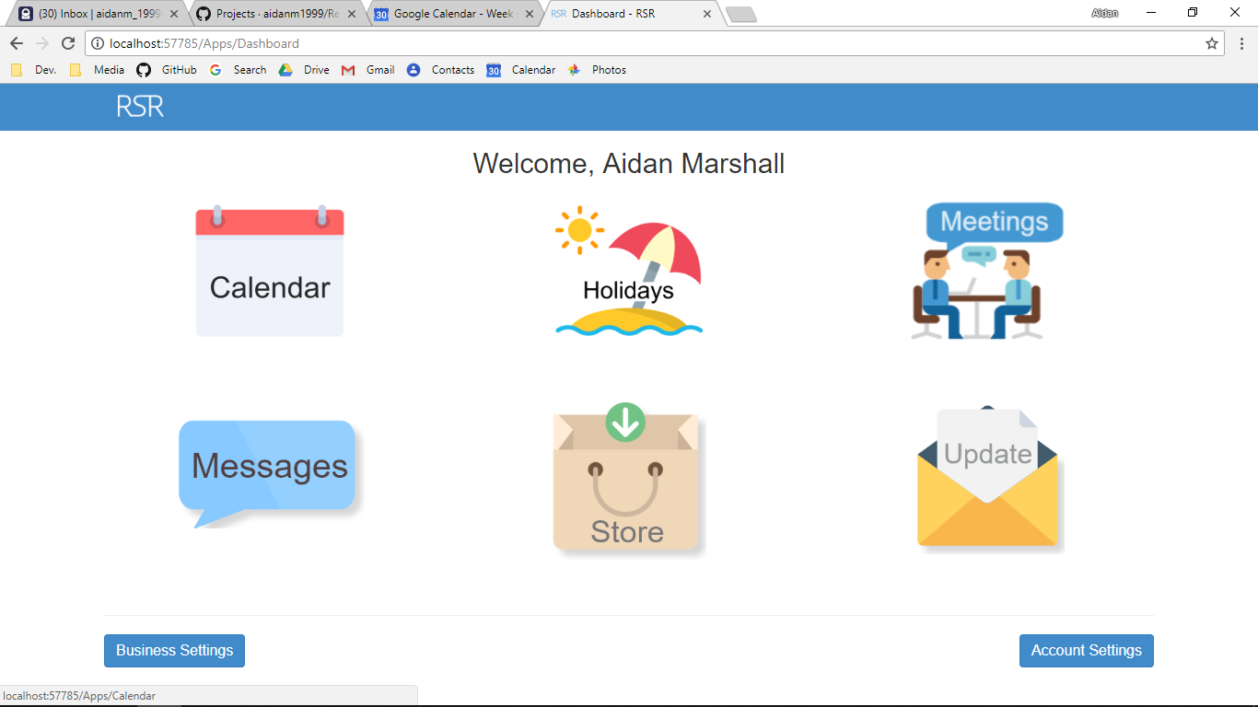

Screenshot After:



Additional Screenshot (if applicable):

Additional Notes (if applicable):

Test Case ID: AA10 Attempt Number: 1

Action: User clicks on the Save button

Comprehensive Test Type: Not Applicable

Test Data: Not Applicable

Expected Output: The shift is written to the database

Actual Output: As expected

Result: Pass

Reason for fail (if applicable):

Error Type (if applicable):

Remediation (if applicable):

Screenshot Before:

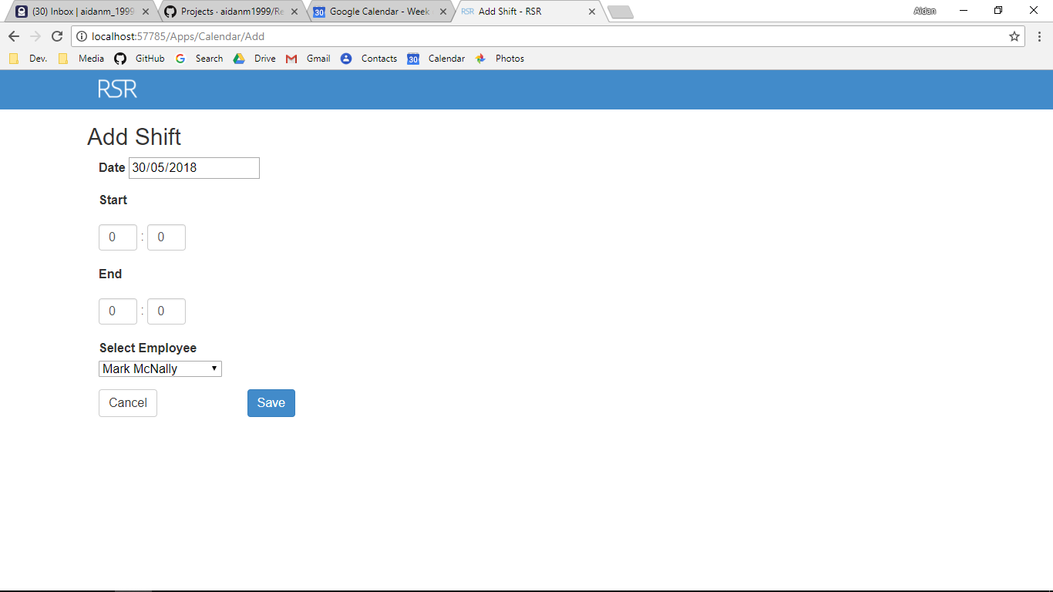

Screenshot After:

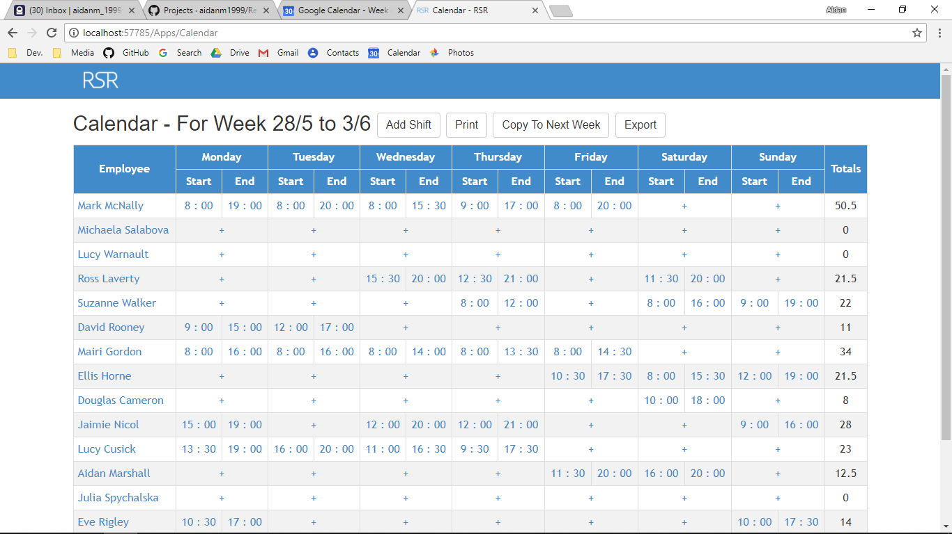

Additional Screenshot (if applicable):

Additional Notes (if applicable):

Test Case ID: AA11 Attempt Number: 1

Action: User clicks on the Delete button

Comprehensive Test Type: Not Applicable

Test Data: Not Applicable

Expected Output: The shift is deleted from the database

Actual Output: As expected

Result: Pass

Reason for fail (if applicable):

Error Type (if applicable):

Remediation (if applicable):

Screenshot Before:

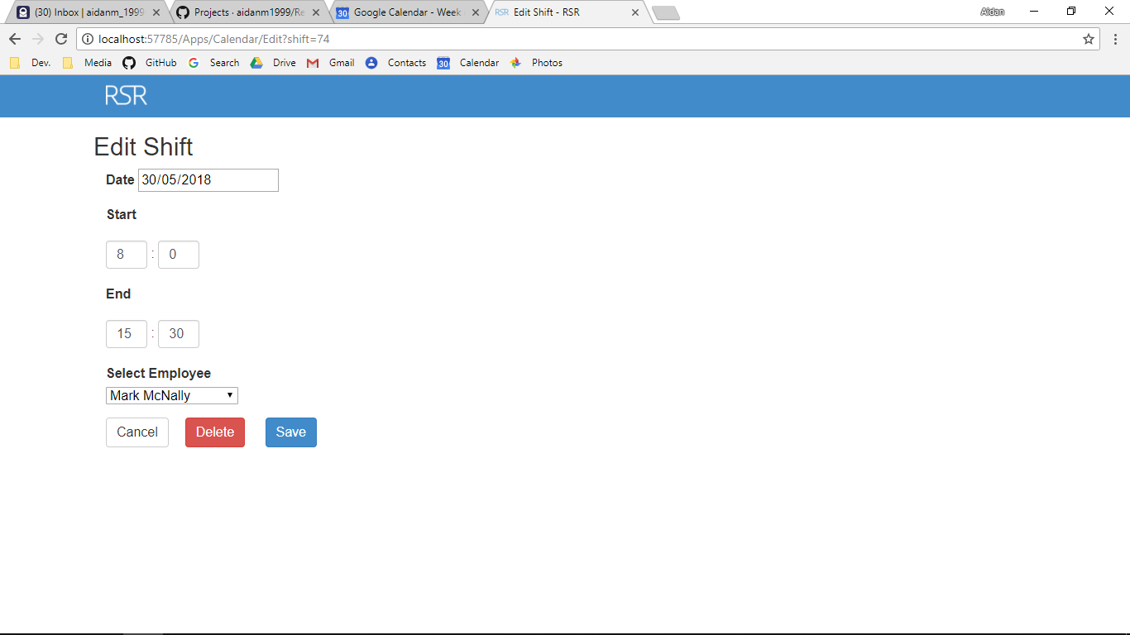

Screenshot After:



Additional Screenshot (if applicable):

Additional Notes (if applicable):

Test Case ID: AA12 Attempt Number: 1

Action: User clicks on the Accept button

Comprehensive Test Type: Not Applicable

Test Data: Not Applicable

Expected Output: The holiday is accepted

Actual Output: As expected

Result: Pass

Reason for fail (if applicable):

Error Type (if applicable):

Remediation (if applicable):

Screenshot Before:

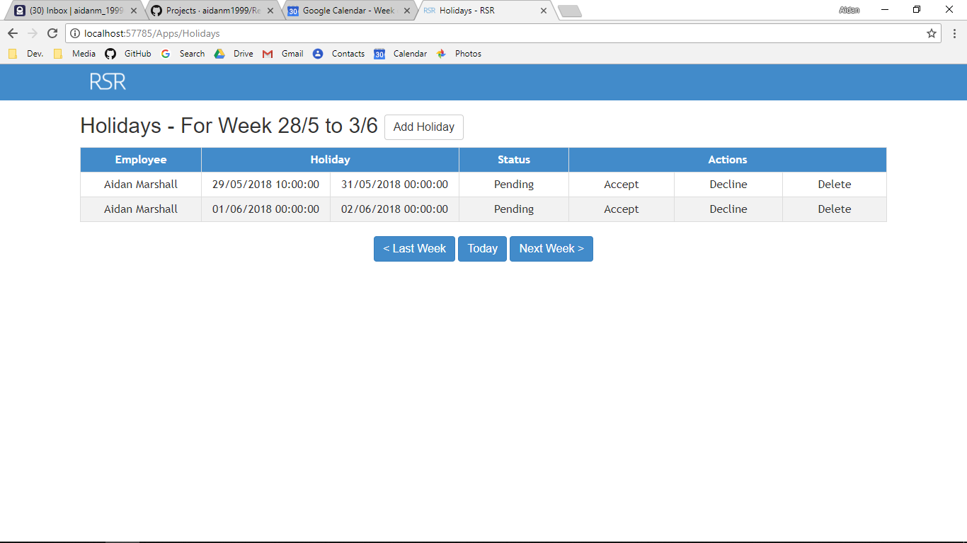

Screenshot After:

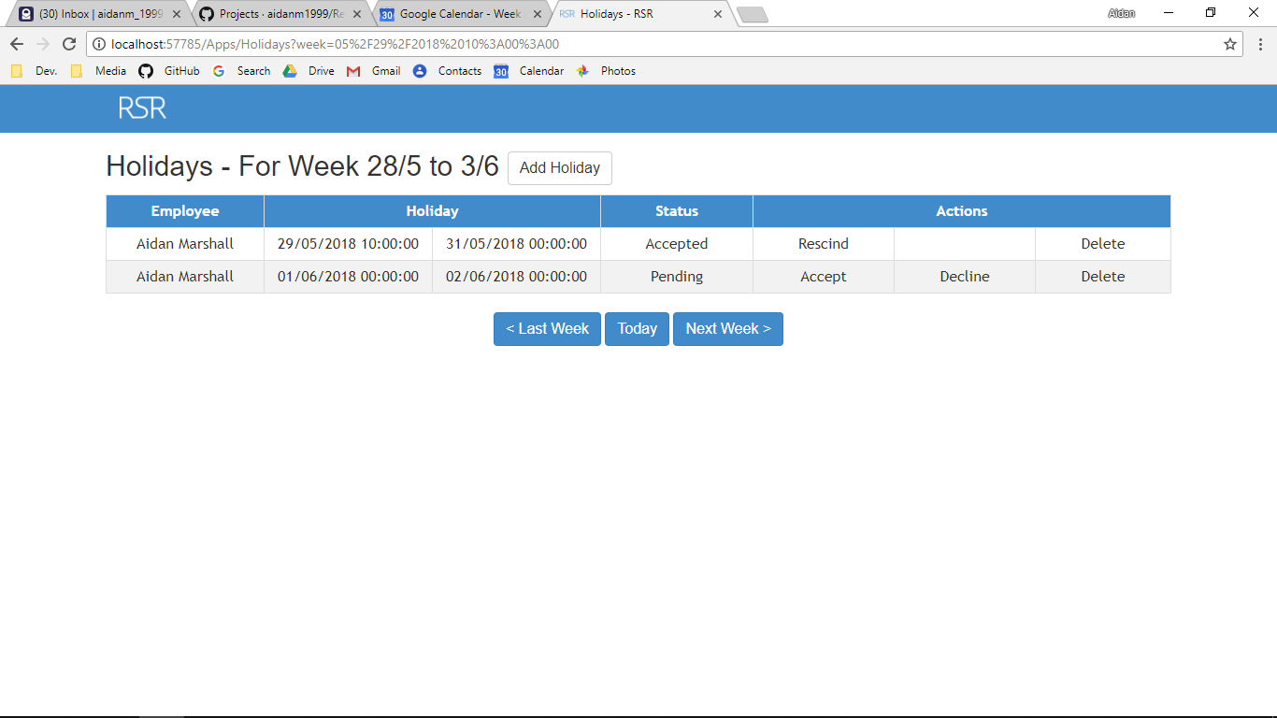

Additional Screenshot (if applicable):

Additional Notes (if applicable):

Test Case ID: AA13 Attempt Number: 1

Action: User clicks on the Decline button

Comprehensive Test Type: Not Applicable

Test Data: Not Applicable

Expected Output: The holiday is declined

Actual Output: As expected

Result: Pass

Reason for fail (if applicable):

Error Type (if applicable):

Remediation (if applicable):

Screenshot Before:



Screenshot After:

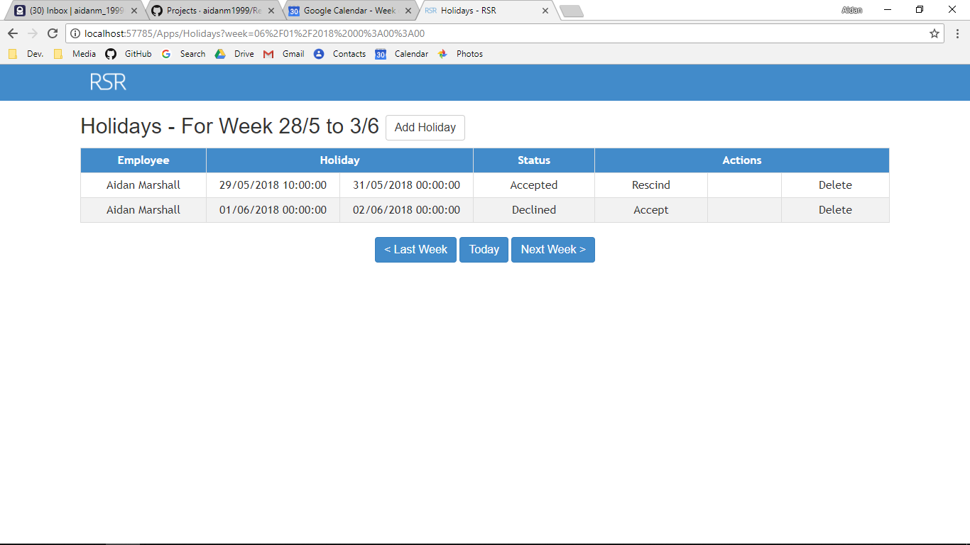

Additional Screenshot (if applicable):

Additional Notes (if applicable):

Test Case ID: AA14 Attempt Number: 1

Action: User clicks on the Delete button

Comprehensive Test Type: Not Applicable

Test Data: Not Applicable

Expected Output: The holiday is deleted

Actual Output: As expected

Result: Pass

Reason for fail (if applicable):

Error Type (if applicable):

Remediation (if applicable):

Screenshot Before:



Screenshot After:

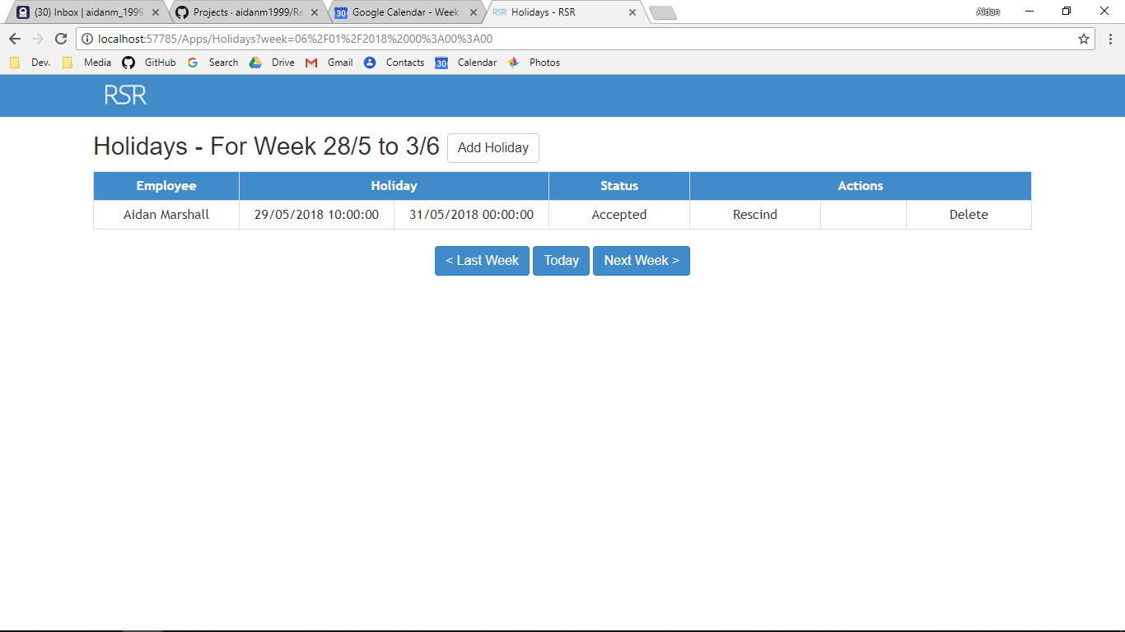

Additional Screenshot (if applicable):

Additional Notes (if applicable):

Test Case ID: AA15 Attempt Number: 1

Action: User clicks on the Rescind button

Comprehensive Test Type: Not Applicable

Test Data: Not Applicable

Expected Output: The holiday is accepted

Actual Output: As expected

Result: Pass

Reason for fail (if applicable):

Error Type (if applicable):

Remediation (if applicable):

Screenshot Before:



Screenshot After:

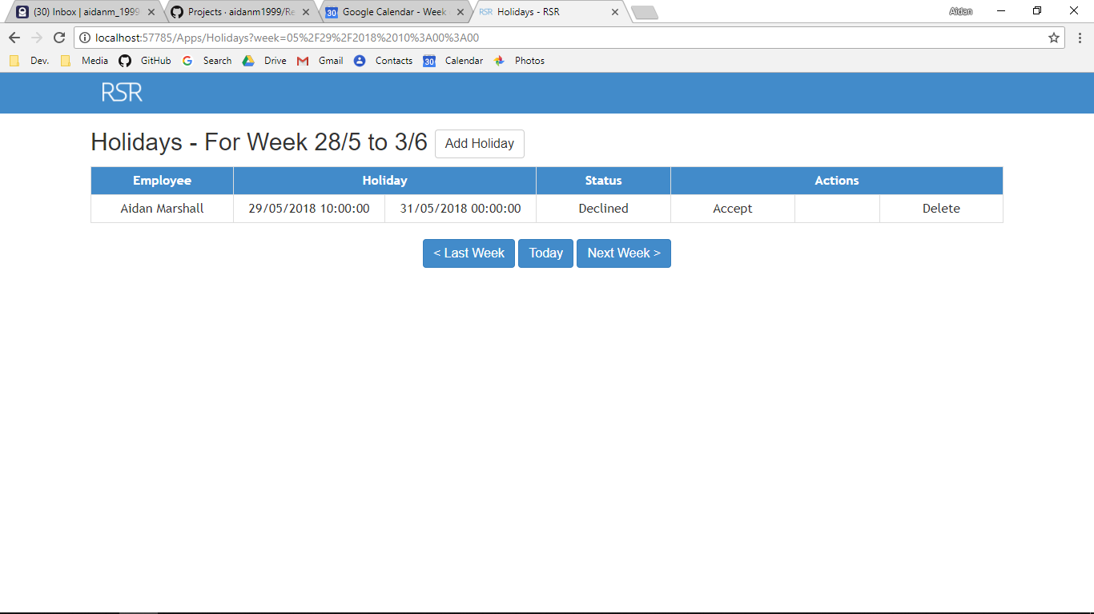

Additional Screenshot (if applicable):

Additional Notes (if applicable):

Test Case ID: AA16 Attempt Number: 1

Action: User clicks on the Employee’s Name in calendar

Comprehensive Test Type: Not Applicable

Test Data: Not Applicable

Expected Output: Creates a doughnut chart which shows all the hours of each user in that business, a line chart that shows the average hours per user per day versus the users hours per day and this weeks hours worked for that user versus last weeks hours.

Actual Output: As expected

Result: Pass

Reason for fail (if applicable):

Error Type (if applicable):

Remediation (if applicable):

Screenshot Before:



Screenshot After:

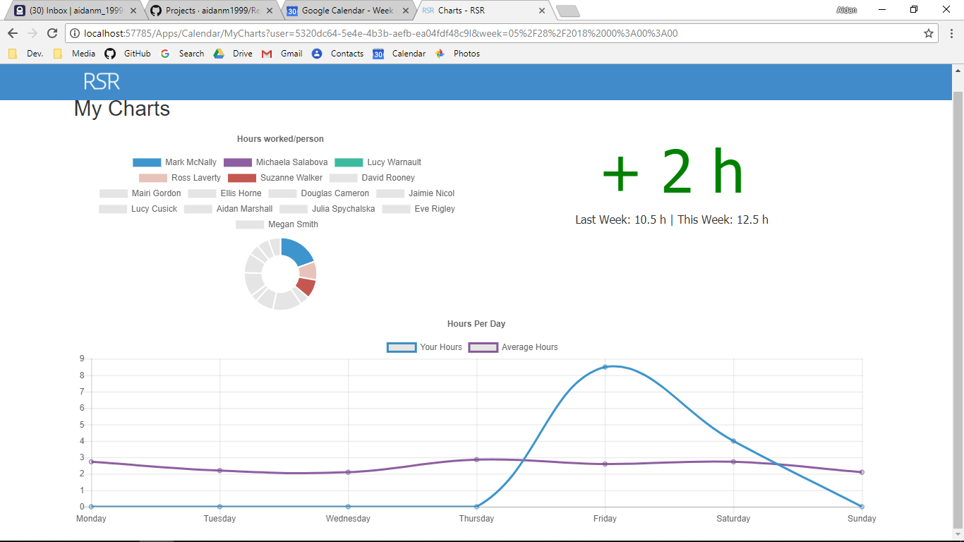

Additional Screenshot (if applicable):

Additional Notes (if applicable):

Test Case ID: AV1 Attempt Number: 1

Action: User inputs type name

Comprehensive Test Type: Normal

Test Data: Line Manager

Expected Output: The type can be added (if all other data is valid)

Actual Output: As expected

Result: Pass

Reason for fail (if applicable):

Error Type (if applicable):

Remediation (if applicable):

Screenshot Before:

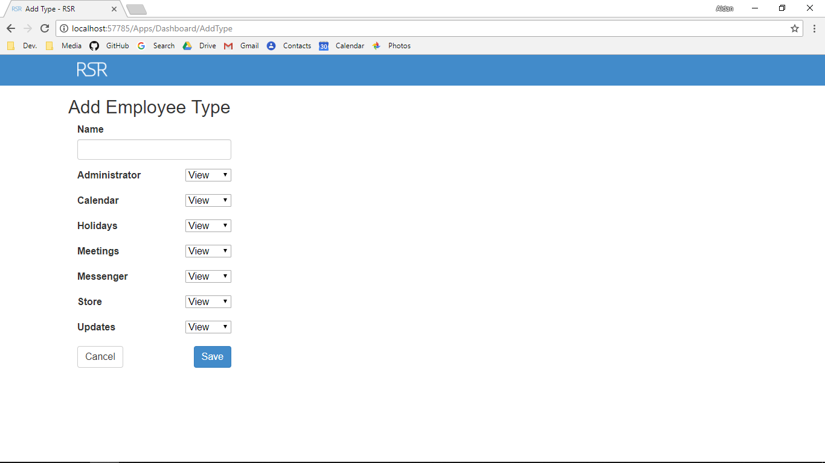

Screenshot After:

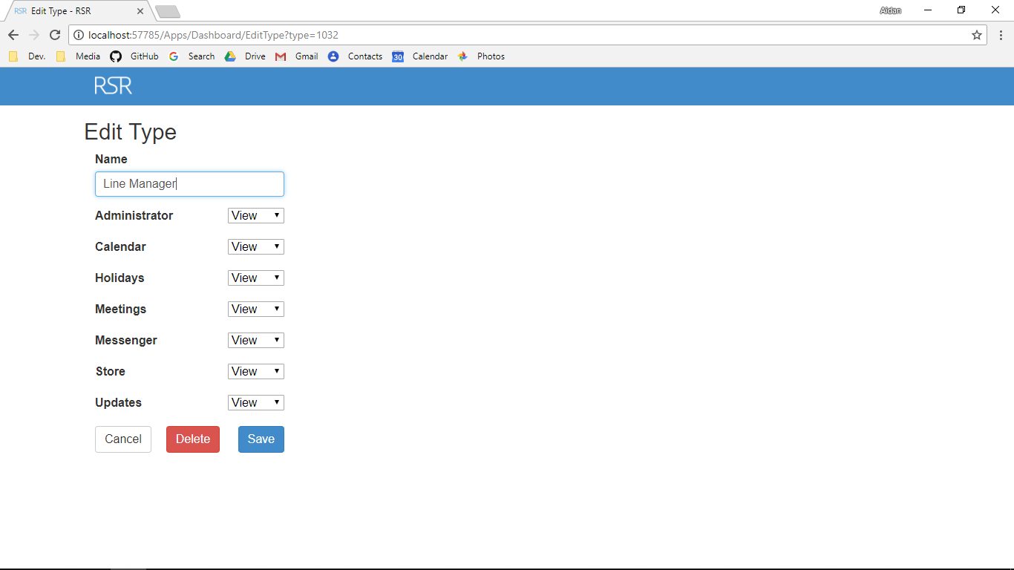

Additional Screenshot (if applicable):

Additional Notes (if applicable):

Test Case ID: AV1 Attempt Number: 1

Action: User inputs type name

Comprehensive Test Type: Extreme

Test Data: LM

Expected Output: The type can be added (if all other data is valid)

Actual Output: As expected

Result: Pass

Reason for fail (if applicable):

Error Type (if applicable):

Remediation (if applicable):

Screenshot Before:



Screenshot After:

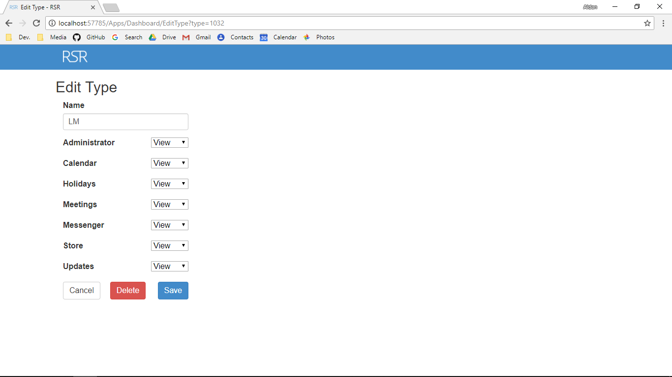

Additional Screenshot (if applicable):

Additional Notes (if applicable):

Test Case ID: AV1 Attempt Number: 1

Action: User inputs type name

Comprehensive Test Type: Exceptional

Test Data: LINEMANANAN ANANANANA NANANANANA NANANAN ANANANANA NANANANANANANA NANANANAN NNAN ANANAGERRR RRRRRRRRRRR

Expected Output: The type cannot be added

Actual Output: As expected

Result: Pass

Reason for fail (if applicable):

Error Type (if applicable):

Remediation (if applicable):

Screenshot Before:



Screenshot After:

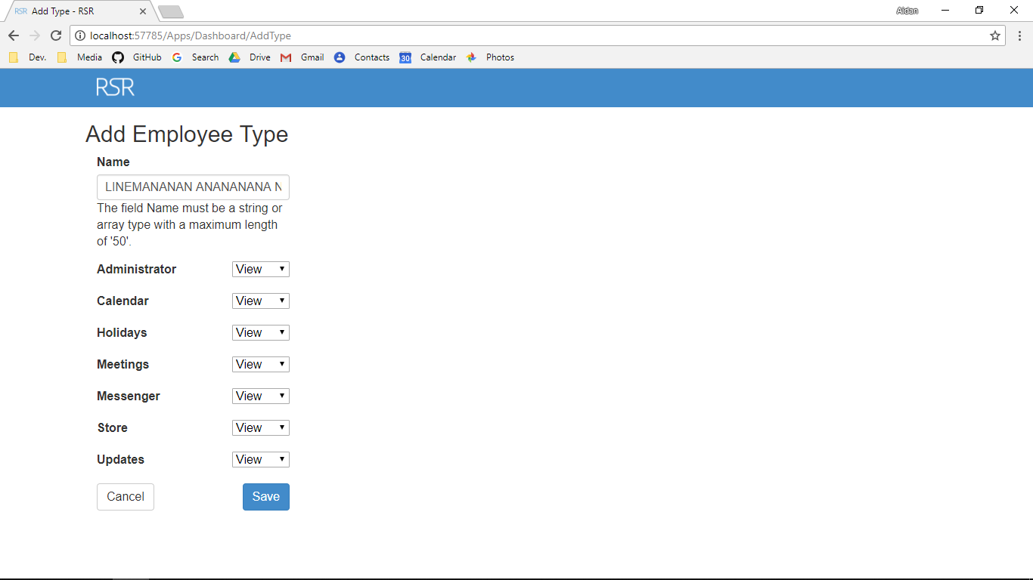

Additional Screenshot (if applicable):

Additional Notes (if applicable):

Test Case ID: AV2 Attempt Number: 1

Action: User inputs Administrator type

Comprehensive Test Type: Normal

Test Data: View

Expected Output: The type can be added (if all other data is valid)

Actual Output: As expected

Result: Pass

Reason for fail (if applicable):

Error Type (if applicable):

Remediation (if applicable):

Screenshot Before:

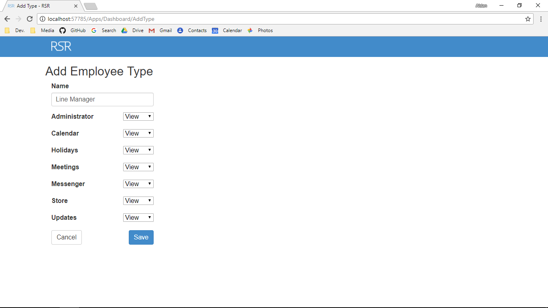

Screenshot After:



Additional Screenshot (if applicable):

Additional Notes (if applicable):

Test Case ID: AV3 Attempt Number: 1

Action: User inputs Calendar type

Comprehensive Test Type: Normal

Test Data: Edit

Expected Output: The type can be added (if all other data is valid)

Actual Output: As expected

Result: Pass

Reason for fail (if applicable):

Error Type (if applicable):

Remediation (if applicable):

Screenshot Before:



Screenshot After:

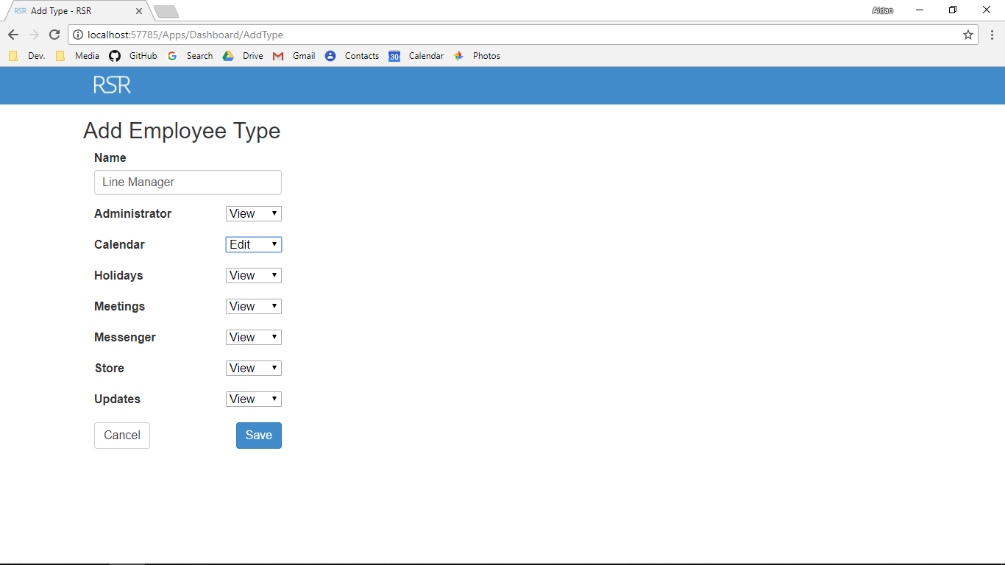

Additional Screenshot (if applicable):

Additional Notes (if applicable):

Test Case ID: AV4 Attempt Number: 1

Action: User inputs Holidays type

Comprehensive Test Type: Normal

Test Data: Edit

Expected Output: The type can be added (if all other data is valid)

Actual Output: As expected

Result: Pass

Reason for fail (if applicable):

Error Type (if applicable):

Remediation (if applicable):

Screenshot Before:

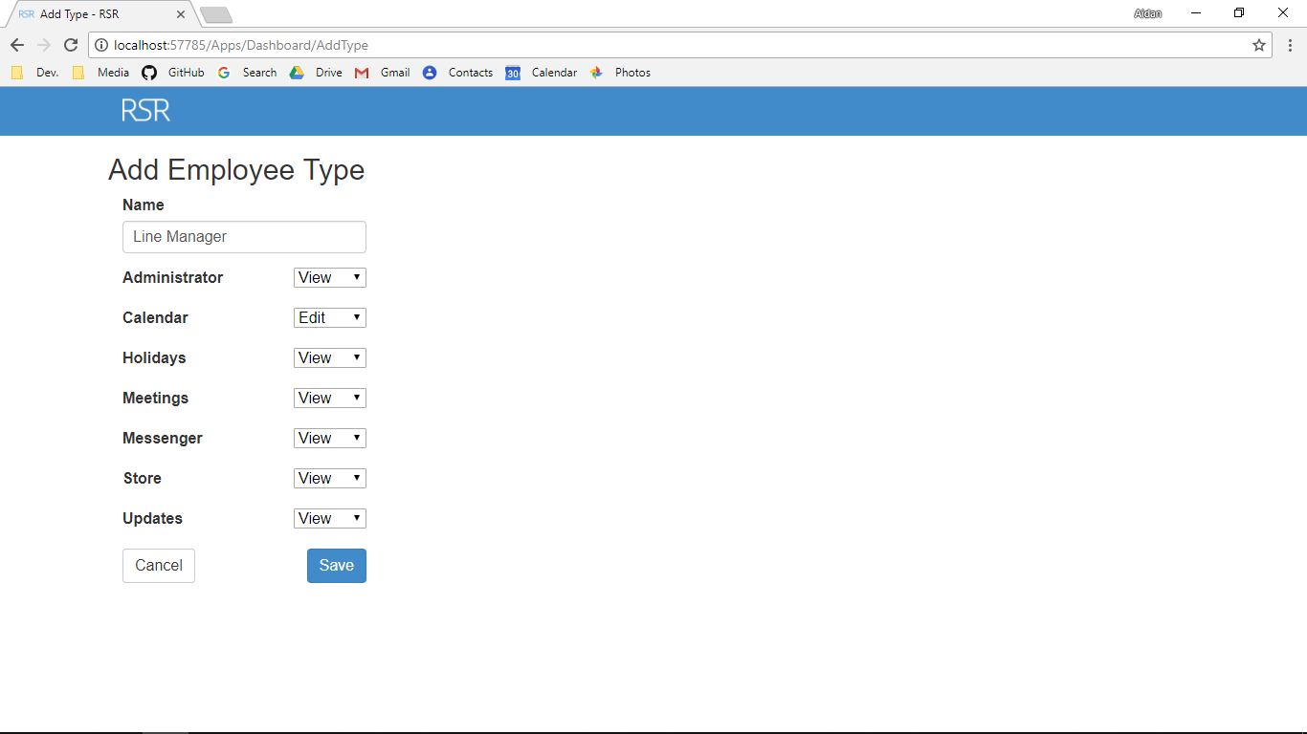

Screenshot After:

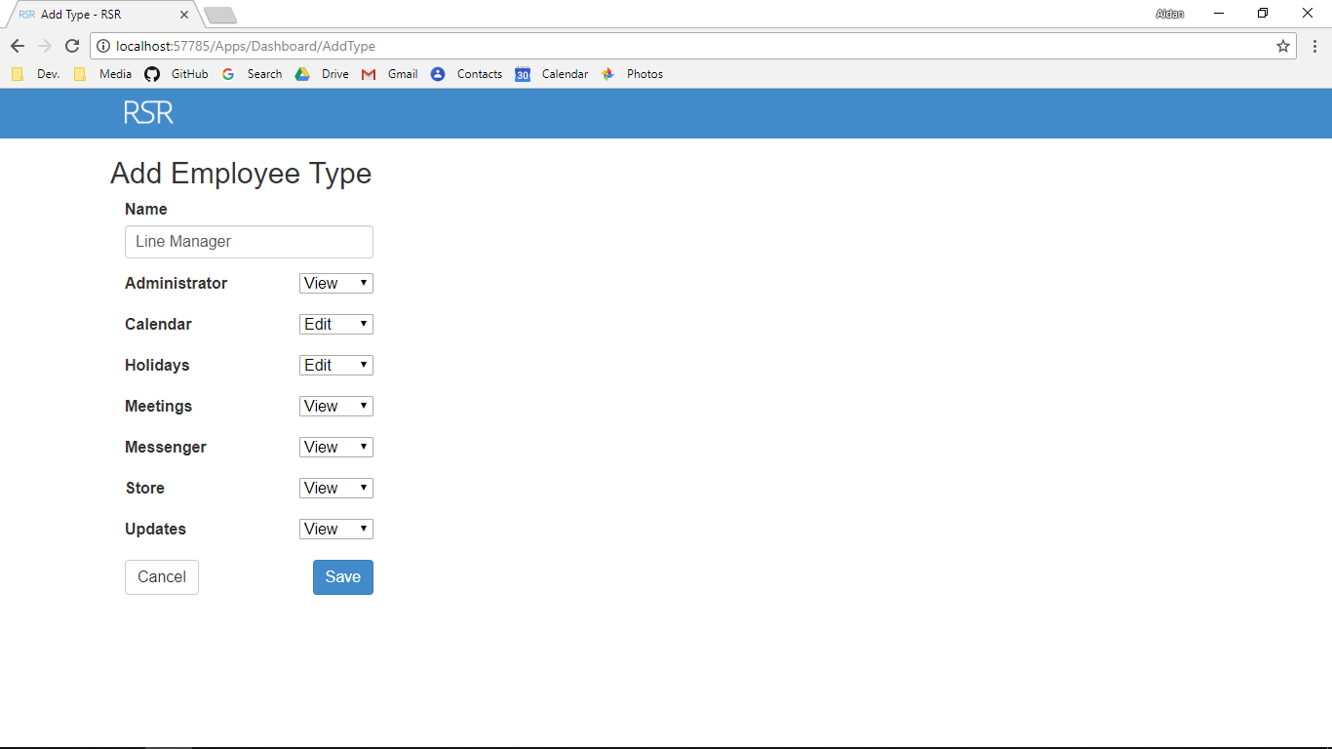

Additional Screenshot (if applicable):

Additional Notes (if applicable):

Test Case ID: AV5 Attempt Number: 1

Action: User inputs Meetings type

Comprehensive Test Type: Normal

Test Data: Neither

Expected Output: The type can be added (if all other data is valid)

Actual Output: As expected

Result: Pass

Reason for fail (if applicable):

Error Type (if applicable):

Remediation (if applicable):

Screenshot Before:

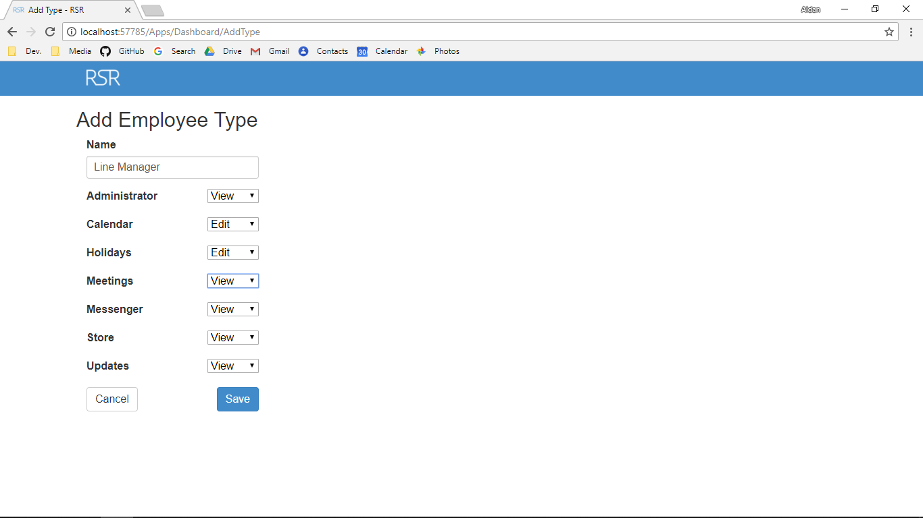

Screenshot After:

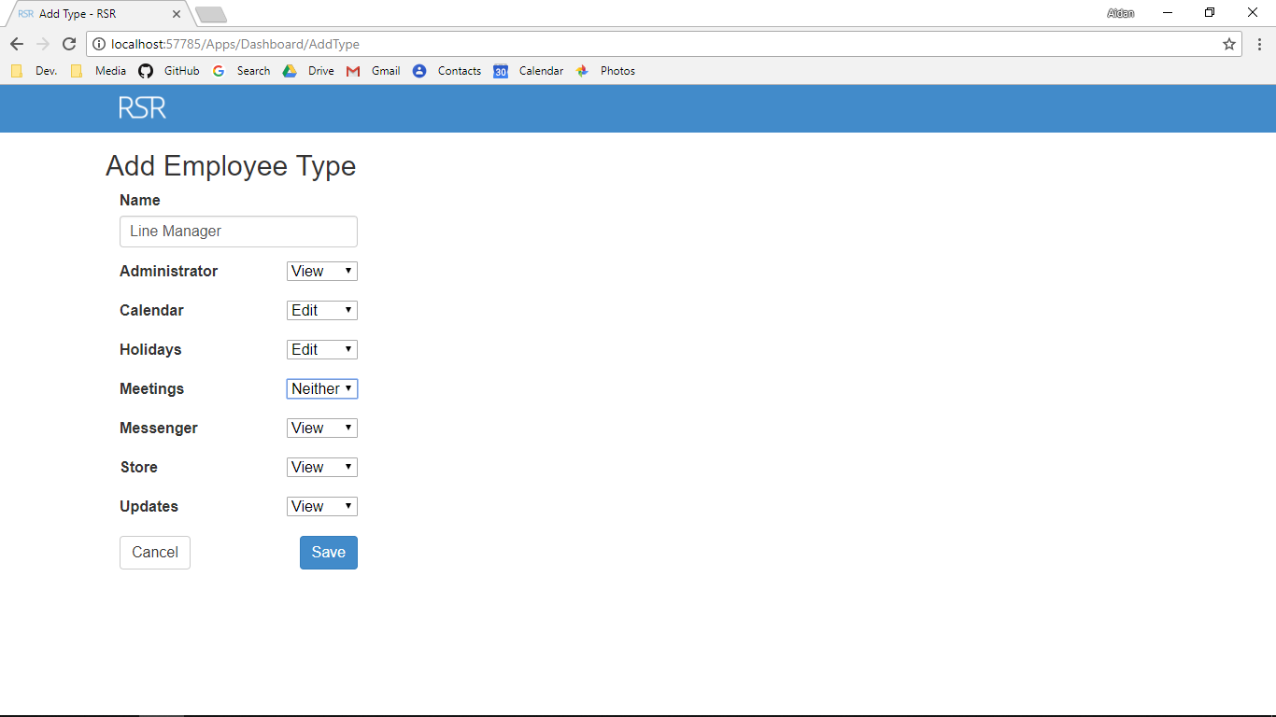

Additional Screenshot (if applicable):

Additional Notes (if applicable):

Test Case ID: AV6 Attempt Number: 1

Action: User inputs Messenger type

Comprehensive Test Type: Normal

Test Data: Neither

Expected Output: The type can be added (if all other data is valid)

Actual Output: As expected

Result: Pass

Reason for fail (if applicable):

Error Type (if applicable):

Remediation (if applicable):

Screenshot Before:

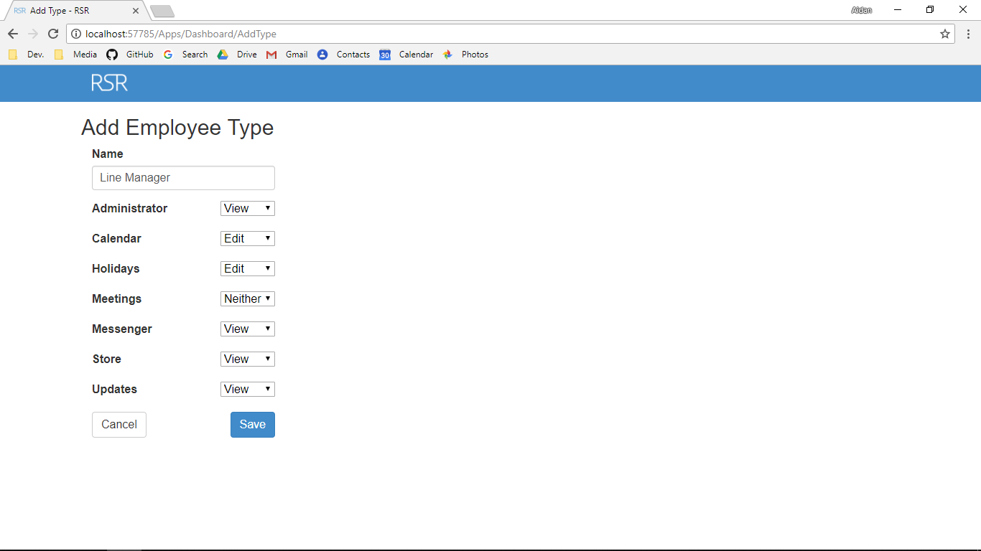

Screenshot After:

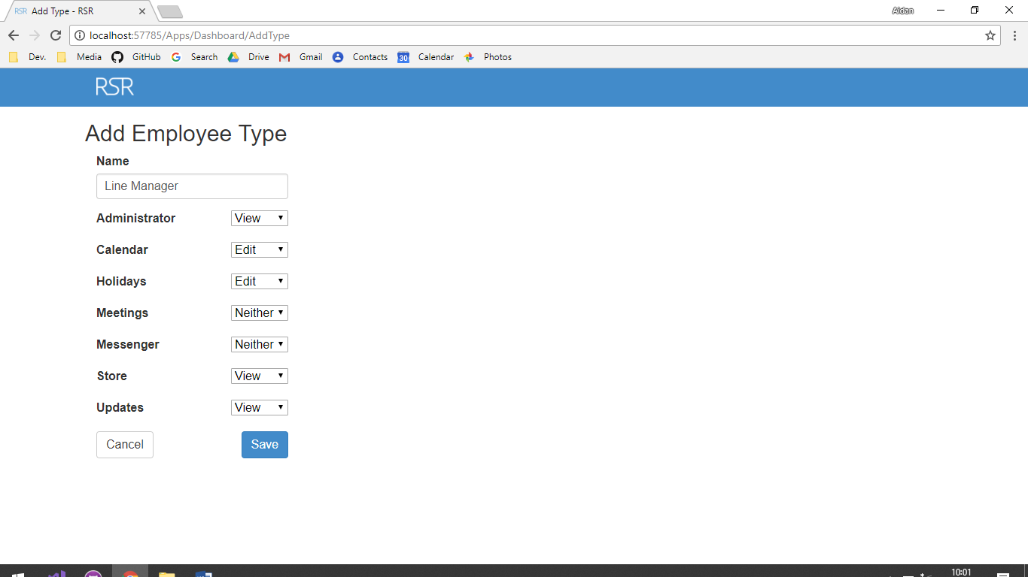

Additional Screenshot (if applicable):

Additional Notes (if applicable):

Test Case ID: AV7 Attempt Number: 1

Action: User inputs Store type

Comprehensive Test Type: Normal

Test Data: Neither

Expected Output: The type can be added (if all other data is valid)

Actual Output: As expected

Result: Pass

Reason for fail (if applicable):

Error Type (if applicable):

Remediation (if applicable):

Screenshot Before:



Screenshot After:

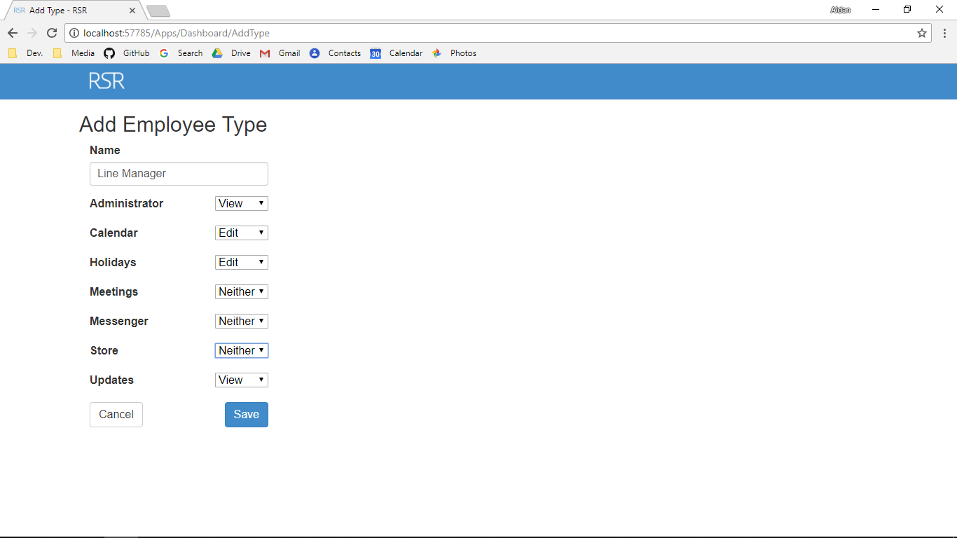

Additional Screenshot (if applicable):

Additional Notes (if applicable):

Test Case ID: AV8 Attempt Number: 1

Action: User inputs Updates type

Comprehensive Test Type: Normal

Test Data: Neither

Expected Output: The type can be added (if all other data is valid)

Actual Output: As expected

Result: Pass

Reason for fail (if applicable):

Error Type (if applicable):

Remediation (if applicable):

Screenshot Before:



Screenshot After:

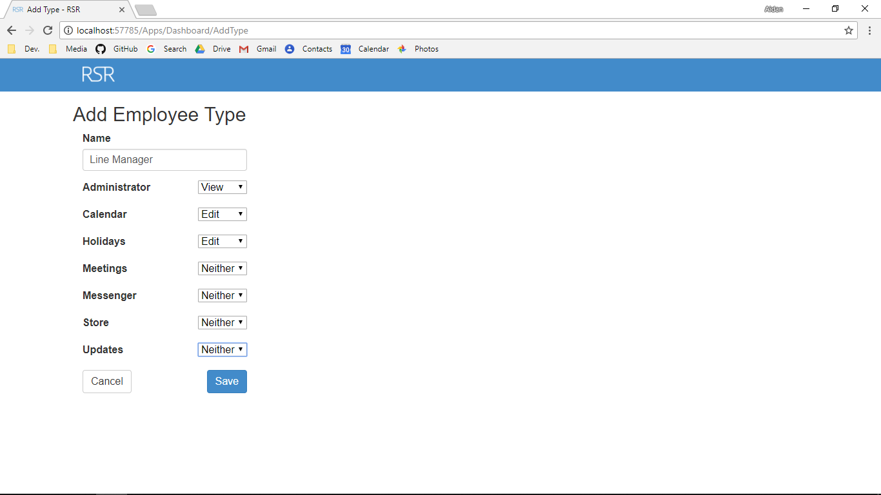

Additional Screenshot (if applicable):

Additional Notes (if applicable):

Test Case ID: AV9 Attempt Number: 1

Action: User inputs type name

Comprehensive Test Type: Normal

Test Data: Line Manager

Expected Output: The type can be added (if all other data is valid)

Actual Output: As expected

Result: Pass

Reason for fail (if applicable):

Error Type (if applicable):

Remediation (if applicable):

Screenshot Before:



Screenshot After:



Additional Screenshot (if applicable):

Additional Notes (if applicable):

Test Case ID: AV9 Attempt Number: 1

Action: User inputs type name

Comprehensive Test Type: Extreme

Test Data: LM

Expected Output: The type can be added (if all other data is valid)

Actual Output: As expected

Result: Pass

Reason for fail (if applicable):

Error Type (if applicable):

Remediation (if applicable):

Screenshot Before:



Screenshot After:



Additional Screenshot (if applicable):

Additional Notes (if applicable):

Test Case ID: AV9 Attempt Number: 1

Action: User inputs type name

Comprehensive Test Type: Exceptional

Test Data: LINEMANANAN ANANANANA NANANANANA NANANAN ANANANANA NANANANANANANA NANANANAN NNAN ANANAGERRR RRRRRRRRRRR

Expected Output: The type cannot be added

Actual Output: As expected

Result: Pass

Reason for fail (if applicable):

Error Type (if applicable):

Remediation (if applicable):

Screenshot Before:



Screenshot After:

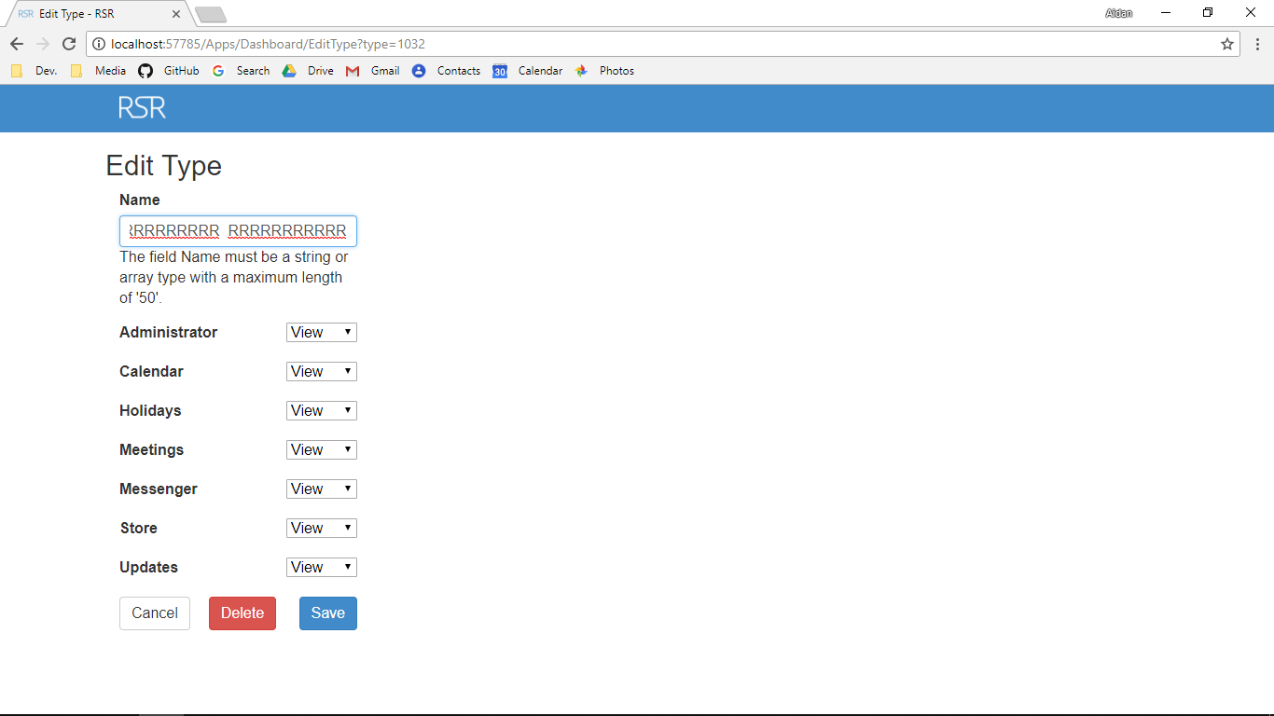

Additional Screenshot (if applicable):

Additional Notes (if applicable):

Test Case ID: AV10 Attempt Number: 1

Action: User inputs Administrator type

Comprehensive Test Type: Normal

Test Data: View

Expected Output: The type can be added (if all other data is valid)

Actual Output: As expected

Result: Pass

Reason for fail (if applicable):

Error Type (if applicable):

Remediation (if applicable):

Screenshot Before:

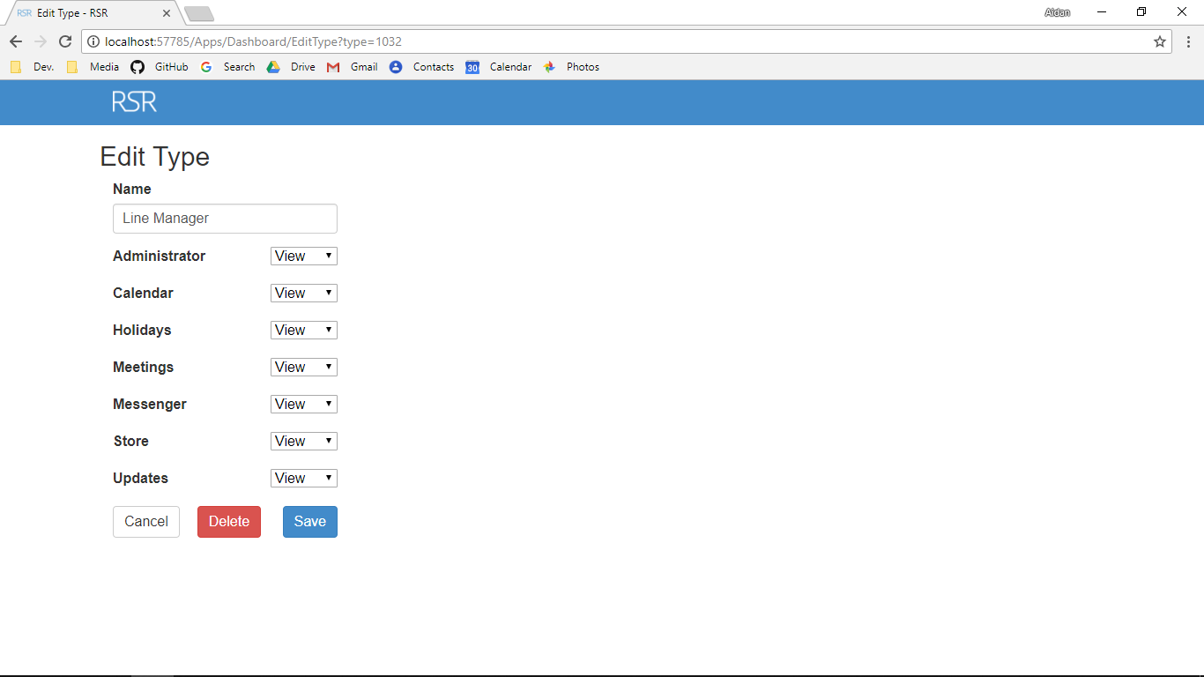

Screenshot After:



Additional Screenshot (if applicable):

Additional Notes (if applicable):

Test Case ID: AV11 Attempt Number: 1

Action: User inputs Calendar type

Comprehensive Test Type: Normal

Test Data: Edit

Expected Output: The type can be added (if all other data is valid)

Actual Output: As expected

Result: Pass

Reason for fail (if applicable):

Error Type (if applicable):

Remediation (if applicable):

Screenshot Before:



Screenshot After:

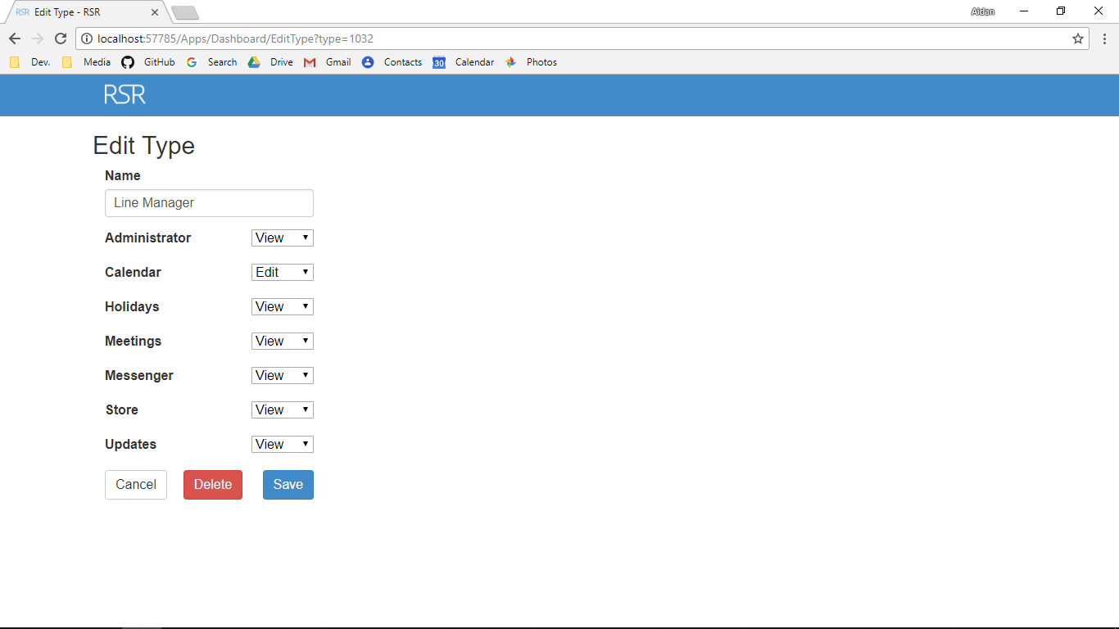

Additional Screenshot (if applicable):

Additional Notes (if applicable):

Test Case ID: AV12 Attempt Number: 1

Action: User inputs Holidays type

Comprehensive Test Type: Normal

Test Data: Edit

Expected Output: The type can be added (if all other data is valid)

Actual Output: As expected

Result: Pass

Reason for fail (if applicable):

Error Type (if applicable):

Remediation (if applicable):

Screenshot Before:



Screenshot After:

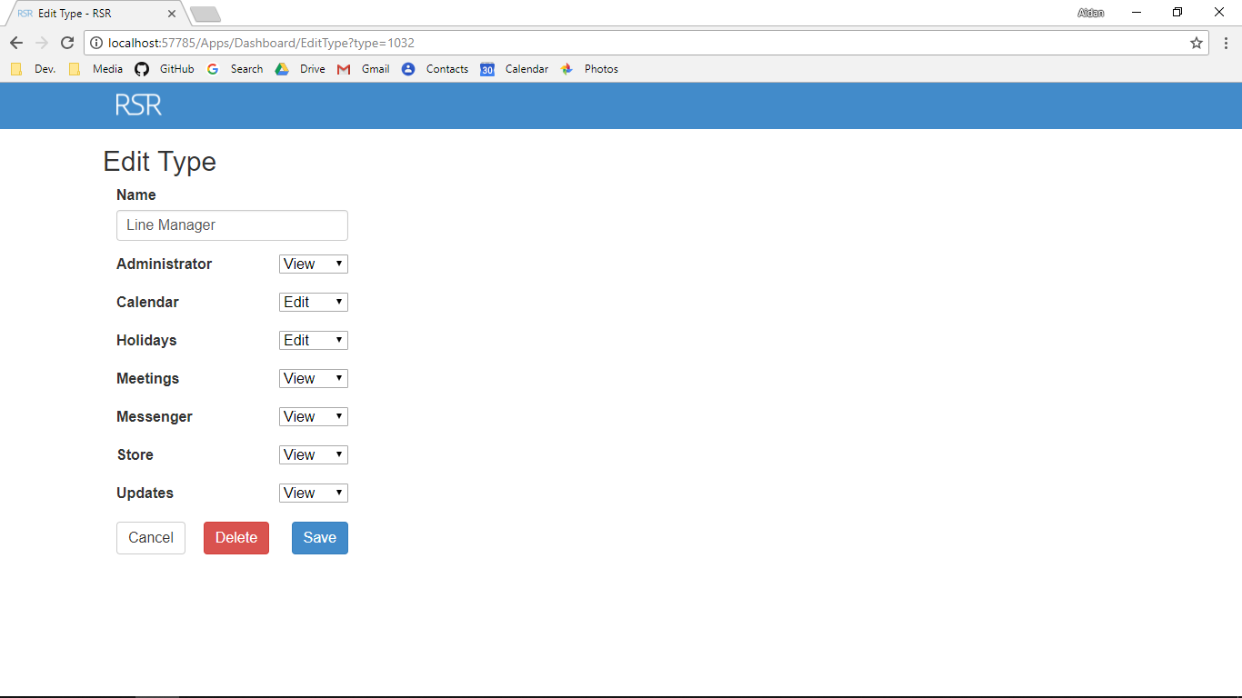

Additional Screenshot (if applicable):

Additional Notes (if applicable):

Test Case ID: AV13 Attempt Number: 1

Action: User inputs Meetings type

Comprehensive Test Type: Normal

Test Data: Neither

Expected Output: The type can be added (if all other data is valid)

Actual Output: As expected

Result: Pass

Reason for fail (if applicable):

Error Type (if applicable):

Remediation (if applicable):

Screenshot Before:

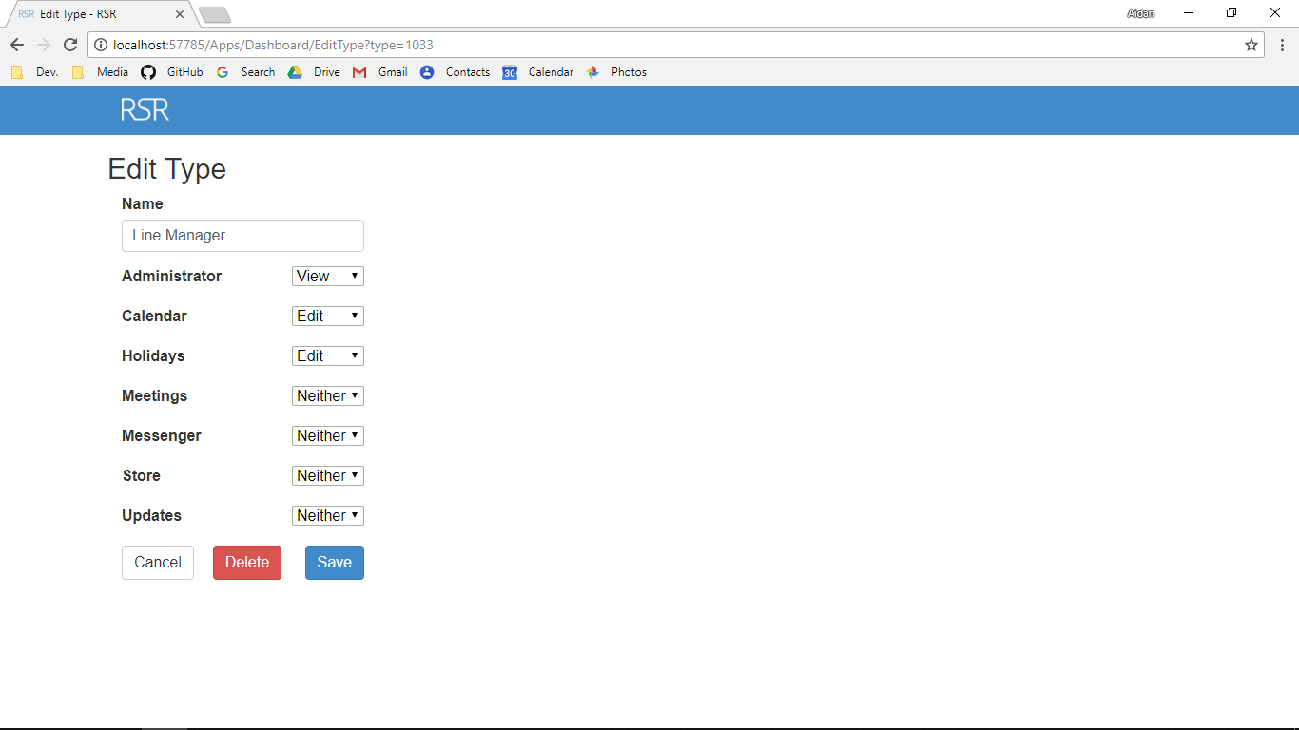

Screenshot After:



Additional Screenshot (if applicable):

Additional Notes (if applicable):

Test Case ID: AV14 Attempt Number: 1

Action: User inputs Messenger type

Comprehensive Test Type: Normal

Test Data: Neither

Expected Output: The type can be added (if all other data is valid)

Actual Output: As expected

Result: Pass

Reason for fail (if applicable):

Error Type (if applicable):

Remediation (if applicable):

Screenshot Before:



Screenshot After:



Additional Screenshot (if applicable):

Additional Notes (if applicable):

Test Case ID: AV15 Attempt Number: 1

Action: User inputs Store type

Comprehensive Test Type: Normal

Test Data: Neither

Expected Output: The type can be added (if all other data is valid)

Actual Output: As expected

Result: Pass

Reason for fail (if applicable):

Error Type (if applicable):

Remediation (if applicable):

Screenshot Before:



Screenshot After:



Additional Screenshot (if applicable):

Additional Notes (if applicable):

Test Case ID: AV16 Attempt Number: 1

Action: User inputs Updates type

Comprehensive Test Type: Normal

Test Data: Neither

Expected Output: The type can be added (if all other data is valid)

Actual Output: As expected

Result: Pass

Reason for fail (if applicable):

Error Type (if applicable):

Remediation (if applicable):

Screenshot Before:



Screenshot After:



Additional Screenshot (if applicable):

Additional Notes (if applicable):

Test Case ID: AV17 Attempt Number: 1

Action: User inputs email address

Comprehensive Test Type: Normal

Test Data: test@gmail.com

Expected Output: The type can be added (if all other data is valid)

Actual Output: As expected

Result: Pass

Reason for fail (if applicable):

Error Type (if applicable):

Remediation (if applicable):

Screenshot Before:

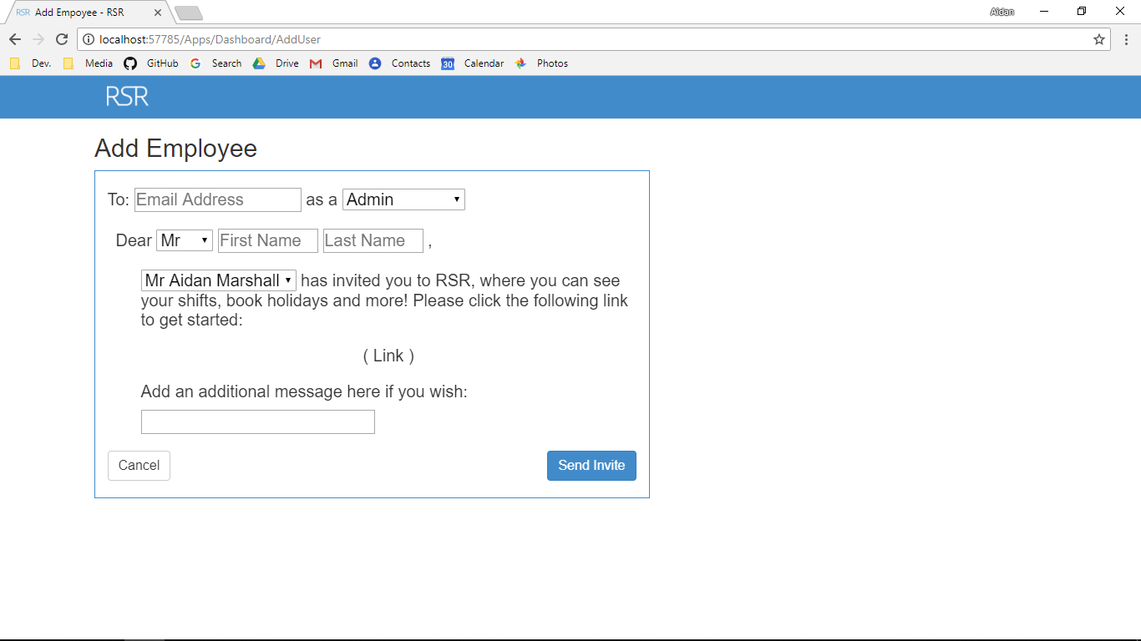

Screenshot After:

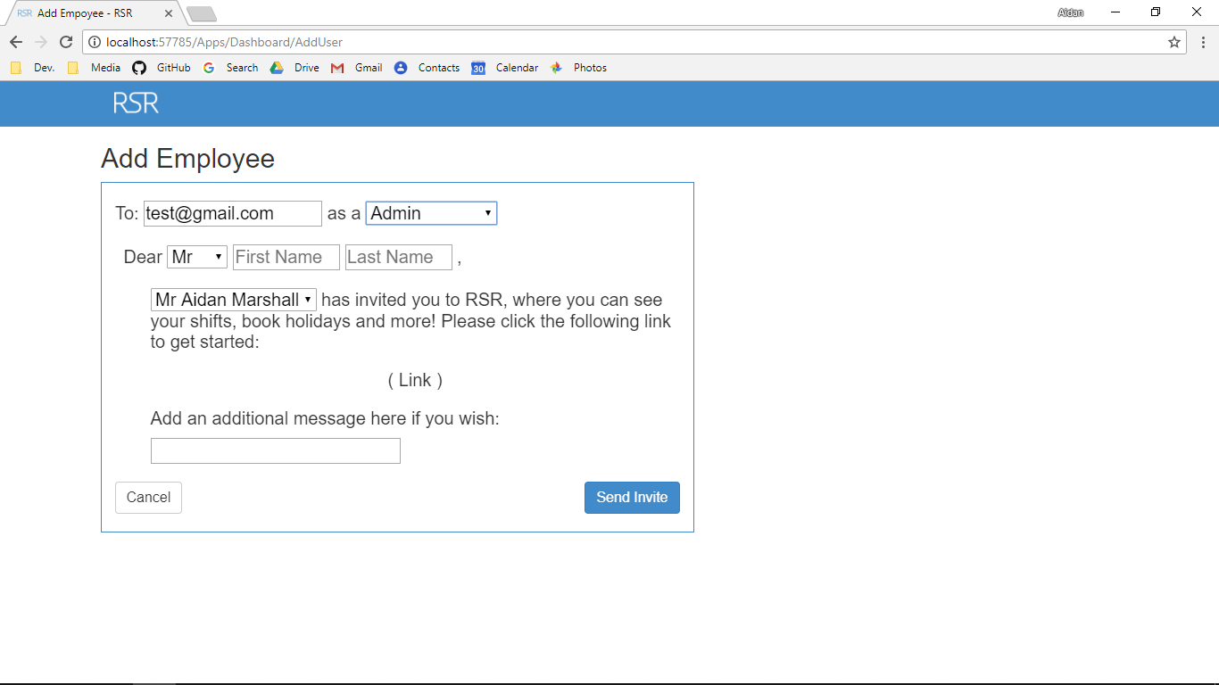

Additional Screenshot (if applicable):

Additional Notes (if applicable):

Test Case ID: AV18 Attempt Number: 1

Action: User inputs type

Comprehensive Test Type: Normal

Test Data: Line Manager

Expected Output: The type can be added (if all other data is valid)

Actual Output: As expected

Result: Pass

Reason for fail (if applicable):

Error Type (if applicable):

Remediation (if applicable):

Screenshot Before:



Screenshot After:

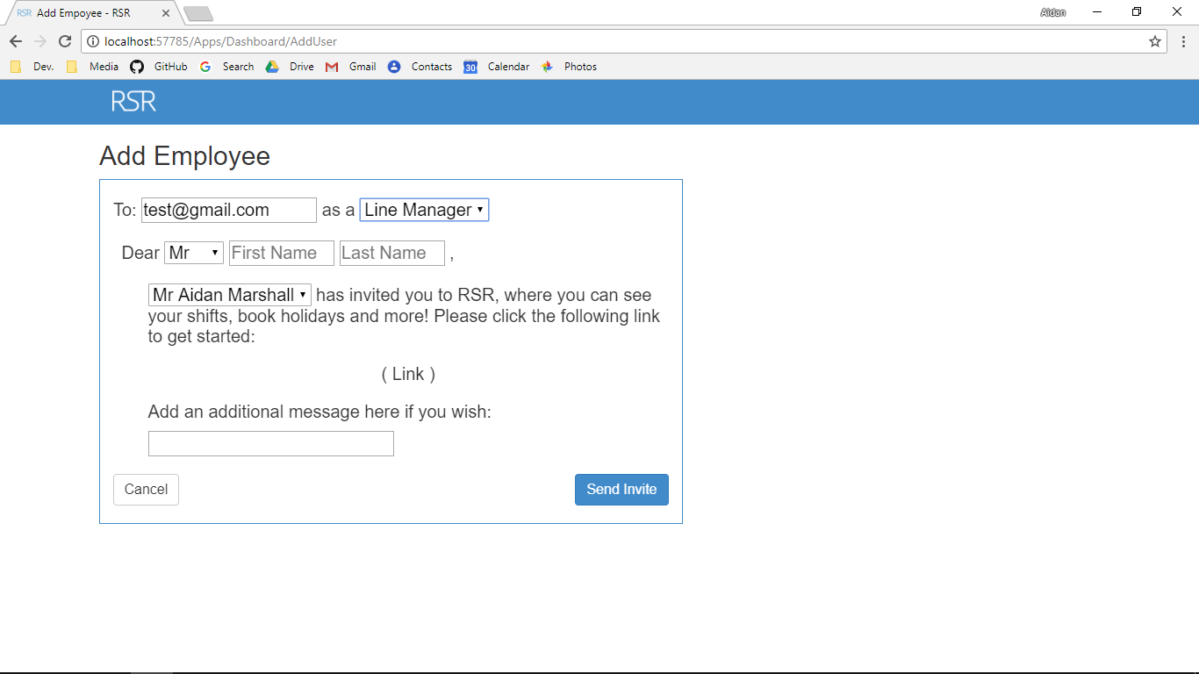

Additional Screenshot (if applicable):

Additional Notes (if applicable):

Test Case ID: AV19 Attempt Number: 1

Action: User inputs title

Comprehensive Test Type: Normal

Test Data: Mrs

Expected Output: The type can be added (if all other data is valid)

Actual Output: As expected

Result: Pass

Reason for fail (if applicable):

Error Type (if applicable):

Remediation (if applicable):

Screenshot Before:



Screenshot After:

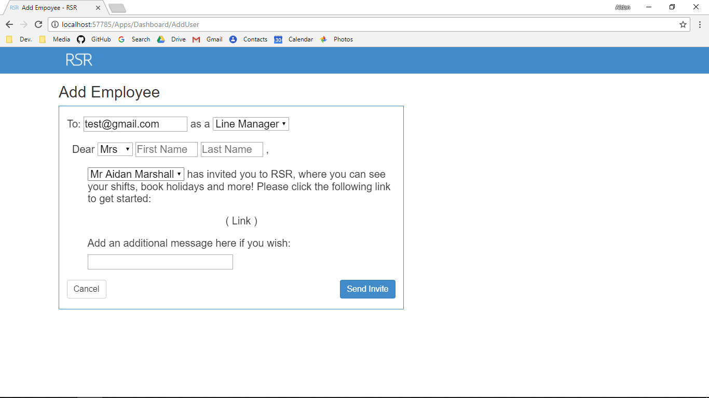

Additional Screenshot (if applicable):

Additional Notes (if applicable):

Test Case ID: AV20 Attempt Number: 1

Action: User inputs first name

Comprehensive Test Type: Normal

Test Data: Name: Jane

Expected Output: The user can be added (if all other data is valid)

Actual Output: As expected

Result: Pass

Reason for fail (if applicable):

Error Type (if applicable):

Remediation (if applicable):

Screenshot Before:

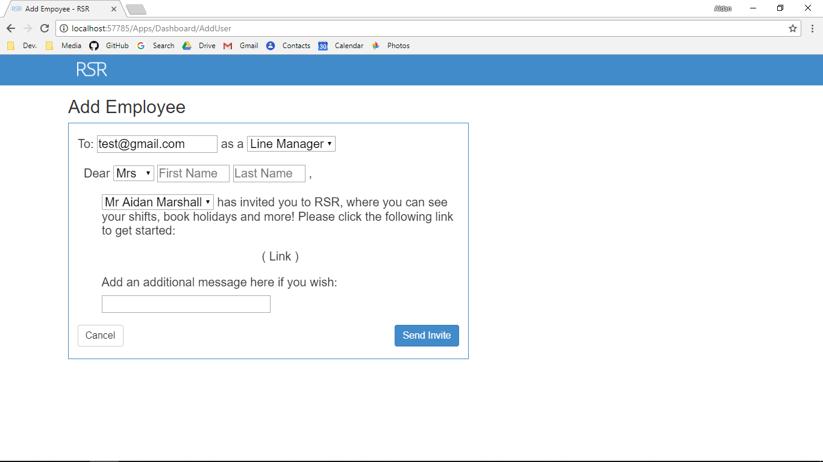

Screenshot After:

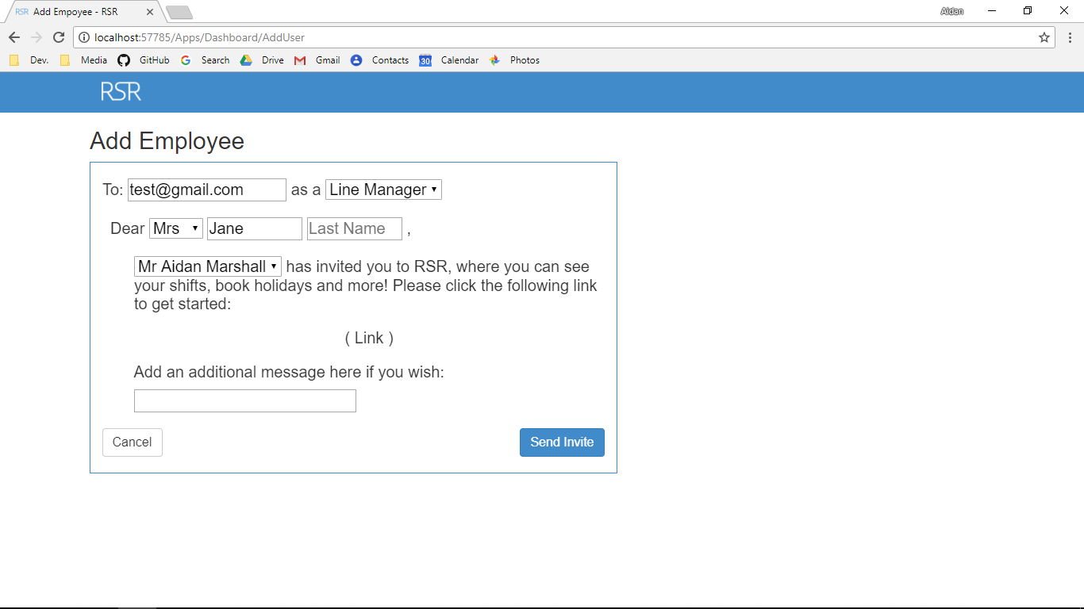

Additional Screenshot (if applicable):

Additional Notes (if applicable):

Test Case ID: AV21 Attempt Number: 1

Action: User inputs last name

Comprehensive Test Type: Normal

Test Data: Name: Tester

Expected Output: The user can be added (if all other data is valid)

Actual Output: As expected

Result: Pass

Reason for fail (if applicable):

Error Type (if applicable):

Remediation (if applicable):

Screenshot Before:



Screenshot After:

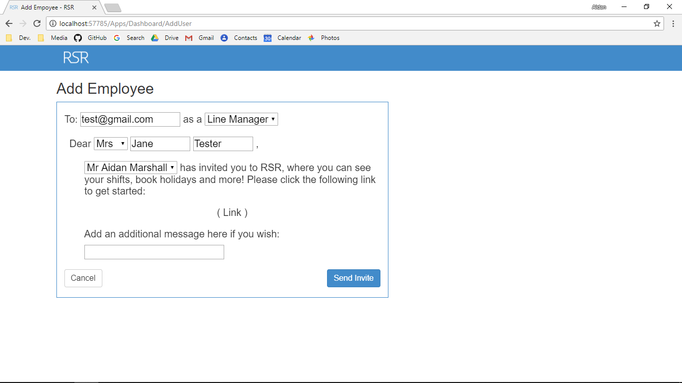

Additional Screenshot (if applicable):

Additional Notes (if applicable):

Test Case ID: AV22 Attempt Number: 1

Action: User inputs Up their name

Comprehensive Test Type: Normal

Test Data: Mr Marshall

Expected Output: The type can be added (if all other data is valid)

Actual Output: As expected

Result: Pass

Reason for fail (if applicable):

Error Type (if applicable):

Remediation (if applicable):

Screenshot Before:



Screenshot After:

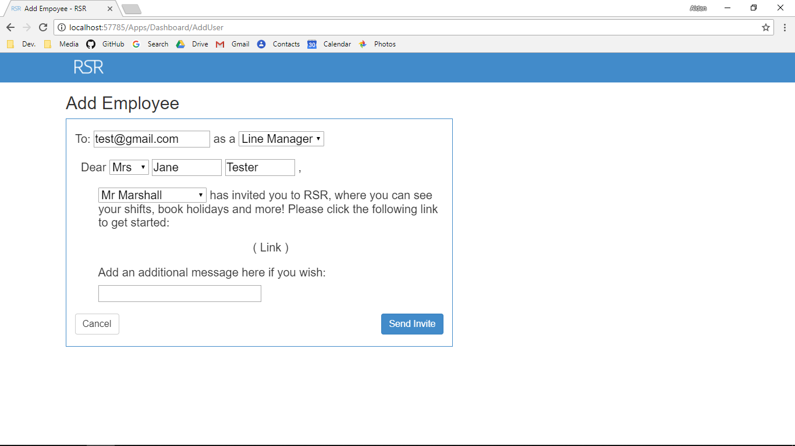

Additional Screenshot (if applicable):

Additional Notes (if applicable):

Test Case ID: AV23 Attempt Number: 1

Action: User inputs additional message

Comprehensive Test Type: Normal

Test Data: Message: Welcome onboard

Expected Output: The user can be added (if all other data is valid)

Actual Output: As expected

Result: Pass

Reason for fail (if applicable):

Error Type (if applicable):

Remediation (if applicable):

Screenshot Before:



Screenshot After:

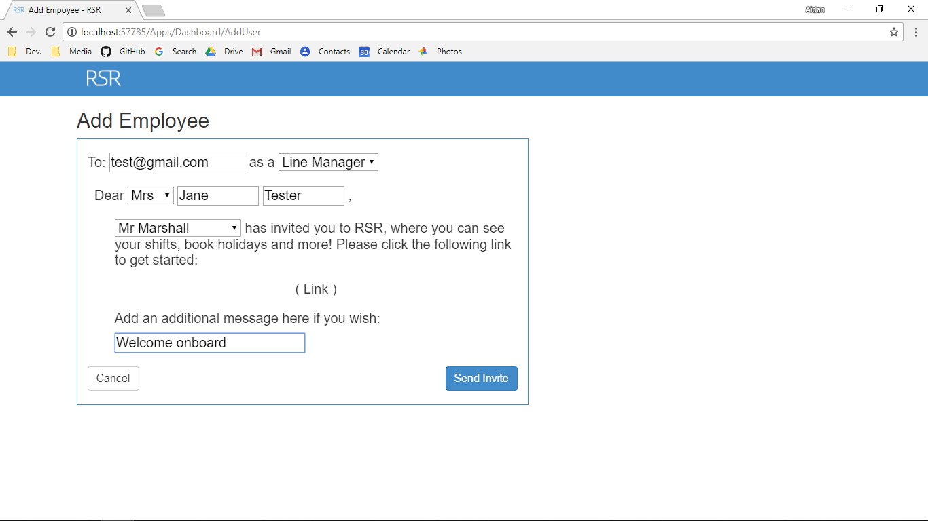

Additional Screenshot (if applicable):

Additional Notes (if applicable):

Test Case ID: AV24 Attempt Number: 1

Action: User inputs title

Comprehensive Test Type: Normal

Test Data: Mrs

Expected Output: The user name is edited

Actual Output: As expected

Result: Pass

Reason for fail (if applicable):

Error Type (if applicable):

Remediation (if applicable):

Screenshot Before:

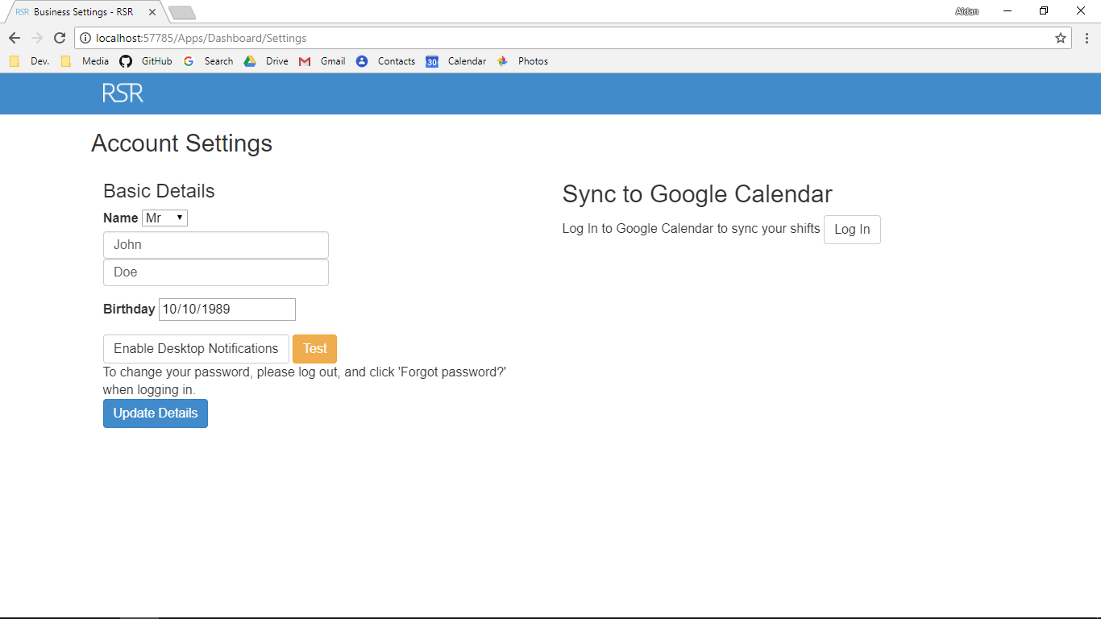

Screenshot After:

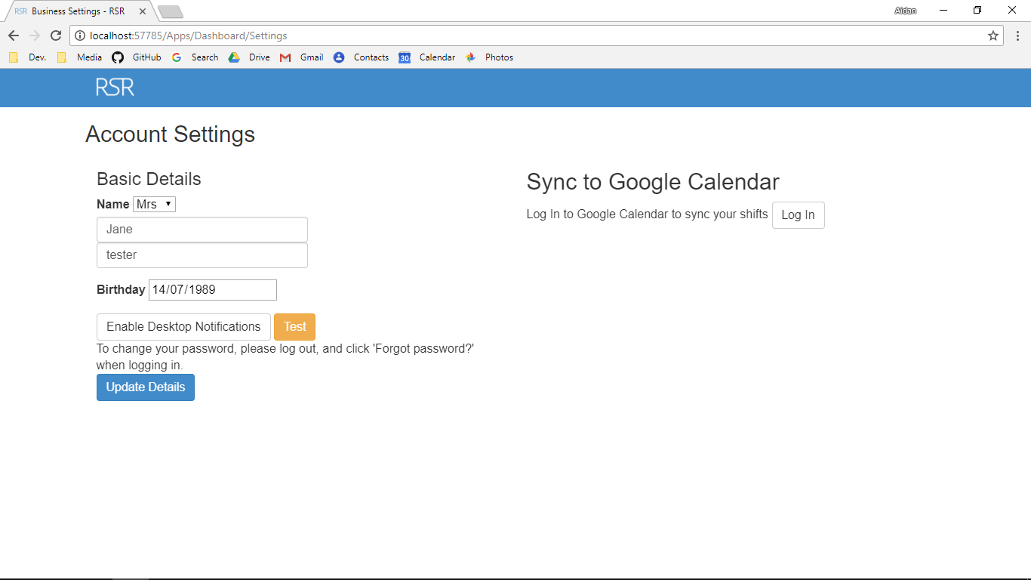

Additional Screenshot (if applicable):

Additional Notes (if applicable):

Test Case ID: AV25 Attempt Number: 1

Action: User inputs first name

Comprehensive Test Type: Normal

Test Data: Name: Jane

Expected Output: The user can be edited (if all other data is valid)

Actual Output: As expected

Result: Pass

Reason for fail (if applicable):

Error Type (if applicable):

Remediation (if applicable):

Screenshot Before:



Screenshot After:



Additional Screenshot (if applicable):

Additional Notes (if applicable):

Test Case ID: AV26 Attempt Number: 1

Action: User inputs last name

Comprehensive Test Type: Normal

Test Data: Name: Tester

Expected Output: The user can be edited (if all other data is valid)

Actual Output: As expected

Result: Pass

Reason for fail (if applicable):

Error Type (if applicable):

Remediation (if applicable):

Screenshot Before:



Screenshot After:



Additional Screenshot (if applicable):

Additional Notes (if applicable):

Test Case ID: AV27 Attempt Number: 1

Action: User inputs birth day

Comprehensive Test Type: Normal

Test Data: Name: 14/7/1989

Expected Output: The user can be edited (if all other data is valid)

Actual Output: As expected

Result: Pass

Reason for fail (if applicable):

Error Type (if applicable):

Remediation (if applicable):

Screenshot Before:



Screenshot After:



Additional Screenshot (if applicable):

Additional Notes (if applicable):

Test Case ID: AV28 Attempt Number: 1

Action: User inputs shift user

Comprehensive Test Type: Normal

Test Data: Name: Jane

Expected Output: The shift is made (if all other data is valid)

Actual Output: As expected

Result: Pass

Reason for fail (if applicable):

Error Type (if applicable):

Remediation (if applicable):

Screenshot Before:

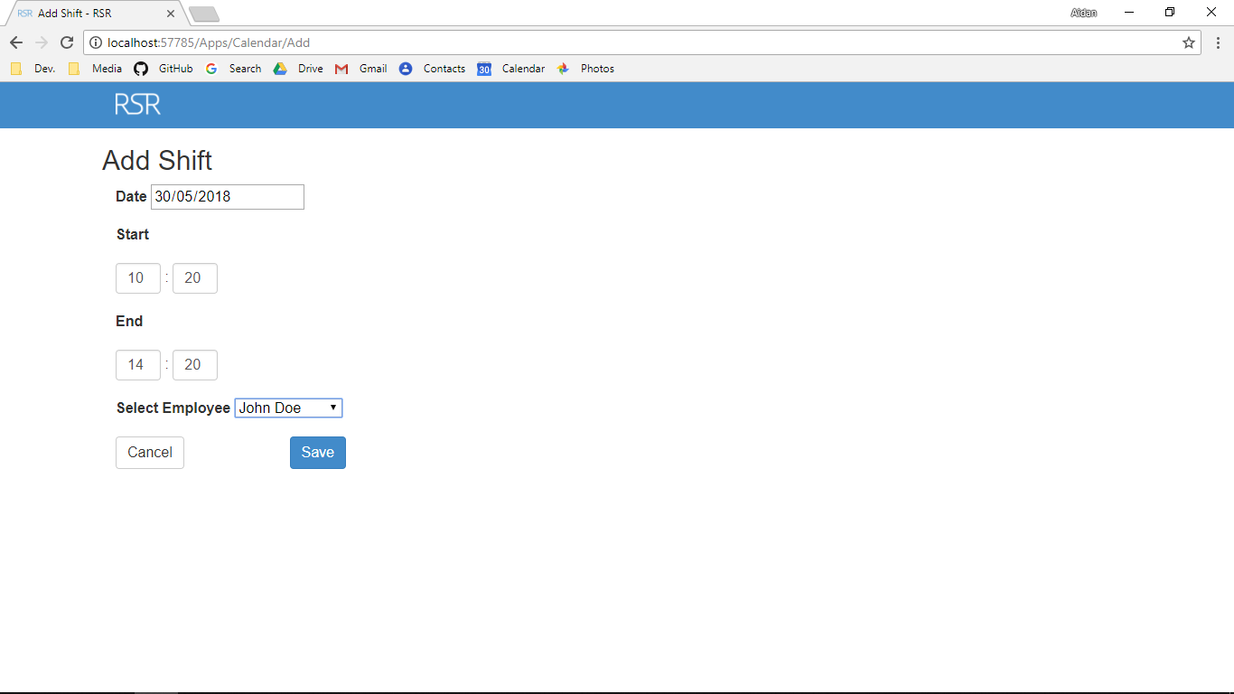

Screenshot After:

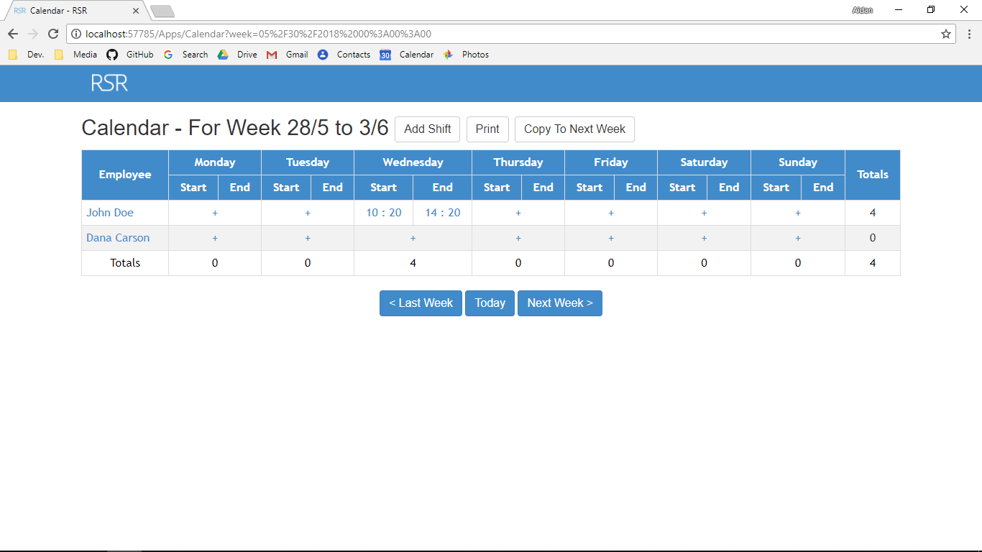

Additional Screenshot (if applicable):

Additional Notes (if applicable):

Test Case ID: AV29 Attempt Number: 1

Action: User inputs Date

Comprehensive Test Type: Normal

Test Data: Name 30/5/18

Expected Output: The shift is made (if all other data is valid)

Actual Output: As expected

Result: Pass

Reason for fail (if applicable):

Error Type (if applicable):

Remediation (if applicable):

Screenshot Before:



Screenshot After:



Additional Screenshot (if applicable):

Additional Notes (if applicable):

Test Case ID: AV30 Attempt Number: 1

Action: User inputs minute

Comprehensive Test Type: Normal

Test Data: Name: 20

Expected Output: The shift is made (if all other data is valid)

Actual Output: As expected

Result: Pass

Reason for fail (if applicable):

Error Type (if applicable):

Remediation (if applicable):

Screenshot Before:



Screenshot After:



Additional Screenshot (if applicable):

Additional Notes (if applicable):

Test Case ID: AV31 Attempt Number: 1

Action: User start hour

Comprehensive Test Type: Normal

Test Data: 10

Expected Output: The shift is made (if all other data is valid)

Actual Output: As expected

Result: Pass

Reason for fail (if applicable):

Error Type (if applicable):

Remediation (if applicable):

Screenshot Before:



Screenshot After:



Additional Screenshot (if applicable):

Additional Notes (if applicable):

Test Case ID: AV32 Attempt Number: 1

Action: User inputs the end minute

Comprehensive Test Type: Normal

Test Data: Name: 20

Expected Output: The shift is made (if all other data is valid))

Actual Output: As expected

Result: Pass

Reason for fail (if applicable):

Error Type (if applicable):

Remediation (if applicable):

Screenshot Before:



Screenshot After:



Additional Screenshot (if applicable):

Additional Notes (if applicable):

Test Case ID: AV33 Attempt Number: 1

Action: User inputs end hour

Comprehensive Test Type: Normal

Test Data: Name: 14

Expected Output: The shift is made (if all other data is valid)

Actual Output: As expected

Result: Pass

Reason for fail (if applicable):

Error Type (if applicable):

Remediation (if applicable):

Screenshot Before:



Screenshot After:



Additional Screenshot (if applicable):

Additional Notes (if applicable):

Test Case ID: AV34 Attempt Number: 1

Action: User inputs shift user

Comprehensive Test Type: Normal

Test Data: Name: Jane

Expected Output: The shift is made (if all other data is valid)

Actual Output: As expected

Result: Pass

Reason for fail (if applicable):

Error Type (if applicable):

Remediation (if applicable):

Screenshot Before:



Screenshot After:



Additional Screenshot (if applicable):

Additional Notes (if applicable):

Test Case ID: AV35 Attempt Number: 1

Action: User inputs Date

Comprehensive Test Type: Normal

Test Data: Name 30/5/18

Expected Output: The shift is made (if all other data is valid)

Actual Output: As expected

Result: Pass

Reason for fail (if applicable):

Error Type (if applicable):

Remediation (if applicable):

Screenshot Before:



Screenshot After:



Additional Screenshot (if applicable):

Additional Notes (if applicable):

Test Case ID: AV36 Attempt Number: 1

Action: User inputs minute

Comprehensive Test Type: Normal

Test Data: Name: 20

Expected Output: The shift is made (if all other data is valid)

Actual Output: As expected

Result: Pass

Reason for fail (if applicable):

Error Type (if applicable):

Remediation (if applicable):

Screenshot Before:



Screenshot After:



Additional Screenshot (if applicable):

Additional Notes (if applicable):

Test Case ID: AV37 Attempt Number: 1

Action: User start hour

Comprehensive Test Type: Normal

Test Data: 10

Expected Output: The shift is made (if all other data is valid)

Actual Output: As expected

Result: Pass

Reason for fail (if applicable):

Error Type (if applicable):

Remediation (if applicable):

Screenshot Before:



Screenshot After:



Additional Screenshot (if applicable):

Additional Notes (if applicable):

Test Case ID: AV37 Attempt Number: 1

Action: User inputs the end minute

Comprehensive Test Type: Normal

Test Data: Name: 20

Expected Output: The shift is made (if all other data is valid))

Actual Output: As expected

Result: Pass

Reason for fail (if applicable):

Error Type (if applicable):

Remediation (if applicable):

Screenshot Before:



Screenshot After:



Additional Screenshot (if applicable):

Additional Notes (if applicable):

Test Case ID: AV39 Attempt Number: 1

Action: User inputs user

Comprehensive Test Type: Normal

Test Data: Name: 14

Expected Output: The shift is made (if all other data is valid)

Actual Output: As expected

Result: Pass

Reason for fail (if applicable):

Error Type (if applicable):

Remediation (if applicable):

Screenshot Before:



Screenshot After:



Additional Screenshot (if applicable):

Additional Notes (if applicable):

Test Case ID: AV41 Attempt Number: 1

Action: User inputs holiday start date

Comprehensive Test Type: Normal

Test Data: Name: Jane

Expected Output: The holiday is made (if all other data is valid)

Actual Output: As expected

Result: Pass

Reason for fail (if applicable):

Error Type (if applicable):

Remediation (if applicable):

Screenshot Before:

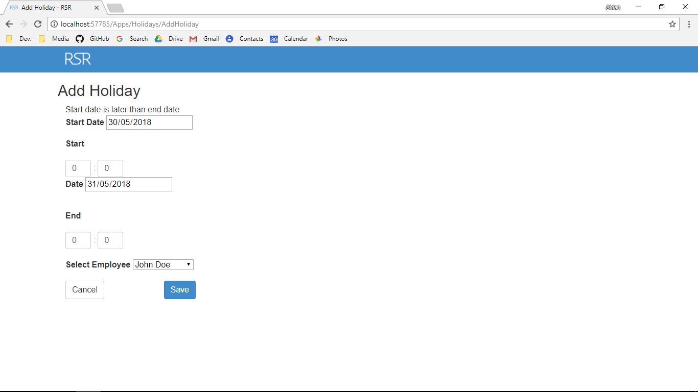

Screenshot After:

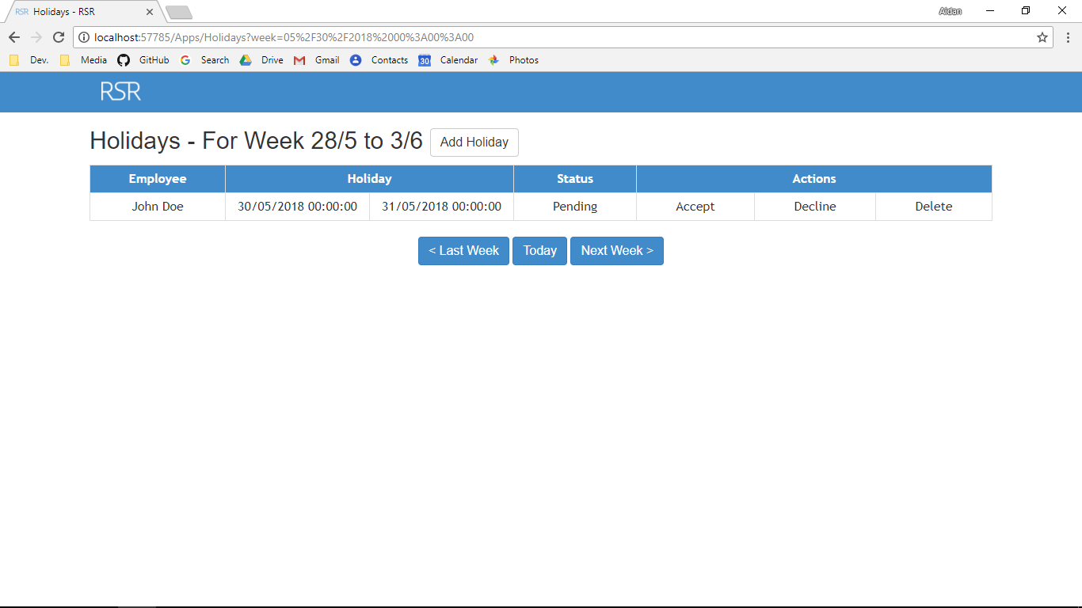

Additional Screenshot (if applicable):

Additional Notes (if applicable):

Test Case ID: AV42 Attempt Number: 1

Action: User inputs Start min

Comprehensive Test Type: Normal

Test Data: Name 30/5/18

Expected Output: The holiday is made (if all other data is valid)

Actual Output: As expected

Result: Pass

Reason for fail (if applicable):

Error Type (if applicable):

Remediation (if applicable):

Screenshot Before:



Screenshot After:



Additional Screenshot (if applicable):

Additional Notes (if applicable):

Test Case ID: AV43 Attempt Number: 1

Action: User inputs minute

Comprehensive Test Type: Normal

Test Data: Name: 20

Expected Output: The holiday is made (if all other data is valid)

Actual Output: As expected

Result: Pass

Reason for fail (if applicable):

Error Type (if applicable):

Remediation (if applicable):

Screenshot Before:



Screenshot After:



Additional Screenshot (if applicable):

Additional Notes (if applicable):

Test Case ID: AV44 Attempt Number: 1

Action: User writes end minute

Comprehensive Test Type: Normal

Test Data: 10

Expected Output: The holiday is made (if all other data is valid)

Actual Output: As expected

Result: Pass

Reason for fail (if applicable):

Error Type (if applicable):

Remediation (if applicable):

Screenshot Before:



Screenshot After:



Additional Screenshot (if applicable):

Additional Notes (if applicable):

Test Case ID: AV45 Attempt Number: 1

Action: User inputs end hour

Comprehensive Test Type: Normal

Test Data: Name: 20

Expected Output: The holiday is made (if all other data is valid))

Actual Output: As expected

Result: Pass

Reason for fail (if applicable):

Error Type (if applicable):

Remediation (if applicable):

Screenshot Before:



Screenshot After:



Additional Screenshot (if applicable):

Additional Notes (if applicable):

Test Case ID: AV46 Attempt Number: 1

Action: User inputs end date

Comprehensive Test Type: Normal

Test Data: Name: 14

Expected Output: The holiday is made (if all other data is valid)

Actual Output: As expected

Result: Pass

Reason for fail (if applicable):

Error Type (if applicable):

Remediation (if applicable):

Screenshot Before:



Screenshot After:



Additional Screenshot (if applicable):

Additional Notes (if applicable):

Test Case ID: AV47 Attempt Number: 1

Action: User inputs holiday start date

Comprehensive Test Type: Normal

Test Data: Name: Jane

Expected Output: The holiday is made (if all other data is valid)

Actual Output: As expected

Result: Pass

Reason for fail (if applicable):

Error Type (if applicable):

Remediation (if applicable):

Screenshot Before:



Screenshot After:



Additional Screenshot (if applicable):

Additional Notes (if applicable):

Test Case ID: AV48 Attempt Number: 1

Action: User inputs Start min

Comprehensive Test Type: Normal

Test Data: Name 30/5/18

Expected Output: The holiday is made (if all other data is valid)

Actual Output: As expected

Result: Pass

Reason for fail (if applicable):

Error Type (if applicable):

Remediation (if applicable):

Screenshot Before:



Screenshot After:



Additional Screenshot (if applicable):

Additional Notes (if applicable):

Test Case ID: AV49 Attempt Number: 1

Action: User inputs minute

Comprehensive Test Type: Normal

Test Data: Name: 20

Expected Output: The holiday is made (if all other data is valid)

Actual Output: As expected

Result: Pass

Reason for fail (if applicable):

Error Type (if applicable):

Remediation (if applicable):

Screenshot Before:



Screenshot After:



Additional Screenshot (if applicable):

Additional Notes (if applicable):

Test Case ID: AV50 Attempt Number: 1

Action: User writes end minute

Comprehensive Test Type: Normal

Test Data: 10

Expected Output: The holiday is made (if all other data is valid)

Actual Output: As expected

Result: Pass

Reason for fail (if applicable):

Error Type (if applicable):

Remediation (if applicable):

Screenshot Before:



Screenshot After:



Additional Screenshot (if applicable):

Additional Notes (if applicable):

Test Case ID: AV51 Attempt Number: 1

Action: User inputs end hour

Comprehensive Test Type: Normal

Test Data: Name: 20

Expected Output: The holiday is made (if all other data is valid))

Actual Output: As expected

Result: Pass

Reason for fail (if applicable):

Error Type (if applicable):

Remediation (if applicable):

Screenshot Before:



Screenshot After:



Additional Screenshot (if applicable):

Additional Notes (if applicable):

Test Case ID: AV52 Attempt Number: 1

Action: User inputs end date

Comprehensive Test Type: Normal

Test Data: Name: 14

Expected Output: The holiday is made (if all other data is valid)

Actual Output: As expected

Result: Pass

Reason for fail (if applicable):

Error Type (if applicable):

Remediation (if applicable):

Screenshot Before:



Screenshot After:



Additional Screenshot (if applicable):

Additional Notes (if applicable):

Test Case ID: AV53 Attempt Number: 1

Action: User inputs end date

Comprehensive Test Type: Normal

Test Data: Name: 14

Expected Output: The holiday is made (if all other data is valid)

Actual Output: As expected

Result: Pass

Reason for fail (if applicable):

Error Type (if applicable):

Remediation (if applicable):

Screenshot Before:



Screenshot After:



Additional Screenshot (if applicable):

Additional Notes (if applicable):

# 30.4 - Test Cases Work Log

| Entry | Description | Person | Date | Mins Spent |
| --- | --- | --- | --- | --- |
| 1 | Formatted the document | Aidan Marshall | 30/5/18 | 2 |
| 2 | Wrote the prepopulated data section | Aidan Marshall | 30/5/18 | 2 |
| 3 | Described the layout of the test cases | Aidan Marshall | 30/5/18 | 2 |
| 4 | Wrote the test log | Aidan Marshall | 30/5/18 | 567 |
| 5 | Completed the test cases | Aidan Marshall | 30/5/18 | 439 |
| 1012 | | | | |